trade facilitation measures concerning sanitary certificates for hydrobiological products and resources
COMMUNICATION FROM PERU
The following communication, received on 20 August 2020, is being circulated at the request of the delegation of Peru.

_______________

            - As the spread of COVID-19 poses a global health issue, air transport restrictions have been applied, affecting courier services used to send sanitary certificates and other international trade documents, thereby delaying the trade transactions of Peruvian exporters and importers of hydrobiological fishery and aquaculture products and resources.
            - In order to optimize international trade in hydrobiological products and resources under the current circumstances, the National Fisheries Health Agency of Peru (SANIPES) has begun to issue "sanitary certificates with digital signature" with the following security measures: digital signatures guaranteed by the Peruvian government, a QR/CUVE code and an alpha-numeric code to immediately verify the authenticity of the document.
            - Given that, under the current circumstances, the issuance of "sanitary certificates with digital signature" for hydrobiological products and resources has been positively received by the health authorities of some WTO Members, SANIPES urges countries to adopt this measure permanently.
            - The "sanitary certificates with digital signature" include a digital signature guaranteed by the Peruvian Government, a QR/CUVE code and an alpha-numeric code to immediately verify the authenticity of the document through the official website, or at: http://app02.sanipes.gob.pe:8089/Publico/Consulta_Documento.
            - Attached are the guidelines for verifying sanitary certificates with digital signature. Please send any requests for further information to the following email address: dhcpa@sanipes.gob.pe.
            - In addition, under the WTO Agreement on the Application of Sanitary and Phytosanitary Measures, equivalence of this measure will be applied in the case of imports of hydrobiological products and resources into Peru. As a result, the submission of paper certificates may be exempted as long as a virtual validation mechanism is available.
            - Consequently, in terms of cooperation between WTO Members, Peru requests countries to apply reciprocal measures for the acceptance of health certificates with digital signatures on a permanent basis.

ANNEX

VERIFICATION OF SANITARY CERTIFICATES WITH DIGITAL SIGNATURE
In order to optimize foreign trade in hydrobiological products and resources under the current circumstances, SANIPES will permanently issue "sanitary certificates with digital signature" with the following security measures: digital signatures guaranteed by the Peruvian Government, a QR/CUVE code and an alpha-numeric code.
The following steps are involved in the "sanitary certificates with digital signature":

- SANIPES issues the sanitary certificate with digital signature, the QR/CUVE code and the alpha-numeric code.
- The competent authority may verify the authenticity of the sanitary certificate with digital signature through the SANIPES website, by using the QR/CUVE code or at:
http://app02.sanipes.gob.pe:8089/Publico/Consulta_Documento, taking the following steps:
  - Firstly, identify the alpha-numeric code (just below the QR/CUVE code) on the sanitary certificate:
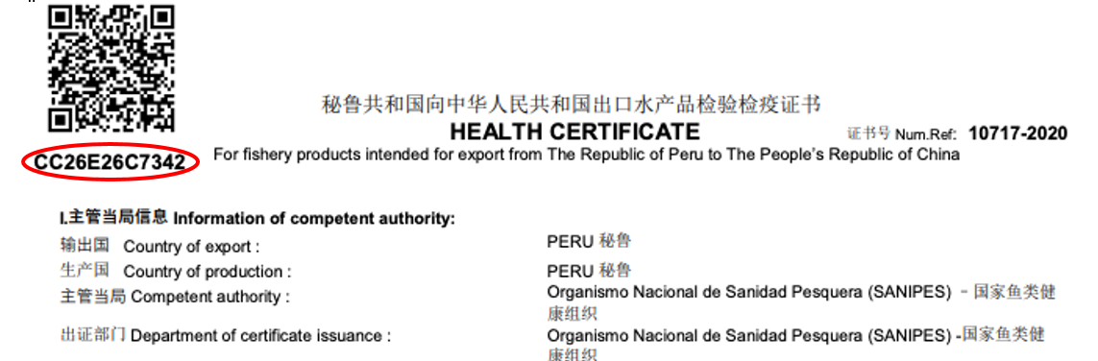

  - Next, visit http://app02.sanipes.gob.pe:8089/Publico/Consulta_Documento (SANIPES website):
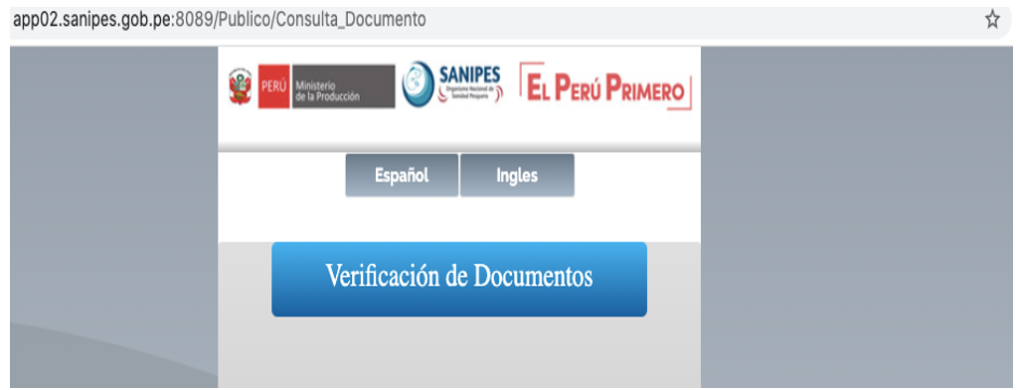

  - Enter the document code (alpha-numeric code) and the captcha:
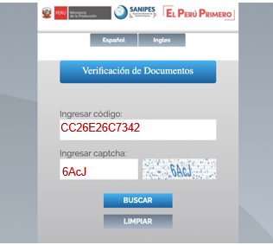
  - Lastly, access the PDF of the sanitary certificate issued by SANIPES:
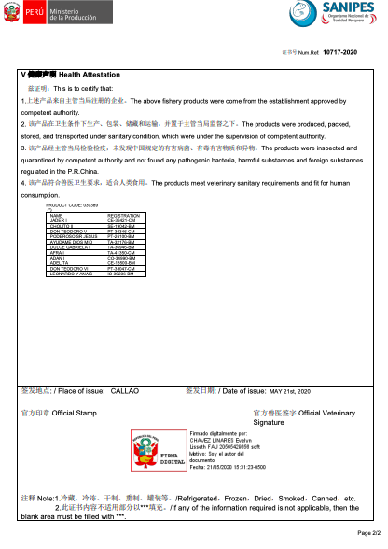
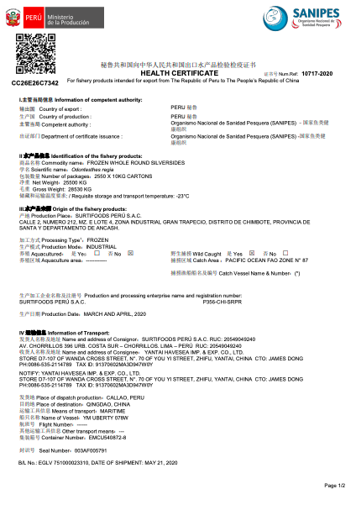

- Should any queries arise, the competent authority may contact SANIPES directly at the following email address: dhcpa@sanipes.gob.pe.

__________

