submission by canada

transparency issues in domestic support notifications

The following submission, dated 12 May 2021, is being circulated at the request of the delegation of Canada.

**_______________**

The objective of this paper is to illustrate how various transparency issues in notifications affect Members' ability to analyze and deepen our understanding of the state of domestic support in agriculture. This paper identifies different types of transparency issues in domestic support notifications and uses an evidence-based approach to quantify their prevalence. The paper also presents the most recent trends in domestic support using Canada's domestic support analytical tool ([JOB/AG/190](https://docs.wto.org/dol2fe/Pages/SS/directdoc.aspx?filename=q:/Jobs/AG/190-01.pdf&Open=True)), and looks at the implications of data gaps in analyzing the total amount of domestic support provided by Members and the percentage of Members who are using certain categories of domestic support.

# METHODOLOGY

All data used to conduct this analysis were sourced from Canada's domestic support analytical tool ([JOB/AG/190](https://docs.wto.org/dol2fe/Pages/SS/directdoc.aspx?filename=q:/Jobs/AG/190-01.pdf&Open=True)). The analytical tool includes all DS:1 notifications submitted by Members as of 17 November 2020 for the 2001 to 2019 period, as well as additional third party data for exchange rates (International Financial Statistics (IFS)) and for unnotified value of production numbers (FAO). Full methodological details can be found in the Excel worksheet labelled *Info* in [JOB/AG/190](https://docs.wto.org/dol2fe/Pages/SS/directdoc.aspx?filename=q:/Jobs/AG/190-01.pdf&Open=True).

# TRANSPARENCY ISSUES AND DATA GAPS

Notifications provide information on the domestic support practices of WTO Members. Having a large number of Members providing up to date notifications which cover all measures in favour of agricultural producers with quality information is vital to the Membership's collective ability to undertake a thorough assessment of the state of play of domestic support in agriculture.

## Participation in the Notification Process

One of the transparency issues in domestic support can be attributed to Members that have never submitted an annual domestic support notification. Out of 135 Members in 2020[1], 34 Members have not submitted a domestic support notification in the 2001–2019 period. This means that assessments on domestic support practices are based on only 75% (or 101) of the Membership.

Figure 1: Number of Members that submitted at least one notification since 2001, as of 17 November 2020



## Timeliness of Notifications

The timeliness of notifications is a second type of transparency issue that impedes the analysis of domestic support. For the 101 Members who submitted at least one notification since 2001, the median year of their most recent notification was 2016. As of 17 November 2020, 16 Members have submitted a notification for notification year 2019 and three Members have not submitted a notification later than notification year 2004.

Figure 2: Distribution of the number of Members by most recent year of Domestic Support notification, as of 17 November 2020



The year selected to describe and assess trends in domestic support will have implications for the quality and completeness of information. As shown on figure 3, the number of DS:1 notifications submitted to the WTO, as of 17 November 2020, is relatively comparable for the 2001 to 2015 years, but the number of notifications submitted is lower for more recent years. For example, statistics extracted from the year 2016 (i.e., the median for the most recent notifications) will yield outcomes that reflect the notifications of only 63 Members[2] (or 62% of the 101 Members having submitted at least one notification). Taking into account the 34 Members who have yet to submit a notification since 2001, these 63 Members represent only 47% of the 135 Members. The further back we go in time, the more comprehensive the results are, as they include a greater number of Members. However, there is a trade-off in respect of whether older notifications can be reflective of the current situation of a Member.

Figure 3: Number of Members that have submitted a DS:1 notification, 2001-2019



## Omitted support from DS:1 Notifications

Transparency issues can also be found in the domestic support notifications submitted by the WTO Membership. The WTO Trade Policy Review mechanism highlights the differences between the agricultural policies applied by Members and the agricultural policies reported in the domestic support notifications. Notifications of most WTO Members typically underreport domestic support when compared against the agricultural programs identified in the trade policy reviews or a search of a Member's website. Many programs and measures are also omitted in the domestic support notifications. This issue is also discussed regularly in the Committee on Agriculture (COA).[3] Some domestic support notifications notably omit some Green Box general services (paragraph 2, Annex 2), such as expenditures related to inspection services, pest and disease control services, or infrastructural services. Other notifications exclude more trade and production related forms of domestic support, including product and non-product specific Amber Box programs, and market price support policies.

Perhaps the best indication that Members exclude certain elements of their domestic support policies from notifications is the number of Members that have reported having no support over the years (in both the Green Box and Article 6). This is in contrast to information about agricultural programs that can be found on a Member's governmental web site. Between 2001 and 2019, on average 11 Members notified no support in any given year with a high of 17 Members notifying no support in 2002. In total, 20 Members reported no support in at least one year, and a total of 12 Members reported no domestic support in all their notifications between 2001 and 2019.[4]

Figure 4: Number of Members that notified having no Domestic Support, 2001-2019



## Quality of Notifications

A significant number of transparency issues are also related to the quality of domestic support notifications notified by Members. A review of notifications and questions posed in the WTO Committee on Agriculture ([JOB/AG/181](https://docs.wto.org/dol2fe/Pages/SS/directdoc.aspx?filename=q:/Jobs/AG/181.pdf&Open=True)) identified many transparency issues related to quality of notifications. This notably includes incomplete descriptions of programs, classification and non-notification issues, data manipulation related to inflation and changes in notified currency, and inconsistencies in how Members notify similar programs. A more accurate and detailed representation of programs in notifications would help to better monitor and analyze the total amount of domestic support provided by Members and the percentage of Members who are using certain categories of domestic support.

## Relative-Based Analysis: The Importance of Value of Production

To compare the level of agricultural support of Members with an agriculture sector of varying size, it is necessary to have a common basis for comparison. The total agriculture value of production (VOP) remains a generally accessible and standardized source of data to use as a basis for scaling Members domestic support levels against the size of their respective agriculture sector.

Figure 5: Number of Member that have reported total Value of Production, 2001-2019

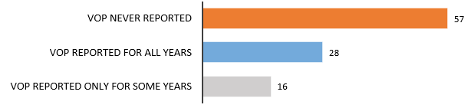

According to the analysis conducted, 57 Members have never reported to the Secretariat or in a notification total value of production for any year since 2001; 28 Members have reported this information for all years; and 16 Members did not consistently reported this information for all years.[5], [6] The inclusion of total value of production data in Members' notifications was also analyzed in [JOB/AG/181](https://docs.wto.org/dol2fe/Pages/SS/directdoc.aspx?filename=q:/Jobs/AG/181.pdf&Open=True). Although total value of production is only required to determine *de minimis* when Members notify non-product specific AMS, the WTO would benefit from more Members reporting their total value of production data (even for the Members that do not report non-product specific AMS) in order to avoid having to rely on third-party sources (e.g., the FAO) to compare data on a relative basis.

At the very least, Members who are notifying non-product specific AMS and product-specific AMS should be required to notify total value of production and value of production for each product. This requirement would not create an additional burden since Members would need this data in order to determine *de minimis*.

# TOTAL DOMESTIC SUPPORT

## Effects of Transparency Issues on Total Domestic Support

Our ability to monitor total domestic support (i.e. the sum of all domestic support notified by Members) of the WTO Membership is affected by the transparency issues identified in the first section:

1. the number of Members participating in the notification exercise;
2. the delay in notifications;
3. omitted support in notifications, and;
4. the quality of the information.

These issues impair our collective ability to quantify the overall amount and nature of the domestic support Members have provided. The calculated total amounts based on Members' notifications should therefore be seen as the minimum quantifiable value at a specific time and not as fixed and immutable data.

Despite transparency issues limiting the full picture of total domestic support, there are findings that reinforce the reliability of domestic support amounts to identify certain trends.

First, domestic support notified by the ten largest users of domestic support represents over 90%[7] of all support notified by Members and these Members' notifications are generally more up-to-date than those of many other Members.[8] Given the size of the support provided by the largest users, the relative weight of the missing notifications or omitted support from smaller Members (transparency item a., b., c.) is likely to be too low to have a decisive impact on the overall trend. On the other hand, this means that this metric is reflective of the behaviour of the largest Members more than smaller Members. Furthermore this also means that the quality of information and omitted support (transparency item c., d.) provided by the largest users of domestic support would have a large impact on this metric.

Second, as it will be demonstrated in section 4, it is rare to observe a change in the type of support reported by a Member. Measures that have already been notified once in a notification tend to be notified in subsequent notifications. This seems to indicate that although there are "gaps" in Members' data, the overall amounts are comparable over time, because they tend to capture evolutions in the same programs over time. Comparability over time remains however sensitive to the quality of information reported by Members.

## Trends in Total Domestic Support

Figure 6: Total Support in all Domestic Support categories, 2001-2019

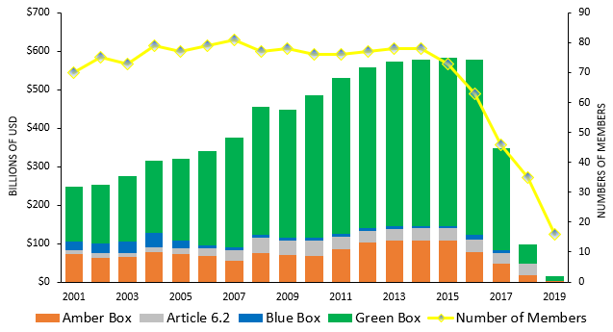

Figure 6 – Total domestic support has been increasing year after year, but the growth has slowed in recent years. Green Box continues to account for the majority of support reported by Members. As shown above, support under the Green Box as a percentage of total domestic support increases year after year.

Figure 7: Total Article 6 support, 2001-2019

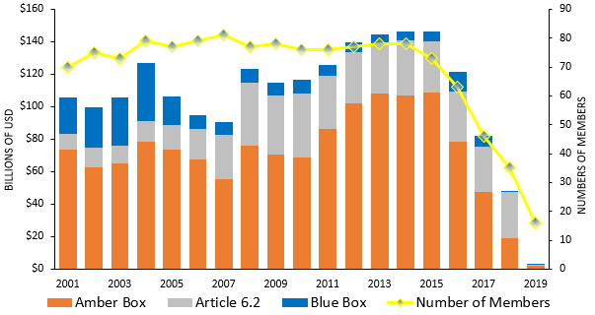

Figure 7 – Support under Article 6 has grown at a slower pace than the Green Box since 2001. Since 2008, notified support in Blue Box and under Article 6.2 has been relatively stable. Support notified under the Amber Box (support under Articles 6.3 and 6.4) has also stabilized in recent years, but has sharply declined in 2016.

Figure 8: Total Amber Box, CTAMS and *de minimis*, 2001-2019

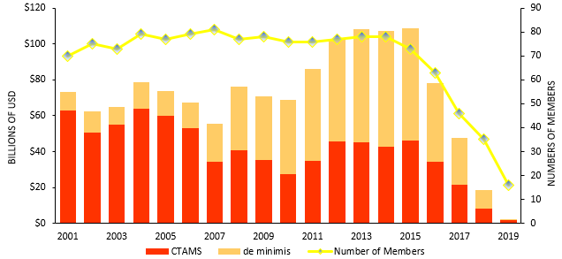

Figure 8 - The share of Amber Box support (CTAMS + *de minimis*) notified under the current total AMS (CTAMS) has significantly decreased since 2001. On the other hand, support notified under *de minimis* now represents the majority of Amber Box support.

Figure 9: Share of Amber Box – non product-specific AMS vs. product-specific AMS (%), 2001-2019

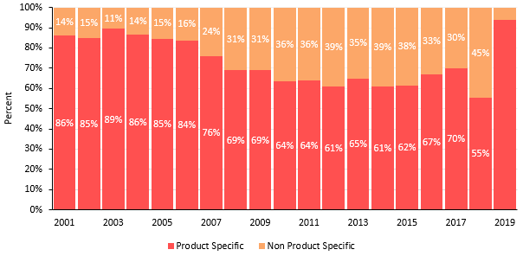

Figure 9 – The share of Amber Box support reported under product specific AMS has declined since 2001. The product-specific AMS to non product-specific AMS ratio has been relatively stable since 2008.

# Percentage of Members using certain categories of domestic SUpport

## Effects of Transparency Issues on the Ability to Monitor the Types of Domestic Support Used by Members

The numbers and percentages of Members reporting support under the different categories of support provide a better understanding of the types of support used by Members. The percentage of Members reporting a specific type of support is calculated as the number of Members that have notified support under that category of support, divided by the number of Members that have submitted a notification for that year. This metric is very sensitive to the data gaps identified in this paper, but reveals details on the practices of all Members that have notified information, regardless of their size. Unlike total support data, the percentage of Members using each type of support can be more impacted by missing notifications, however the direction of this effect is not predetermined (could be positive or negative).

## Trends in the Percentages of Members Reporting Support in each Category

This section presents a data series on the percentage of Members that reported using certain types of support over the years. The denominator (number of Members) to calculate the percentage of Members reporting support varies every year depending on the number of notifications submitted for that specific year.

Table 1: Percentage of Members reporting support by main categories of Domestic Support, 2001–2019

|  |  |  |  |  |
| --- | --- | --- | --- | --- |
|  | Amber Box | Article 6.2* | Green Box | Blue Box |
| 2001 | 41% | 45% | 76% | 4% |
| 2002 | 43% | 45% | 75% | 4% |
| 2003 | 44% | 44% | 82% | 4% |
| 2004 | 43% | 49% | 80% | 4% |
| 2005 | 42% | 49% | 81% | 4% |
| 2006 | 43% | 63% | 81% | 5% |
| 2007 | 44% | 52% | 84% | 5% |
| 2008 | 44% | 51% | 84% | 5% |
| 2009 | 44% | 48% | 81% | 5% |
| 2010 | 42% | 46% | 84% | 5% |
| 2011 | 42% | 46% | 82% | 5% |
| 2012 | 44% | 52% | 83% | 5% |
| 2013 | 47% | 47% | 81% | 5% |
| 2014 | 45% | 51% | 81% | 5% |
| 2015 | 44% | 49% | 79% | 5% |
| 2016 | 48% | 51% | 83% | 8% |
| 2017 | 46% | 43% | 83% | 7% |
| 2018 | 40% | 48% | 83% | 3% |
| 2019 | 38% | 36% | 94% | 6% |

* Relative to the number of Members that may exempt support under Article 6.2.

Table 1 – The percentage of Members reporting support in the main categories of domestic support has been stable over time and has only experienced small variations between 2001 and 2016. Green Box is the type of support with the highest proportion of users (81% on average), followed by Article 6.2 (48% of developing Members that may exempt support under Article 6.2), the Amber Box (43%), and the Blue Box (5%).

Table 2: Percentage of Members reporting support in Green Box sub-categories, 2001‑2019

|  | General Services | Direct Payments | Domestic Food Aid | Public Stockholding for Food Security Purposes |
| --- | --- | --- | --- | --- |
|  | Para.2 | Paras. 5-13 | Para. 4 | Para. 3 |
| 2001 | 76% | 44% | 20% | 20% |
| 2002 | 75% | 47% | 20% | 19% |
| 2003 | 82% | 52% | 21% | 19% |
| 2004 | 80% | 51% | 22% | 19% |
| 2005 | 81% | 53% | 22% | 22% |
| 2006 | 81% | 51% | 22% | 23% |
| 2007 | 84% | 56% | 25% | 26% |
| 2008 | 82% | 55% | 21% | 26% |
| 2009 | 81% | 53% | 23% | 26% |
| 2010 | 83% | 57% | 21% | 24% |
| 2011 | 80% | 54% | 21% | 21% |
| 2012 | 82% | 53% | 22% | 23% |
| 2013 | 79% | 50% | 22% | 18% |
| 2014 | 79% | 50% | 22% | 18% |
| 2015 | 78% | 48% | 19% | 18% |
| 2016 | 83% | 57% | 21% | 17% |
| 2017 | 83% | 54% | 24% | 17% |
| 2018 | 83% | 63% | 23% | 23% |
| 2019 | 88% | 63% | 6% | 19% |

Table 2 – The percentage of Members reporting support in all Green Box subcategories has also been stable since 2001. The general service subcategory is the most used Green Box category (80% on average), followed by direct payments (52%), domestic food aid (21.4%) and public stockholding for food security purposes (21.2%).

Table 3: Percentage of Members – product-specific AMS, non product-specific AMS, and CTAMS, 2001-2019

|  |  |  |  |
| --- | --- | --- | --- |
|  | Product Specific AMS | Non-Product Specific AMS | CTAMS |
| 2001 | 37% | 27% | 21% |
| 2002 | 37% | 29% | 24% |
| 2003 | 40% | 30% | 25% |
| 2004 | 39% | 29% | 24% |
| 2005 | 38% | 30% | 26% |
| 2006 | 38% | 32% | 27% |
| 2007 | 40% | 31% | 27% |
| 2008 | 39% | 31% | 23% |
| 2009 | 37% | 31% | 24% |
| 2010 | 36% | 32% | 25% |
| 2011 | 38% | 32% | 22% |
| 2012 | 39% | 32% | 25% |
| 2013 | 41% | 33% | 23% |
| 2014 | 38% | 32% | 23% |
| 2015 | 36% | 32% | 26% |
| 2016 | 40% | 38% | 25% |
| 2017 | 37% | 39% | 22% |
| 2018 | 31% | 31% | 20% |
| 2019 | 25% | 25% | 19% |

Table 3 – Regarding Amber Box, the percentage of Members that notified product-specific AMS and non-product specific AMS did not change significantly over the years.[9] On average, more Members reported product specific AMS (38%) than non-product specific AMS (31%). The number of Members who reported a positive current total AMS (CTAMS) was also relatively stable, at 24% of Members on average.

Figure 10: Number of Members that notified CTAMS over FBTAMS at least once over five years increment, 2001-2019



Figure 10 – A total of nine different Members have reported a current total AMS (CTAMS) support greater than their final bound total AMS (FBTAMS) at least once since 2001.[10] Eight of the nine Members reported CTAMS over FBTAMS for consecutive years, and one Member reported CTAMS over FBTAMS for 14 consecutive years. Five Members reported CTAMS over FBTAMS in their last DS:1 notification year.

# Conclusion

Transparency issues related to the rate of participation in the notification process, the timeliness of notification, the omission of measures and the quality of information contained therein are all elements that contribute to obscuring our understanding of the worldwide state of domestic support in agriculture. Despite these data limitations, an analysis of total support and the percentage of Members using various domestic support categories can provide useful insights into trends in domestic support practices of Members. While undertaking this analysis, it is important to keep in mind the potential bias and limitations stemming from these transparency issues.

Improving transparency can help facilitate the negotiation of new rules on domestic support that address the current situation and practices of WTO Members. Taking steps to increase the participation rate, the frequency of notifications and timeliness of notifications, the completeness and the quality of the information are elements that can be addressed in the short-term.

In addition, additional data on total value of agriculture production and values of production for each product is also needed in order to be able to better compare Members in relative terms. Members that have not notified or have inconsistently reported total value of production should be invited to supplement these submissions by the Membership in support of increased transparency. Members should also reflect on the merits of requiring DS:1 notifications to include total value of production data, even for Members that have not provided non-product specific AMS.

These adjustments are needed to address the current limitations and to improve our understanding of the state of play in the domestic support pillar.

**__________**

1. The European Union and its member States are counted as one Member. The United Kingdom is not listed separately in the tables as it was an EU member State in the years covered in this document. Switzerland and Liechtenstein are also counted as one Member as they submit a joint domestic support notification. The number of Members individually accounted for in any one year is thus smaller than the full number of Members.
2. This number excludes four Members compared to figure 2, as they have submitted earlier notifications, but did not provide a notification for 2016.
3. In [JOB/AG/181](https://docs.wto.org/dol2fe/Pages/SS/directdoc.aspx?filename=q:/Jobs/AG/181.pdf&Open=True), it was identified that Members posed market price support-related questions to at least seven notifying Members regarding the potential omission of market price support measures in their notifications.
4. Yearly differences in the number of Members that have reported no support varies for a variety of reasons, which for the 20 Members includes inconsistencies in submission of notifications, no recent submission of DS:1 notifications, date of accession, measures reported in some years but not others and least-developed status ([G/AG/2](https://docs.wto.org/dol2fe/Pages/SS/directdoc.aspx?filename=Q:/G/AG/2.pdf&Open=True) only requires least-developed Members to submit Supporting Tables DS:1 to DS:3 every two years).
5. A Member was classified in "VOP Reported for All Years" if for each year a DS:1 notification was notified, the total value of production was reported to the Secretariat (as part of CoA-SS transparency exercise) or in the notification itself.
6. This compilation of data does not differentiate whether a Member had to report total value of production to calculate non-product AMS *de minimis* or not.
7. Between 2012 and 2016, the 10 largest domestic support users reported between 90% and 94% of all domestic support.
8. As of 17 November 2020 only one of the 10 largest users of domestic support most recent notification was below the median year of 2016. For that Member, the most recent year was 2015.
9. Product-specific AMS and non product-specific AMS refers to support above and below *de minimis* (Articles 6.3 and 6.4).
10. For ease of understanding, Members with no FBTAMS in their Schedules were assumed to have an FBTAMS of 0.