Fourteenth BIENNIAL REVIEW OF THE IMPLEMENTATION AND OPERATION
OF THE AGREEMENT ON IMPORT LICENSING PROCEDURES
Article 7.1 of the Agreement on Import Licensing Procedures provides that "the Committee shall review as necessary, but at least once every two years, the implementation and operation of this Agreement, taking into account the objectives thereof, and the rights and obligations contained therein".

The main objectives of the Agreement are those listed in the preamble of the Agreement.

The information contained in this document covers the period from 10 October 2020 to 7 October 2022.

_______________

Table of Contents
1 COMMITTEE ON IMPORT LICENSING 2
1.1 Officers 2
1.2 Members 2
1.3 Observers 3
2 Work of the Committee during the review period (2021-2022) 3
2.1 Formal Committee meetings 3
2.1.1 Review of notifications 3
2.1.2 Discussion of specific trade concerns 4
2.1.3 Review and adoption of the Committee's Annual Report to the Council for Trade in Goods 6
2.1.4 Fourteenth biennial review on the implementation and operation of the Agreement 6
2.1.5 Improving transparency in notification procedures of the Agreement 6
2.1.6 E-Agenda 6
2.2 Informal Committee meetings 7
3 TECHNICAL ASSISTANCE ACTIVITIES 7
4 consultation and dispute settlement 7
5 ANALYSIS OF DEVELOPMENTs IN MEMBERS' NOTIFICATION COMPLIANCE 8
5.1 High number of notifications submitted under Article 5.1-5.4 8
5.2 Members largely use the new notification form 8
5.3 A few WTO Members out-performed others in N/2 notification submissions 9
5.4 Protecting human, animal or plant life and health, and protection of the environment as primary reasons for using import licensing measures 10
5.5 Specific changes to legislation/procedures introduced by Members focusing on licensing terms, product coverage, and document requirements 11
5.6 Slight recovery in the number of N/3 notifications 12
ANNEX I 13
ANNEX II 16
ANNEX III 18
ANNEX IV 20

COMMITTEE ON IMPORT LICENSING

Officers
2021:

Chairperson: Mr. Hsin-lung Hung (Chinese Taipei)
Vice-Chairperson: Mrs Lorena Rivera (Colombia)

2022:

Chairperson: Mr. Jia Jie Loh (Singapore)
Vice-Chairperson: Consultations ongoing

Members
Afghanistan  Albania  Angola  Antigua & Barbuda  Argentina  Armenia  Australia  Austria  Bahrain,  Kingdom of  Bangladesh  Barbados  Belgium  Belize  Benin  Bolivia, Plurinational State of  Botswana  Brazil  Brunei Darussalam  Bulgaria  Burkina Faso  Burundi  Cambodia  Cameroon  Canada  Cabo Verde  Central African Rep.  Chad  Chile  China  Colombia  Congo  Costa Rica  Côte d'Ivoire  Croatia  Cuba | Czech Rep.  Cyprus  Dem. Rep. of Congo  Denmark  Djibouti  Dominica  Dominican Rep.  Ecuador  Egypt  El Salvador  Estonia  Eswatini  European Union  Fiji  Finland  France  Gabon  Gambia, The  Georgia  Germany  Ghana  Greece  Grenada  Guatemala  Guinea  Guinea-Bissau  Guyana  Haiti  Honduras  Hong Kong, China  Hungary  Iceland  India  Indonesia  Ireland  Israel  Italy  Jamaica | Japan  Jordan  Kazakhstan  Kenya  Korea, Rep. of  Kuwait, the State of  Kyrgyz Republic  Latvia  Lao People's Democratic Republic  Lesotho  Liberia,  Liechtenstein  Lithuania  Luxembourg  Macao, China  Madagascar  Malawi  Malaysia  Maldives  Mali  Malta  Mauritania  Mauritius  Mexico  Moldova, Rep. of  Mongolia  Montenegro  Morocco  Mozambique  Myanmar  Namibia  Nepal  Netherlands  New Zealand  Nicaragua  Niger | Nigeria  North Macedonia  Norway  Oman  Pakistan  Panama  Papua New Guinea  Paraguay  Peru  Philippines  Poland  Portugal  Qatar  Romania  Russian Federation  Rwanda  St. Kitts & Nevis  St. Lucia  St. Vincent and the Grenadines  Samoa  Saudi Arabia, Kingdom of  Senegal  Seychelles  Sierra Leone  Singapore  Slovak Republic  Slovenia  Solomon Islands  South Africa  Spain  Sri Lanka  Suriname  Sweden  Switzerland  Chinese Taipei  Tanzania  Tajikistan | Thailand  Togo  Tonga  Trinidad & Tobago  Tunisia  Türkiye  Uganda  Ukraine  United Arab Emirates  United Kingdom  United States  Uruguay  Vanuatu  Venezuela, Bolivarian Rep. of  Viet Nam  Yemen  Zambia  Zimbabwe

Observers
Observer Governments

Algeria  Andorra  Azerbaijan  Bahamas  Belarus  Bhutan  Bosnia and Herzegovina  Comoros  Curaçao  Equatorial Guinea  Ethiopia  Holy See (Vatican)  Iran | Iraq  Lebanese Republic  Libya  Sao Tomé and Principe  Serbia  Somalia  South Sudan  Sudan  Syrian Arab Republic  Timor-Leste  Turkmenistan  Uzbekistan

Observer Organizations

IMF, UNCTAD and the World Bank.

Work of the Committee during the review period (2021-2022)

Formal Committee meetings
            - In the two years under review, the Committee held four formal meetings, on 21 April and 8 October 2021, and on 8 April and 7 October 2022. The minutes of these meetings are contained in documents G/LIC/M/52, G/LIC/M/53, G/LIC/M/54 and G/LIC/M/55, respectively.
            - At the formal meetings, the Committee: (i) reviewed Members' notifications under various provisions of the Agreement; (ii) exchanged views on specific trade concerns raised by Members through written questions and replies as well as through oral statements; (iii) reviewed and adopted its annual reports to the Council for Trade in Goods for 2021 and 2022, in accordance with Article 7.4 of the Agreement (G/L/1406 and G/L/1433); (iv) carried out the 14th biennial review of the implementation and operation of the Agreement under Article 7.1 on the basis of a report prepared by the Secretariat (G/LIC/W/57); and (v) continued the discussion regarding improving transparency in notification procedures of the Agreement.

Review of notifications
            - Reviewing Members' notifications under various provisions of the Agreement has been an important function of the Committee. During the reporting period, the Committee reviewed 154 notifications submitted by 22 Members under Article 1.4(a) and/or 8.2(b) and Article 5.1-5.4; and 83 Replies to the Annual Questionnaire on Import Licensing Procedures submitted by 46 Members under Article 7.3. The list of notifications submitted by Members during the reporting period is contained in Annexes I to III.
            - It is worth noting that there remain 13 Members who have not submitted any notification under the Agreement since joining the WTO (see Table 1). As emphasized by the Chairperson repeatedly at each formal meeting, Members that have not yet submitted the required notifications are urged to do so without delay. Members who have technical problems in preparing the notifications are requested to seek assistance from the Secretariat.
Table 1: Members which have not yet notified under any provision of the Agreement
No. | Member | Date of WTO Membership
1 | Belize | 01.01.1995
2 | Congo | 27.03.1997
3 | Djibouti | 31.05.1995
4 | Egypt | 30.06.1995
5 | Guinea-Bissau | 31.05.1995
6 | Liberia | 14.07.2016
7 | Mauritania | 31.05.1995
8 | Mozambique | 26.08.1995
9 | Sierra Leone | 23.07.1995
10 | Solomon Islands | 26.07.1996
11 | Tanzania | 01.01.1995
12 | Vanuatu | 24.08.2012
13 | Yemen | 26.06.2014

            - Regarding the notification obligations under Article 7.3, in addition to the 13 Members listed in Table 1, the following 8 Members have not yet submitted their replies to the Annual Questionnaire.
Table 2: Members which have not yet submitted any reply to the Annual Questionnaire under Article 7.3 of the Agreement
No. | Member | Date of WTO Membership
1 | Afghanistan | 29.07.2016
2 | Angola | 23.11.1996
3 | Benin | 22.02.1996
4 | Eswatini | 01.01.1995
5 | Niger | 13.12.1996
6 | Pakistan | 01.01.1995
7 | Papua New Guinea | 09.06.1996
8 | Samoa | 10.05.2012

            - On the other hand, it is encouraging to see that two Members, Botswana and Guinea, submitted their first annual questionnaire notifications (G/LIC/N/3/BWA/1 and G/LIC/N/3/GIN/1) to the Committee during the review period.
            - Overall, it is recognized that increasing the level of notification compliance and improving the quality of notifications remains a big challenge for this Committee. Compared with the last review period (2019-2020), in this review period (2021-2022), the total number of Members' replies to the annual questionnaire has slightly increased from 74 to 83. How to maintain a relatively high level of notification compliance while not placing an additional burden on Members remains an open question.

Discussion of specific trade concerns
            - Another main function of the Committee is to afford Members the opportunity to consult on any matters relating to the operation of this Agreement and to raise specific trade concerns they may have regarding other Members' import licensing regimes or administrative practices.
            - Following the Rules of Procedures of this Agreement, a total of fifteen documents containing written questions on import licensing systems maintained by other Members, and thirteen documents containing replies, were circulated in the document G/LIC/Q/- series during the review period. These new or follow-up written questions were addressed to the following Members: Argentina; Egypt; India; Indonesia; Panama; and the Philippines. The exchanges among Members based on written questions and replies have provided additional clarity regarding the import licensing practices/legislations of these Members (see Annex IV).
            - In this regard, a working document titled "Consolidated paper of written questions and replies submitted to the Committee on Import Licensing since 1995" (G/LIC/W/51) has been prepared by the Secretariat with a view to providing Members with an easy reference to the G/LIC/Q series documents. At the formal meeting held on 22 October 2018, the Committee agreed that the Secretariat would update the document twice a year to include new submissions. In the review period, the document had been updated four times by the Secretariat, in document G/LIC/W/51/Rev.4, G/LIC/W/51/Rev.5, G/LIC/W/51/Rev.6, and G/LIC/W/51/Rev.7, respectively.
            - In addition, following requests from certain Members, a number of trade issues have also been included in the agenda of formal meetings during the review period (see Table 3). Some of these issues have been listed on the Committee's agenda for many years. At the meetings, the proponents expressed their views on relevant issues and Members concerned provided oral replies. Some issues that were raised before the Committee during the review period were also raised before the Council for Trade in Goods (CTG).
Table 3: Trade issues included as separate agenda items at formal meetings
No | Trade Concerns | Requested by | At formal  meeting(s) on | Raised also at the CTG
1 | Angola: Import licensing requirements | European Union | 7 October 2022  8 April 2022  8 October 2021  21 April 2021 | -
2 | China: Recoverable materials | United States | 8 April 2022  8 October 2021  21 April 2021 | -
3 | Egypt: Import licensing requirements for certain agricultural and processed products | European Union | 7 October 2022  8 April 2022  8 October 2021  21 April 2021 | -
4 | India: Import licensing requirements for boric acid | United States | 8 October 2021  21 APR 2021 | -
5 | India: Importation of pneumatic tyres | European Union | 7 October 2022  8 April 2022  8 October 2021  21 April 2021 | 8 July 2022  8 July 2021
6 | India: Quantitative restrictions on certain pulses | Canada | 8 April 2022  8 October 2021  21 April 2021 | 8 July 2022  8 July 2021  31 March 2021  25 November 2020
7 | Indonesia – Import licensing regime for cellphones, handheld computers and tablets | United States | 21 April 2021 | -
8 | Indonesia: Import licensing restricting policies and practices | Australia | 21 April 2021 | 25 November 2020  31 March 2021  8 July 2021  25 November 2020
9 | Indonesia: Import licensing regime for certain textile products | European Union | 7 October 2022  8 April 2022  8 October 2021  21 April 2021 | -
10 | Indonesia: Import restriction: compulsory registration by importers of steel products | Japan | 7 October 2022  8 April 2022  8 October 2021  21 April 2021 | -
11 | Indonesia: Import restriction on air conditioners | Japan  European Union | 7 October 2022  8 October 2021  21 April 2021 | -
12 | Indonesia: Commodity balancing mechanism | European Union | 7 October 2022 | -
13 | Sri Lanka: Import ban on palm oil | Indonesia | 8 April 2022  8 October 2021 | 8 July 2021
14 | Thailand: Importation of wheat feed | European Union | 7 October 2022  8 April 2022  8 October 2021  21 April 2021 | -
"-" no record of concern being raised at the CTG.

Review and adoption of the Committee's Annual Report to the Council for Trade in Goods
            - In accordance with Article 7.4 of the Agreement, the Committee adopted, on the basis of the documents prepared by the Secretariat (G/LIC/W/55 and G/LIC/W/56), its annual reports to the Council for Trade in Goods. The reports for 2021 and 2022, were adopted and circulated as documents G/L/1406 and G/L/1433, respectively.

Fourteenth biennial review on the implementation and operation of the Agreement
            - Article 7.1 of the Agreement establishes that "the Committee shall review as necessary, but at least once every two years, the implementation and operation of this Agreement, taking into account the objectives thereof, and the rights and obligations contained therein."
            - Article 7.2 of the Agreement stipulates that "As a basis for the Committee review, the Secretariat shall prepare a factual report based on information provided under Article 5, responses to the annual questionnaire on import licensing procedures and other relevant reliable information which is available to it. This report shall provide a synopsis of the aforementioned information, in particular indicating any changes or developments during the period of the review and including any other information as agreed by the Committee."
            - At its formal meeting of 7 October 2022, the Committee conducted the 14th biennial review (2021-2022) on the implementation and operation of the Agreement, based on a paper prepared by the Secretariat (G/LIC/W/57). The report was adopted and circulated in document G/LIC/30.

Improving transparency in notification procedures of the Agreement
            - Ensuring transparency of import licensing procedures applied by WTO Members is one of the main objectives of the Agreement. Taking into account the complexity of notification obligations under the Agreement and the low compliance rate, discussions have been undertaken by the Committee on how to improve transparency and notification procedures. Since 2016, "Improving transparency in notification procedures of the Agreement – Report by the Chairperson" has been included on the agenda of the Committee's formal meetings.
            - At four formal Committee meetings during the review period, the Chairpersons reported on their consultations on this issue. At these meetings, many Members indicated their support for the work carried out by the Chair and the Secretariat so far. Members also expressed their willingness to continue the work regarding improving transparency and streamlining notification procedures of the Agreement in the future.

E-Agenda
            - At the Committee meeting held on 8 October 2021, Members approved the establishment of an eAgenda for the Committee. The eAgenda was meant to facilitate the work of delegations and of the Secretariat in building the meeting agenda, including adding items, making relevant documents directly available to participants in electronic form, and the sharing of statements via the eAgenda. A pilot version of the eAgenda was made available by the Secretariat for delegations' registration and testing between 6 July and 31 August 2022. The eAgenda became operational as from the Committee meeting of 7 October 2022.

Informal Committee meetings
            - During the review period, the Committee held two informal meetings. Both meetings were held under the chairpersonship of Mr Hsin-lung Hung (Harvey) (Chinese Taipei). The meeting on 20 September 2021 discussed the following issues: (i) update on the status of the import licensing website; (ii) introduction of the new e-learning course on the Agreement on import licensing procedures; (iii) the possibility of introducing an N2 online notification form; (iv) streamlining import licensing work, including the improvement and update of the Article 7.3 notification format and introduction of an eAgenda; and (v) announcement of the import licensing notification workshop which was held in a virtual format.
            - At the informal meeting of 7 March 2022, the Chairperson, Mr. Hsin-lung Hung (Harvey), provided an update on the status of the eAgenda project for the Import Licensing Committee. The Secretariat introduced a draft online form, replicating the entries in the current N/2 form (G/LIC/28), which is meant to allow Members to submit notifications via the website. Members were also invited to discuss possible ways forward on how to improve the level of notifications of the annual N/3 questionnaire as well as address the difficulties encountered by several Members in filling in the questionnaire. In addition, the Chairperson, based on the experience of the previous years, proposed that the Secretariat hold a training activity on Import Licensing in virtual mode in the three languages and with participation of all Members. The Chairperson also sought delegations' views on the possibility of holding an experience sharing session on import licensing procedures, also in respect of COVID-19 related goods.

TECHNICAL ASSISTANCE ACTIVITIES
            - In spite of the limitations to in-person activities and travel restrictions due the Covid-19 pandemic, the Secretariat continued to hold its annual Workshop on Import Licensing in virtual mode in 2021 and 2022. The objective of the Workshop is to improve developing Member officials' understanding of the Agreement and to strengthen their capacity to prepare and analyse import licensing notifications. The fourth Workshop on Import Licensing took place from 4 to 6 October 2021. Seventy-two government officials representing 32 WTO Members (including LDCs) and Acceding Governments participated in the three-day workshop. The fifth Workshop on Import Licensing was conducted in English and Spanish and was open to participation by all WTO Members. It took place on 27 and 28 September 2022 in English, and on 29 September in Spanish. Eighty-seven (87) government officials representing 35 WTO Members (including LDCs) registered for the three-day workshop.
            - During the review period, upon the request of the Kingdom of Saudi Arabia a Member-specific technical assistance workshop on import licensing and notifications was held in a virtual format in December 2021. At the Committee's formal meetings, Members encouraged the Secretariat to continue its targeted technical assistance in this regard.
            - In addition, training sessions on import licensing issues were also presented during the Advanced Trade Policy Course (ATPC) in Geneva in 2022, the Regional Trade Policy Course (RTPC) in a virtual mode for Arab and Middle East countries, English-speaking Africa, and Latin American Members in 2021, and for Asia and Pacific in 2022.

consultation and dispute settlement
            - On 26 January 2022, the European Union (document G/LIC/D/54) submitted a request for consultations on "Egypt – Registration Requirements relating to the Importation of Certain products" (DS609), where Article 1 (inter alia, Article 1.2 and 1.5) and Article 3 (inter alia, Article 3.3, 3.5(e) and 3.5(f)) of the Agreement on Import Licensing Procedures were cited. The case was at the consultation stage.

ANALYSIS OF DEVELOPMENTs IN MEMBERS' NOTIFICATION COMPLIANCE
            - The notification template contained in document G/LIC/28 had not only reduced the workload of the government officials preparing these notifications, but had also improved transparency in relation to Members' import licensing regimes. In addition, the clear and structured information provided through a wide use of this notification template had made it possible for the Secretariat to continue undertaking an in-depth analysis on notifications in this biennial report. In this regard, the Secretariat compared the notifications submitted in this review period with past notifications and summarized its findings as follows:

High number of notifications submitted under Article 5.1-5.4
            - A comparison of the number of notifications reviewed among the three most recent biennial cycles showed that, in comparison with the 2017-2018 review period, there had been a significant increase in N/2 notifications in the 2019-2020 and 2021-2022 review periods. As demonstrated in Graph 1, the number of notifications submitted under Article 5.1-5.4 in 2021-2022 had remained very high (154). In contrast, the drop in N/1 notifications during this period could be attributed to the fact that more Members had used the N/2 notification form contained in document G/LIC/28 to fulfil their notification obligations under the three provisions instead of using two separate forms for notifications under Article 1.4(a), Article 8.2(b), and Article 5.1-5.4 (G/LIC/22).
Graph 1: Number of notifications submitted in past review periods
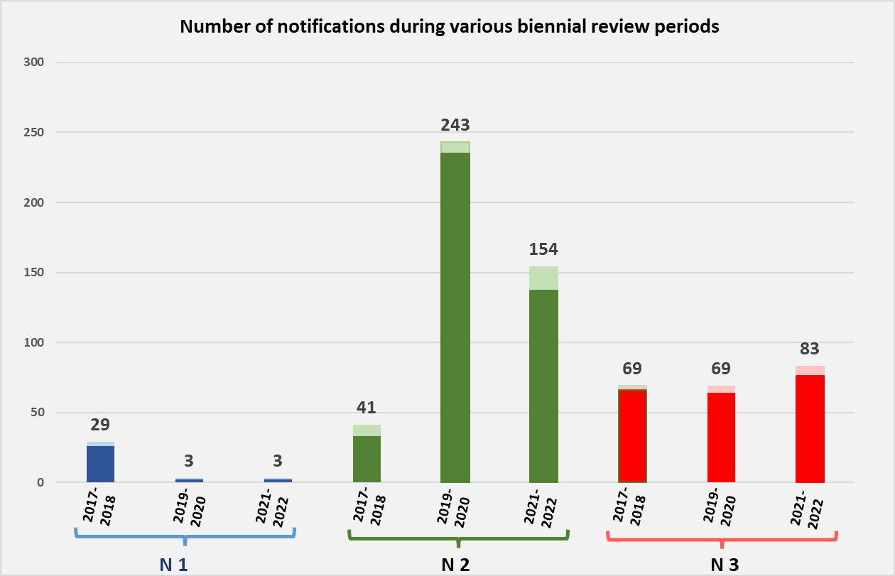

Note: The lightly shaded section in each column indicates the number of notification addenda and corrigenda. The number at the top of each column shows the total number of notifications submitted during the review periods, including addenda and corrigenda.

Members largely use the new notification form
            - Since the introduction of the G/LIC/28 in 2019, Members have shown enthusiasm for it, and the quasi totality of N/2 notifications submitted during the review period were submitted using this format. As highlighted in Graph 2, among the 22 Members that submitted N/2 notifications during the review period, 21 Members used the G/LIC/28 form. Only one Member used the older format. In terms of notifications, 147 out of 154 new N/2 notifications had been submitted using the G/LIC/28 format (Graph 3).
Graph 2: WTO Members using new notification templates

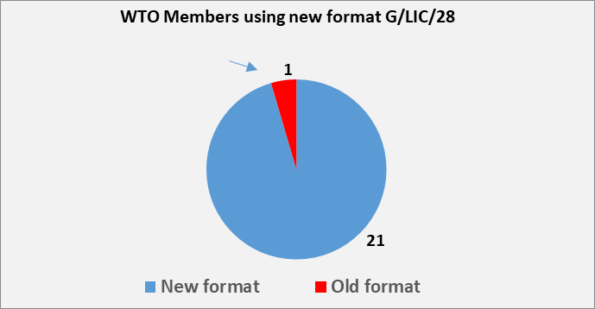
Graph 3: N/2 notifications in new template
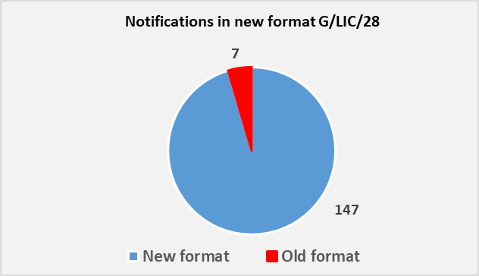

A few WTO Members out-performed others in N/2 notification submissions
            - Graph 4 shows how relatively few Members together contributed to the majority of new submissions. In particular, the Republic of Korea, the United Kingdom, the Kingdom of Bahrain and Cambodia submitted most of the N/2 notifications (27, 19, 15 and 15, respectively) in this review period. They are followed by Ukraine (12), India (12) and the European Union (9). Graph 4 provides a detailed review of the number of N/2 notifications submitted by Members.
Graph 4: Members submitting most N/2 notifications during the review period
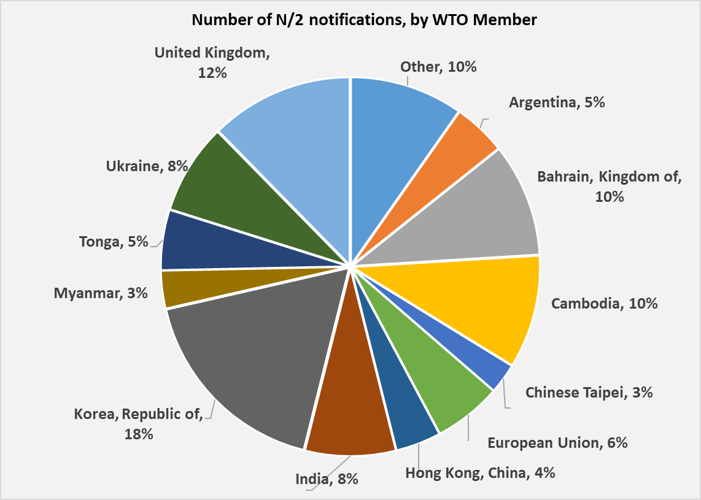

Protecting human, animal or plant life and health, and protection of the environment as primary reasons for using import licensing measures
            - Regarding the different administrative purposes for applying import licensing measures, among all those reported, 48% concerned the protection of human, animal or plant life and health, and protection of the environment; 18% concerned the collection of trade statistics or market surveillance; 13% concerned quota (including TRQ) administration; 7% concerned the regulation of the imports of arms, ammunition or fissionable materials and safeguards to national security; 5% concerned obligations under the UN Charter and other international treaties (including CITES, the Basel Convention, the Rotterdam Convention, and UNSC Resolutions); 5% concerned the protection of patents, trademarks, and copyrights, and the prevention of deceptive practices; and, finally, 4% concerned the protection of public morals (Graph 5).
Graph 5: Different administrative purposes for applying import licensing measures
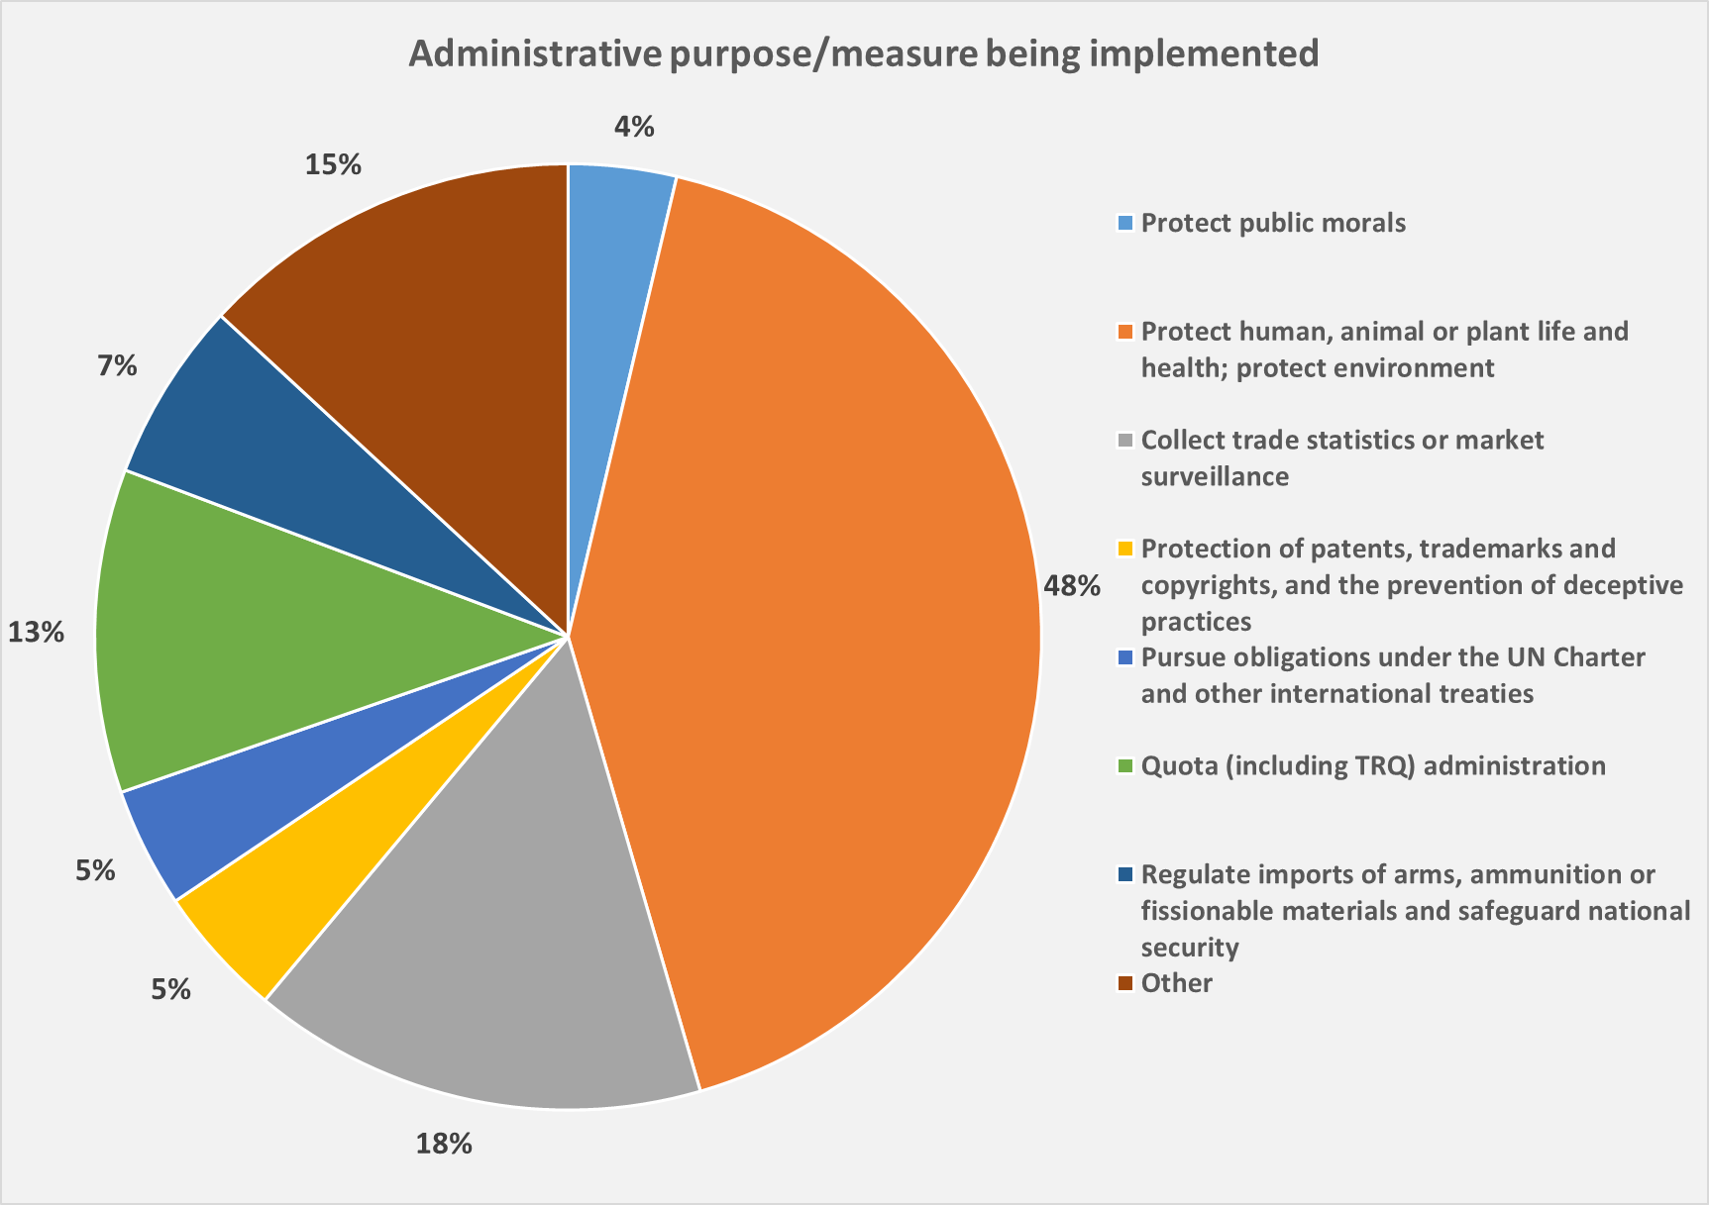

Specific changes to legislation/procedures introduced by Members focusing on licensing terms, product coverage, and document requirements
            - With regard to changes to previously notified licensing procedures, the vast majority of changes (25 out of 27) were reported to undertake "modifications of specific details in the existing legislations/procedures". Further analysis showed that one fifth of all the notifications introduced changes in other licence conditions (including suspension of specific provisions, merging of different legislations); followed by modifications concerned changes in administrative body(ies) for submission of applications (18%); product coverage (17%) and administrative bodies to issue licence (10%) (see Graph 6).
Graph 6: Modification of existing licensing procedures: type of changes
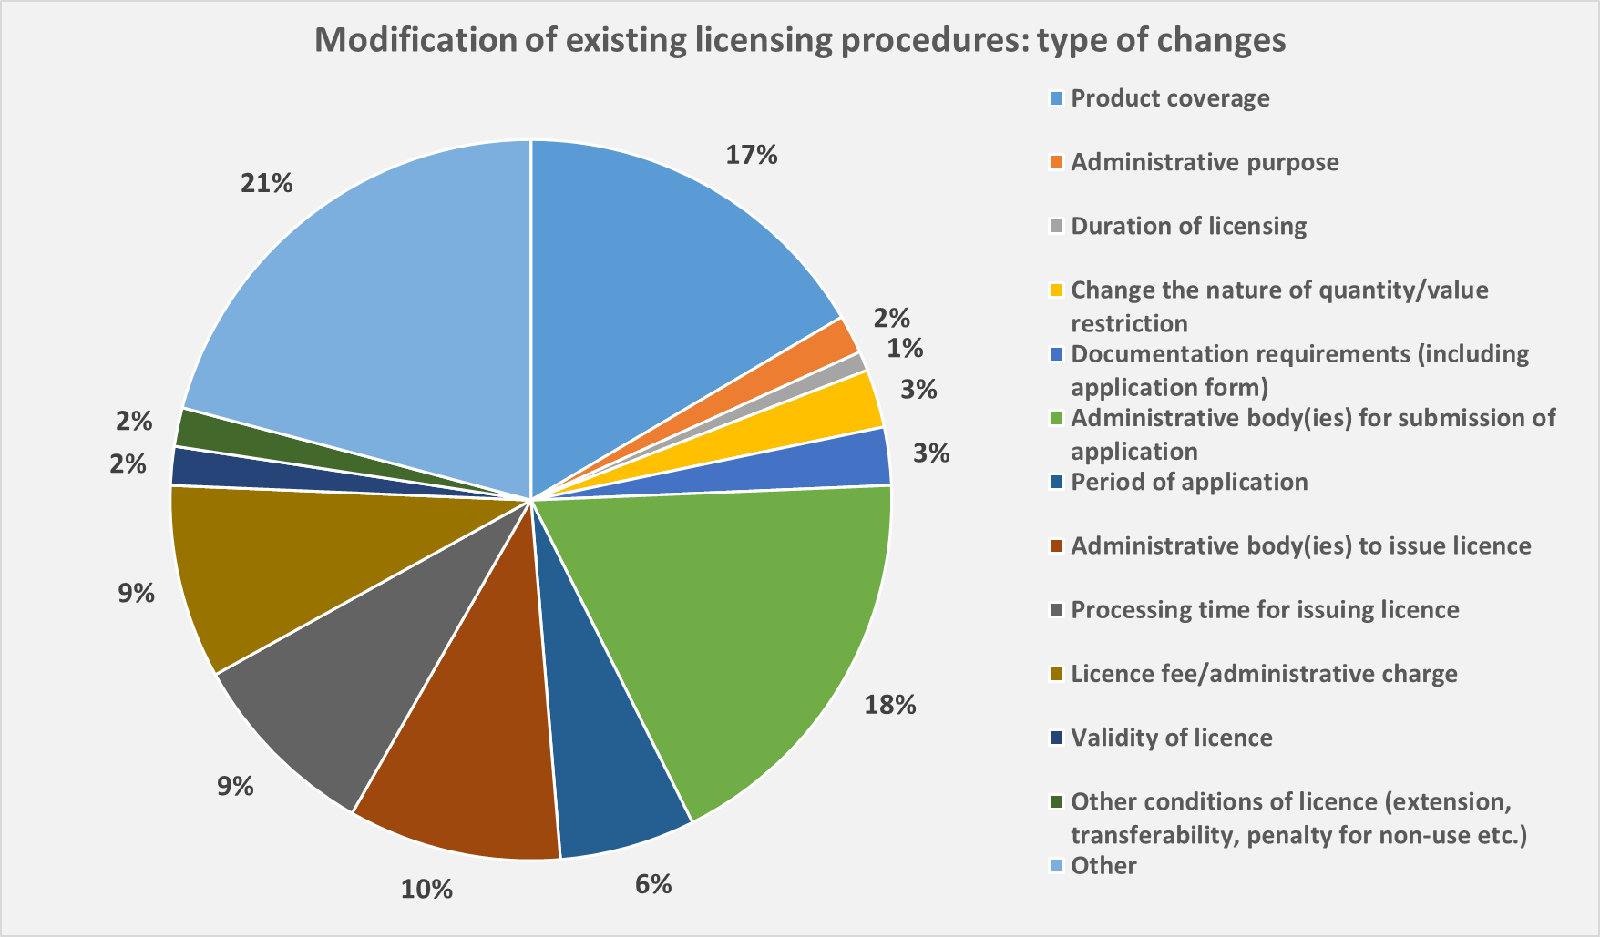

Slight recovery in the number of N/3 notifications
            - Regarding N/3 notifications, the review period has seen a slight recovery from a declining trend. The number of annual questionnaire submissions grew steadily between 1995 and 2002. In the 2001-2002 review period, 99 N/3 notifications were submitted – the highest number ever received by the Committee. Peaks were also registered in the 2009-2010, 2011-2012 and 2013-2014 review periods with an average of 96 notifications in each period. Between 2014 and 2020 the trend has been declining, in 2021-2022 biennial period, 83 annual questionnaire notifications have been submitted by the WTO Members (see Graph 7), an average of 41 notifications per year, corresponding to about 25% of WTO Members who are required to submit an annual notification according to Article 7.3 of the Import Licensing Agreement.
Graph 7: Number of N/3 notifications during biennial review periods since 1995
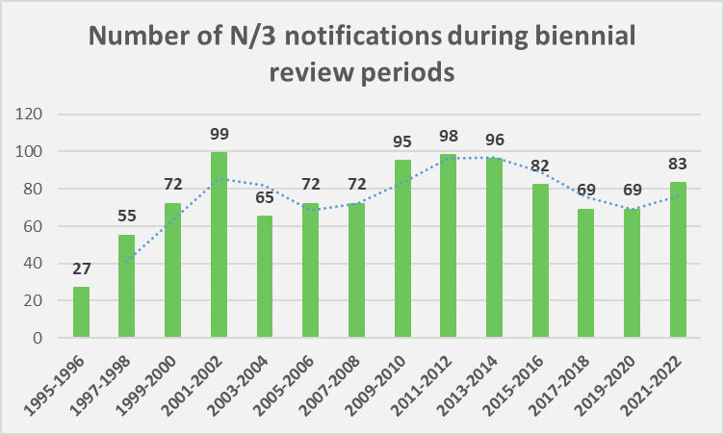

ANNEX I
Notifications received from Members during the review period
(from 10.10.2020 - 07.10.2022)
MEMBER | ARTICLE 1.4 (a)/8.2 (b) and ARTICLE 5 | ARTICLE 7.3
AFGHANISTAN
ALBANIA |  | G/LIC/N/3/ALB/10  G/LIC/N/3/ALB/11
ANGOLA
ANTIGUA & BARBUDA
ARGENTINA | G/LIC/N/2/ARG/28/Add.8-14 | G/LIC/N/3/ARG/16-18
ARMENIA
AUSTRALIA |  | G/LIC/N/3/AUS/13-15
BAHRAIN, KINGDOM OF | G/LIC/N/2/BHR/1-14  G/LIC/N/2/BHR/4/Corr.1
BANGLADESH
BARBADOS
BELIZE
BENIN
BOLIVIA, PLURINATIONAL STATE OF
BOTSWANA |  | G/LIC/N/3/BWA/1
BRAZIL
BRUNEI DARUSSALAM
BURKINA FASO
BURUNDI
CAMBODIA | G/LIC/N/2/KHM/1-15 | G/LIC/N/3/KHM/4
CAMEROON
CANADA |  | G/LIC/N/3/CAN/20
CABO VERDE
CENTRAL AFRICAN REP.
CHAD
CHILE |  | G/LIC/N/3/CHL/9
CHINA
COLOMBIA |  | G/LIC/N/3/COL/14  G/LIC/N/3/COL/15
CONGO
CONGO, DEM. REP.
COSTA RICA |  | G/LIC/N/3/CRI/18
CÔTE D'IVOIRE
CROATIA
CUBA |  | G/LIC/N/3/CUB/11
DOMINICA
DOMINICAN REP. | G/LIC/N/2/DOM/1
ECUADOR | G/LIC/N/2/ECU/1  G/LIC/N/2/ECU/2
EGYPT
EL SALVADOR
ESWATINI
EUROPEAN UNION | G/LIC/N/2/EU/14-18  G/LIC/N/2/EU/13-16/Corr.1 | G/LIC/N/3/EU/10-11
FIJI
GABON
GAMBIA, THE
GEORGIA |  | G/LIC/N/3/GEO/9
GHANA
GRENADA
GUATEMALA |  | G/LIC/N/3/GTM/5
GUINEA BISSAU
GUINEA, REP. OF |  | G/LIC/N/3/GIN/1
GUYANA
HAITI
HONDURAS |  | G/LIC/N/3/HND/11-13
HONG KONG, CHINA | G/LIC/N/2/HKG/17-21  G/LIC/N/2/HKG/18/Corr.1 | G/LIC/N/3/HKG/24-26
ICELAND
INDIA | G/LIC/N/1/IND/15  G/LIC/N/2/IND/12-22
INDONESIA |  | G/LIC/N/3/IDN/12-13
ISRAEL | G/LIC/N/2/ISR/5 | G/LIC/N/3/ISR/5
JAMAICA
JAPAN | G/LIC/N/2/JPN/5 | G/LIC/N/3/JPN/20
JORDAN
KAZAKHSTAN |  | G/LIC/N/3/KAZ/5-6
KENYA
KOREA, REP. OF | G/LIC/N/2/KOR/24-48  G/LIC/N/2/KOR/42/Corr.1  G/LIC/N/2/KOR/46/Add.1 | G/LIC/N/3/KOR/13-14
KUWAIT, THE STATE OF
KYRGYZ REP.
LAO, PDR
LESOTHO
MACAO, CHINA | G/LIC/N/2/MAC/2-3 | G/LIC/N/3/MAC/24-25
MADAGASCAR
MALAWI
MALAYSIA |  | G/LIC/N/3/MYS/15
MALDIVES
MALI |  | G/LIC/N/3/MLI/10-11
MAURITANIA
MAURITIUS |  | G/LIC/N/3/MUS/11
MEXICO |  | G/LIC/N/3/MEX/7-8
MOLDOVA, REP. OF
MONGOLIA
MONTENEGRO |  | G/LIC/N/3/MNE/5
MOROCCO
MOZAMBIQUE
MYANMAR | G/LIC/N/2/MMR/3-7
NAMIBIA
NEPAL
NEW ZEALAND |  | G/LIC/N/3/NZL/7-8
NICARAGUA |  | G/LIC/N/3/NIC/11-14
NIGER
NIGERIA
NORTH MACEDONIA
NORWAY |  | G/LIC/N/3/NOR/10
OMAN
PAKISTAN
PANAMA |  | G/LIC/N/3/PAN/12-13
PAPUA NEW GUINEA
PARAGUAY
PERU
PHILIPPINES | G/LIC/N/2/PHL/140 | G/LIC/N/3/PHL/13/Corr.1  G/LIC/N/3/PHL/14  G/LIC/N/3/PHL/14/Rev.1
QATAR
RUSSIAN FEDERATION |  | G/LIC/N/3/RUS/6
RWANDA
ST. KITTS & NEVIS
ST. LUCIA
ST. VINCENT AND THE GRENADINES
SAMOA
SAUDI ARABIA, KINGDOM OF | G/LIC/N/2/SAU/3
SEYCHELLES | G/LIC/N/2/SYC/2-3 | G/LIC/N/3/SYC/4
SENEGAL
SIERRA LEONE
SINGAPORE |  | G/LIC/N/3/SGP/16-17
SOLOMON ISLANDS
SOUTH AFRICA
SRI LANKA
SURINAME
SWITZERLAND-LIECHTENSTEIN |  | G/LIC/N/3/CHE/17-18
THE SEPARATE CUSTOMS TERRITORY OF TAIWAN, PENGHU, KINMEN AND MATSU | G/LIC/N/2/TPKM/14-17 | G/LIC/N/3/TPKM/10/Corr.1  G/LIC/N/3/TPKM/11  G/LIC/N/3/TPKM/12  G/LIC/N/3/TPKM/12/Corr.1
TAJIKISTAN
TANZANIA
THAILAND | G/LIC/N/2/THA/6 | G/LIC/N/3/THA/8
TOGO
TONGA | G/LIC/N/2/TON/1-8 | G/LIC/N/3/TON/2
TRINIDAD AND TOBAGO
TUNISIA
TÜRKIYE |  | G/LIC/N/3/TUR/17-19
UGANDA
UKRAINE | G/LIC/N/2/UKR/10-21 | G/LIC/N/3/UKR/13-15
UNITED ARAB EMIRATES |  | G/LIC/N/3/ARE/2
UNITED KINGDOM | G/LIC/N/1/GBR/1  G/LIC/N/1/GBR/1/Add.1  G/LIC/N/2/GBR/1-15  G/LIC/N/2/GBR/8/Corr.1 G/LIC/N/2/GBR/13/Corr.1 | G/LIC/N/3/GBR/1-2
UNITED STATES | G/LIC/N/2/USA/4-6 | G/LIC/N/3/USA/17-19
URUGUAY |  | G/LIC/N/3/URY/15
VANUATU
VENEZUELA, BOLIVARIAN REP. OF
VIET NAM
ZAMBIA
ZIMBABWE
TOTAL | 154  (Corrigendum or Revision included) | 83

ANNEX II
Notifications received under articles 1.4(a) and/or 8.2(b) and article 5.1-5.4 during the review period
(10.10.2020 - 07.10.2022)
MEMBER | DOCUMENT | DATE OF ISSUANCE OF THE DOCUMENT
ARGENTINA | G/LIC/N/2/ARG/28/Add.8  G/LIC/N/2/ARG/28/Add.9  G/LIC/N/2/ARG/28/Add.10  G/LIC/N/2/ARG/28/Add.11  G/LIC/N/2/ARG/28/Add.12  G/LIC/N/2/ARG/28/Add.13  G/LIC/N/2/ARG/28/Add.14 | 10.11.2020  29.04.2021  28.09.2021  27.11.2021  17.12.2021  29.07.2022  13.09.2022
BAHRAIN, KINGDOM OF | G/LIC/N/2/BHR/1-14  G/LIC/N/2/BHR/4/Corr.1 | 16.02.2021  15.02.2021
CAMBODIA | G/LIC/N/2/KHM/1-15 | 04.10.2022
DOMINICAN REPUBLIC | G/LIC/N/2/DOM/1 | 29.09.2022
ECUADOR | G/LIC/N/2/ECU/1  G/LIC/N/2/ECU/2 | 25.03.2021  14.04.2022
EUROPEAN UNION | G/LIC/N/2/EU/14  G/LIC/N/2/EU/15-16  G/LIC/N/2/EU/13-16/Corr.1 | 03.02.2021  04.10.2021  02.11.2021
HONG KONG, CHINA | G/LIC/N/2/HKG/17  G/LIC/N/2/HKG/18  G/LIC/N/2/HKG/18/Corr.1  G/LIC/N/2/HKG/19  G/LIC/N/2/HKG/20  G/LIC/N/2/HKG/21 | 29.04.2021  17.11.2021  27.01.2022  31.01.2022  01.08.2022  17.08.2022
INDIA | G/LIC/N/1/IND/15  G/LIC/N/2/IND/12-17  G/LIC/N/2/IND/18-20  G/LIC/N/2/IND/21-22 | 20.04.2022  28.05.2021  09.02.2022  21.04.2022
ISRAEL | G/LIC/N/2/ISR/5 | 25.03.2021
JAPAN | G/LIC/N/2/JPN/5 | 01.07.2022
KOREA, REPUBLIC OF | G/LIC/N/2/KOR/24-41  G/LIC/N/2/KOR/42-48  G/LIC/N/2/KOR/42/Corr.1  G/LIC/N/2/KOR/46/Add.1 | 27.10.2020  25.10.2021  09.12.2021  09.12.2021
MACAO, CHINA | G/LIC/N/2/MAC/2  G/LIC/N/2/MAC/3 | 21.01.2021  17.09.2021
MYANMAR | G/LIC/N/2/MMR/3  G/LIC/N/2/MMR/4  G/LIC/N/2/MMR/5  G/LIC/N/2/MMR/6  G/LIC/N/2/MMR/7 | 04.02.2021  06.12.2021  14.02.2022  14.03.2022  14.04.2022
PHILIPPINES | G/LIC/N/2/PHL/140 | 25.02.2021
SAUDI ARABIA, KINGDOM OF | G/LIC/N/2/SAU/3 | 19.10.2021
SEYCHELLES | G/LIC/N/2/SYC/2-3 | 20.01.2022
THAILAND | G/LIC/N/2/THA/6 | 02.05.2022
THE SEPARATE CUSTOMS TERRITORY OF TAIWAN, PENGHU, KINMEN AND MATSU | G/LIC/N/2/TPKM/14-17 | 11.02.2021
TONGA | G/LIC/N/2/TON/1-4  G/LIC/N/2/TON/5-8 | 03.08.2021  24.08.2021
UKRAINE | G/LIC/N/2/UKR/10  G/LIC/N/2/UKR/11-13  G/LIC/N/2/UKR/14-16  G/LIC/N/2/UKR/17-20  G/LIC/N/2/UKR/21 | 28.01.2021  25.03.2021  16.12.2021  17.12.2021  11.01.2022
UNITED KINGDOM | G/LIC/N/1/GBR/1  G/LIC/N/1/GBR/1/Add.1  G/LIC/N/2/GBR/1-2  G/LIC/N/2/GBR/3-11  G/LIC/N/2/GBR/8/Corr.1  G/LIC/N/2/GBR/12  G/LIC/N/2/GBR/13  G/LIC/N/2/GBR/13/Corr.1  G/LIC/N/2/GBR/14  G/LIC/N/2/GBR/15 | 18.02.2021  28.09.2021  18.02.2021  24.02.2021  28.09.2021  28.09.2021  03.02.2022  03.02.2022  29.03.2022  28.06.2022
UNITED STATES | G/LIC/N/2/USA/4  G/LIC/N/2/USA/5  G/LIC/N/2/USA/6 | 25.02.2021  03.08.2021  15.09.2022
22 Members | 154 Notifications  (Corrigendum or Revision included)

ANNEX III
Notifications received under Article 7.3 during the review period
(10.10.2020 - 07.10.2022)
MEMBER  (YEAR NOTIFIED FOR) | DOCUMENT | DATE OF ISSUANCE OF THE DOCUMENT
ALBANIA (2020-2021) | G/LIC/N/3/ALB/10  G/LIC/N/3/ALB/11 | 20.11.2020  10.12.2021
ARGENTINA (2020-2022) | G/LIC/N/3/ARG/16  G/LIC/N/3/ARG/17  G/LIC/N/3/ARG/18 | 10.02.2021  28.09.2021  26.09.2022
AUSTRALIA (2020-2022) | G/LIC/N/3/AUS/13  G/LIC/N/3/AUS/14  G/LIC/N/3/AUS/15 | 22.10.2020  28.09.2021  30.09.2022
BOTSWANA (2021) | G/LIC/N/3/BWA/1 | 06.07.2021
CAMBODIA (2014-2019) | G/LIC/N/3/KHM/4 | 20.01.2022
CANADA (2021) | G/LIC/N/3/CAN/20 | 28.09.2021
CHILE (2021-2022) | G/LIC/N/3/CHL/9 | 29.03.2022
COLOMBIA (2020-2022) | G/LIC/N/3/COL/14  G/LIC/N/3/COL/15 | 04.02.2021  20.01.2022
COSTA RICA (2021) | G/LIC/N/3/CRI/18 | 19.11.2021
CUBA (2021) | G/LIC/N/3/CUB/11 | 12.10.2021
EUROPEAN UNION (2021-2022) | G/LIC/N/3/EU/10  G/LIC/N/3/EU/11 | 17.09.2021  27.09.2022
GEORGIA (2021-2022) | G/LIC/N/3/GEO/9 | 03.02.2022
GUATEMALA (2021) | G/LIC/N/3/GTM/5 | 27.04.2021
GUINEA (2021) | G/LIC/N/3/GIN/1 | 25.03.2021
HONDURAS (2020-2022) | G/LIC/N/3/HND/11  G/LIC/N/3/HND/12  G/LIC/N/3/HND/13 | 20.10.2020  27.04.2021  07.04.2022
HONG KONG, CHINA (2020-2022) | G/LIC/N/3/HKG/24  G/LIC/N/3/HKG/25  G/LIC/N/3/HKG/26 | 19.10.2020  05.10.2021  04.10.2022
INDIA (2020-2021) | G/LIC/N/3/IND/20  G/LIC/N/3/IND/21 | 28.05.2021  20.01.2022
INDONESIA (2020-2021) | G/LIC/N/3/IDN/12  G/LIC/N/3/IDN/13 | 20.10.2020  18.03.2022
ISRAEL (2021) | G/LIC/N/3/ISR/5 | 25.03.2021
JAPAN (2021) | G/LIC/N/3/JPN/20 | 14.02.2022
KAZAKHSTAN (2020-2021) | G/LIC/N/3/KAZ/5  G/LIC/N/3/KAZ/6 | 19.10.2020  20.01.2022
KOREA, REPUBLIC OF (2020-2021) | G/LIC/N/3/KOR/13  G/LIC/N/3/KOR/14 | 02.12.2020  25.10.2021
MACAO, CHINA (2021-2022) | G/LIC/N/3/MAC/24  G/LIC/N/3/MAC/25 | 17.09.2021  04.10.2022
MALAYSIA (2020) | G/LIC/N/3/MYS/15 | 28.01.2021
MALI (2021-2022) | G/LIC/N/3/MLI/10  G/LIC/N/3/MLI/11 | 08.04.2021  04.08.2022
MAURITIUS (2021) | G/LIC/N/3/MUS/11 | 18.01.2022
MEXICO (2020-2022) | G/LIC/N/3/MEX/7  G/LIC/N/3/MEX/8 | 02.06.2021  17.08.2022
MONTENEGRO (2021) | G/LIC/N/3/MNE/5 | 26.11.2021
NEW ZEALAND (2021-2022) | G/LIC/N/3/NZL/7  G/LIC/N/3/NZL/8 | 16.02.2021  17.11.2021
NICARAGUA (2019-2022) | G/LIC/N/3/NIC/11  G/LIC/N/3/NIC/12  G/LIC/N/3/NIC/13  G/LIC/N/3/NIC/14 | 22.03.2022  22.03.2022  22.03.2022  05.10.2022
NORWAY (2021) | G/LIC/N/3/NOR/10 | 27.04.2021
PANAMA (2021-2022) | G/LIC/N/3/PAN/12  G/LIC/N/3/PAN/13 | 27.05.2021  05.04.2022
PHILIPPINES (2019-2021) | G/LIC/N/3/PHL/13/Corr.1  G/LIC/N/3/PHL/14  G/LIC/N/3/PHL/14/Rev.1 | 23.11.2020  06.10.2021  20.12.2021
RUSSIAN FEDERATION (2020-2021) | G/LIC/N/3/RUS/6 | 25.10.2021
SEYCHELLES (2021) | G/LIC/N/3/SYC/4 | 06.12.2021
SINGAPORE (2020-2021) | G/LIC/N/3/SGP/16  G/LIC/N/3/SGP/17 | 28.01.2021  22.03.2022
SWITZERLAND-LIECHTENSTEIN (2021-2022) | G/LIC/N/3/CHE/17  G/LIC/N/3/CHE/18 | 04.10.2021  29.09.2022
THAILAND (2021-2022) | G/LIC/N/3/THA/8 | 12.04.2022
THE SEPARATE CUSTOMS TERRITORY OF TAIWAN, PENGHU, KINMEN AND MATSU (2020-2021) | G/LIC/N/3/TPKM/10/Corr.1  G/LIC/N/3/TPKM/11  G/LIC/N/3/TPKM/12  G/LIC/N/3/TPKM/12/Corr.1 | 20.10.2020  11.02.2021  17.09.2021  28.09.2021
TONGA (2022) | G/LIC/N/3/TON/2 | 21.09.2022
TÜRKIYE (2020-2022) | G/LIC/N/3/TUR/17  G/LIC/N/3/TUR/18-19 | 05.01.2021  22.09.2022
UKRAINE (2020-2022) | G/LIC/N/3/UKR/13  G/LIC/N/3/UKR/14  G/LIC/N/3/UKR/15 | 25.03.2021  28.09.2021  21.07.2022
UNITED ARAB EMIRATES (2022) | G/LIC/N/3/ARE/2 | 06.01.2022
UNITED KINGDOM (2021-2022) | G/LIC/N/3/GBR/1  G/LIC/N/3/GBR/2 | 01.10.2021  28.09.2022
UNITED STATES (2020-2022) | G/LIC/N/3/USA/17  G/LIC/N/3/USA/18  G/LIC/N/3/USA/19 | 14.12.2020  05.10.2021  28.09.2022
URUGUAY (2021) | G/LIC/N/3/URY/15 | 21.12.2021
46 Members | 83 Notifications  (Corrigendum or Revision included)

ANNEX IV
Written questions and replies submitted by Members during the review period (10.10.2020 - 07.10.2022)
MEMBER CONCERNED | QUESTIONS POSED BY MEMBER |  | REPLIES BY MEMBER
ARGENTINA | G/LIC/Q/ARG/20  (8.04.2021) | Questions from the United States to Argentina | G/LIC/Q/ARG/19  (09.11.2020)  G/LIC/Q/ARG/21  (5.07.2021) | Replies from Argentina to United States  Replies from Argentina to United States
BRAZIL |  |  | G/LIC/Q/BRA/26  (11.02.2021) | Additional replies from Brazil to questions from the European Union
EGYPT | G/LIC/Q/EGY/4  (15.04.2021)  G/LIC/Q/EGY/7  (04.05.2021) | Additional questions from the European Union to Egypt  Questions from the European Union to Egypt | G/LIC/Q/EGY/6  (23.04.2021)  G/LIC/Q/EGY/8  (13.10.2021)  G/LIC/Q/EGY/5  (23.04.2021) | Replies from Egypt to the European Union  Replies from Egypt to the European Union  Replies from Egypt to the United States
INDIA | G/LIC/Q/IND/27  (12.11.2020)  G/LIC/Q/IND/28  (13.04.2021) | Questions from the European Union to India  Questions from Canada to India
INDONESIA | G/LIC/Q/IDN/43  (14.01.2021)  G/LIC/Q/IDN/44  (26.05.2021)  G/LIC/Q/IDN/45  (9.07.2021)  G/LIC/Q/IDN/46  (29.03.2022) | Questions from the European Union to Indonesia  Questions from Australia to Indonesia  Questions from Japan to Indonesia  Questions from the United States to Indonesia | G/LIC/Q/IDN/42  (22.10.2020)  G/LIC/Q/IDN/48  (26.04.2022)  G/LIC/Q/IDN/49  (26.04.2022)  G/LIC/Q/IDN/47  (26.04.2022) | Replies from Indonesia to Japan  Replies from Indonesia to the European Union  Replies from Indonesia to Australia  Replies by Indonesia to Japan
PANAMA | G/LIC/Q/PAN/1  (29.03.2022) | Questions from the United States to Panama
PHILIPPINES | G/LIC/Q/PHL/4  (08.04.2021)  G/LIC/Q/PHL/6  (28.09.2021)  G/LIC/Q/PHL/7  (29.03.2022)  G/LIC/Q/PHL/9  (21.09.2022) | Questions from the United States to the Philippines  Questions from the United States to the Philippines  Questions from the United States to the Philippines  Questions from the United States to the Philippines | G/LIC/Q/PHL/5  (13.07.2021)  G/LIC/Q/PHL/8  (11.04.2022) | Replies from the Philippines to the United States  Replies by the Philippines to the questions from the United States
UNITED KINGDOM |  |  | G/LIC/Q/GBR/1  (6.08.2021) | Replies from the United Kingdom to the Russian Federation
TANZANIA | G/LIC/Q/TZA/1  (28.09.2021) | Questions from the United States to Tanzania

__________

This document has been prepared under the Secretariat's own responsibility and is without prejudice to the positions of Members or to their rights and obligations under the WTO.
New notifications were received from Australia (G/LIC/N/3/AUS/15); Cambodia (G/LIC/N/2/KHM/1 - 15); Hong Kong, China (G/LIC/N/3/HKG/26); Macao, China (G/LIC/N/3/MAC/25); Nicaragua (G/LIC/N/3/NIC/14); and Switzerland-Liechtenstein (G/LIC/N/3/CHE/18) after the agenda for the 7 October meeting had closed. These notifications were included in this report among the notifications submitted during the review period and they will be reviewed at the Committee's next meeting.
Corrigenda and Revisions included.
Guinea notified for the first time its import licensing procedures (G/LIC/N/3/GIN/1) under article 7.3 of the Agreement.
Up to 7 October 2022.
At its meeting on 23 October 1996, the Committee reached the Understanding on Procedures for the Review of Notifications Submitted under the Agreement on Import Licensing Procedures, circulated in document G/LIC/4. This Understanding provides that Members' views, and requests for clarification, should be communicated, in writing, to the delegations concerned with copies for information to the Secretariat preferably 21 days, but at least ten working days, in advance of the meeting at which they would be raised. Replies to the questions should also be forwarded to the delegations having raised the questions, in writing, with copies for information to the Secretariat. The questions and replies thus received would be circulated by the Secretariat.
Discussion details are reflected in the relevant paragraphs of documents G/LIC/M/52, G/LIC/M/53, G/LIC/M/54, and G/LIC/M/55 (to be issued), respectively.
The convening email for this informal meeting was circulated on 6 September 2021.
The convening email for this meeting was circulated on 25 February 2022.
The session in French on 28 September 2022 was cancelled due to a low number of participants registering for the workshop (two participants submitted their applications before the 14 September deadline).

