An Undifferentiated WTO: Self-Declared Development Status Risks Institutional Irrelevance
COMMUNICATION FROM THE UNITED STATES
The following communication, dated 15 January 2019, is being circulated at the request of the delegation of the United States.

_______________

Introduction
            - In the preamble to the Marrakesh Agreement Establishing the World Trade Organization, the Parties recognized that "their relations in the field of trade and economic endeavor should be conducted with a view to raising standards of living, ensuring full employment and a large and steadily growing volume of real income and effective demand, and expanding the production of and trade in goods and services, while allowing for the optimal use of the world's resources in accordance with the objective of sustainable development…."
            - Since the WTO's inception in 1995, Members have made significant strides in pursuing these aims. Global Gross National Income (GNI) per capita on a purchasing-power-parity (PPP) basis, adjusted for inflation, surged by nearly two-thirds, from $9,116 in 1995 to $15,072 in 2016. The United Nations Development Program's (UNDP) Human Development Index (HDI) for the world increased from 0.598 to 0.728 between 1990 and 2017. According to the World Bank, between 1993 and 2015 — the most recent year for which comprehensive data on global poverty is available — the percentage of people around the world who live in extreme poverty fell from 33.5 percent to 10 percent, the lowest poverty rate in recorded history. Despite the world population increasing by more than two billion people between 1990 and 2015, the number of people living in extreme poverty fell by more than 1.1 billion during the same period, to about 736 million.
            - Trade appears to have been an important contributor to these positive trends. Between 1995 and 2017, exports of goods more than tripled and exports of services more than quadrupled, increasing by 260 percent and 315 percent, respectively. Underpinned by principles of transparency, openness, and predictability, WTO rules were crafted in part to set conditions most favorable for increasing trade, attracting investment, and improving efficiency.

            - The economic tides since the creation of the WTO have lifted nearly all boats. Regional data, as shown in Table 1, makes this clear. For example, the share of the population in East Asia and the Pacific living in extreme poverty fell from 54 percent in 1993 to 2 percent in 2015 (from 902 million people in 1995 to 47 million, a 95 percent decline); in South Asia, the share fell from 45 percent in 1993 to 12 percent in 2015 (from 542 million people to 216 million, a 60 percent decline); and in Latin America and the Caribbean, the share fell from 13 percent in 1993 to 4 percent in 2015 (from 61 million people to 26 million, a decline of nearly 58 percent). However, it is clear that some countries have not benefited as much from the rising tides. In Sub-Saharan Africa, the decline in the share of population living in extreme poverty was much more modest, from 59 percent in 1993 to 41 percent in 2015. Notably, the number of extremely poor people in Sub-Saharan Africa actually rose by 26 percent (from 327 million to 413 million.) A review of economic, social, trade, and other data for individual WTO Members reveals an even starker picture of economies that have substantially advanced in development and those whose gains have been more modest.
            - While helping to lift WTO Members to disparate levels of development, the economic tides also eroded the old order, including the development divide that was frequently described in "North-South" terms. Under this framing, countries had been broadly grouped into the industrialized "North" and the developing "South." The South had one significant subset, the least-developed countries (LDCs), whose membership was determined according to criteria set by the United Nations. Whatever its usefulness was in 1995, the binary "North-South" construct does not reflect the development realities of 2019.
            - Despite the great development strides made in the years since the WTO's inception, the WTO remains stuck in a simplistic and clearly outdated construct of "North-South" division, developed and developing countries. Each is a seemingly static set, regardless of economic, social, trade, and other indicators. This binary construct does not reflect the realities of 2019. Nor does it reflect how Members viewed development at the time the WTO was created. The preamble to the Marrakesh Agreement Establishing the World Trade Organization recognizes there are "needs and concerns at different levels of economic development," implying there could be many levels of development.
            - We should also recall that in the preamble to the Marrakesh Agreement Establishing the World Trade Organization, Members also expressed their desire to contribute to the objectives noted above "by entering into reciprocal and mutually advantageous arrangements directed to the substantial reduction of tariffs and other barriers to trade and to the elimination of discriminatory treatment in international trade relations." Indeed, this is a foundational principle going back to the GATT 1947.
            - There has been much discussion lately about staying committed to the "rules-based multilateral trading system." However, if you look behind the curtains, that system is hardly monolithic. All the rules apply to a few (the developed countries), and just some of the rules apply to most, the self-declared developing countries. The perpetuation of this construct has severely damaged the negotiating arm of the WTO by making every negotiation a negotiation about setting high standards for a few, and allowing vast flexibilities or exemptions for the many. These are not "reciprocal and mutually advantageous arrangements directed to the substantial reduction of tariffs and other barriers to trade and to the elimination of discriminatory treatment in international trade relations."
            - Other international organizations have recognized that in order to properly carry out their functions, they must make distinctions among what have traditionally been considered "developing country" members. To not do so, puts those that need special and differential treatment (S&D) the most at a disadvantage and perpetuates conduct that is no longer warranted by factual circumstances.

Indicators of a Transformed World Since 1995

Human Development Index
            - UNDP uses the Human Development Index (HDI), a composite index of life expectancy, education, and per capita income indicators, to place countries into four tiers of human development. A country scores a higher HDI when lifespan, education level, and GDP per capita are higher. In its 2016 report, UNDP declared that the progress in human development since 1990 had been "impressive," pointing to several statistics: more than 1 billion people had escaped extreme poverty; 2.1 billion had gained access to improved sanitation; more than 2.6 billion had gained access to an improved source of drinking water; the global under-five mortality rate had been more than halved; and the incidence of HIV, malaria, and tuberculosis had declined. HDI values reflect these positive developments, having increased for nearly every country from 1990 to 2017 by an average of more than 20 percent, with encouraging improvements for LDCs and Sub-Saharan Africa, among others.
            - UNDP noted that progress was uneven since 1998. However, UNDP did not attempt to explore the uneven progress across countries, and instead left it to the reader to sift through the statistical tables.
            - Since 1990, there has been a significant reordering among countries in the HDI, as shown in Table 2. In 1990, China's HDI value (0.502) was far below the world average (0.598); by 2017, it had increased by nearly 50 percent and exceeded the world average (0.752 versus 0.728). The same is true for countries such as Colombia; Thailand; and Turkey. India's HDI also surged nearly 50 percent; in 1990, its HDI value was close to the composite figure for Sub-Saharan Africa, but by 2017 India's HDI value had pulled significantly ahead.
            - Several countries improved their HDI scores to surpass the OECD composite figure and enter the top tier of the HDI. In 1990, the HDI values of countries and customs territories such as Singapore; the Republic of Korea; and Hong Kong, China were lower than the average of the members of the OECD. By 2017, each of their HDI values had surged past the OECD average. During the same period, Singapore's ranking in the index (among countries or territories that were ranked in 1990) improved from 38th to 5th. Countries such as Chile; Argentina; and Qatar made significant gains to near the OECD average.

Macroeconomic Indicators: Economic Production, Per Capita Income, Agriculture, and Urbanization
            - Several macroeconomic indicators show increasing economic differentiation among WTO self-declared developing country Members since 1995. As shown in Table 3, China's GDP in 1995, measured in constant 2010 US dollars, was 2.2 times as large as Sub-Saharan Africa's combined GDP and 5.4 times as large as the combined GDP of the LDCs. Over the next 22 years, China's GDP increased by approximately 587 percent. In 2017, China's GDP was 5.8 times as large as all of Sub-Saharan Africa and 11 times as large as the LDCs' GDP. Similarly, India's GDP jumped 340 percent between 1995 and 2017. India's GDP was 10 percent smaller than the GDP of Sub-Saharan Africa in 1995, but by 2017 it was 50 percent larger. During the same period, India's economy rose from the tenth- to the fifth-largest in the world, leapfrogging Australia; Mexico; Russian Federation; Canada; and Brazil.
            - Figures tracking gross national income (GNI) also reveal greater economic differentiation among WTO self-declared developing country Members, as shown in Graph 1. In 1995, China's GNI per capita (on a purchasing power parity (PPP) basis, measured in constant international dollars) was slightly higher than that of Sub-Saharan Africa, at $2,530. Between 1995 and 2016, China's GNI per capita surged more than five-fold to $14,354, while Sub-Saharan Africa's GNI per capita increased to just $3,387. The GNI per capita of both India and Viet Nam were smaller than that of Sub-Saharan Africa in 1995; by 2016, both countries' GNI per capita had nearly tripled, and were nearly double that of Sub-Saharan Africa.
            - Moreover, certain WTO Members with relatively high GNI per capita in 1995 significantly outpaced the growth of OECD Members through 2016. For example, during that period, Singapore's and Hong Kong, China's GNI per capita jumped more than 70 percent, while the average GNI per capita of OECD members increased at half that rate. By 2016, Singapore's GNI per capita of $78,427 was more than double the OECD's average, and Hong Kong, China's was 44 percent higher. The Republic of Korea more than doubled its GNI per capita to $35,122, nearly matching the OECD average. Many Members, including Chile; Colombia; Egypt; Israel; Malaysia; Macao, China; Mexico; Peru; Philippines; Thailand and Turkey; also posted strong increases during the two decades following the creation of the WTO.
            - In addition, a number of Members in 2016 had GDP per capita figures well above the average for OECD Members, including Brunei Darussalam ($76,870); the State of Kuwait ($74,109); the Kingdom of Saudi Arabia ($51,329); and the United Arab Emirates ($68,121).
            - Graphs 2 and 3 help illustrate the economic differentiation that took place between 1995 and 2017. Graph 2 shows China; Viet Nam; India; Sub-Saharan Africa; and the LDCs clustered relatively close together in 1995, in terms of GNI per capita on a purchasing-power-parity basis. Between 1995 and 2017, Sub-Saharan Africa and the LDCs grew only modestly. After 2000, Viet Nam's and India's GNI per capita growth accelerated, while China's figure surged ahead of those of South Africa and Colombia. Graph 3 shows the Republic of Korea gaining on the OECD average, Hong Kong, China and the Kingdom of Saudi Arabia outpacing the OECD average, and Singapore vaulting above the stratospheric levels of the State of Kuwait and Brunei Darussalam.
            - Sectoral employment data points to Members' different levels of success in moving the workforce away from agriculture. As seen in Graph 4, the share of employment in agriculture as a share of total employment in Sub-Saharan Africa and in LDCs fell by 15 percent and 20 percent, respectively, between 1995 and 2017. India's figure fell by 30 percent. Meanwhile, China's share of employment in agriculture fell by nearly two-thirds – a pace only exceeded by 13 much smaller economies. Shares for Chile, the Republic of Korea, and South Africa also fell sharply, pulling nearly even with the OECD's average share. The shares for Singapore; Hong Kong, China; Argentina; Bahrain; Israel; and Qatar remain well below that of OECD members.
            - Graph 5 shows the continued rise of China and India as agricultural powers. As of 2016, China and India had the largest share of global agricultural value added — the net output of the agricultural sector after adding up all outputs and subtracting intermediate inputs — at more than 24 percent and 11 percent, respectively. This data suggests China and India experienced massive improvements in agricultural productivity between 1995 and 2016, as a smaller pool of labor produced significantly higher value added output. Meanwhile, the EU's and Japan's shares of global agricultural value added fell sharply from 1997 to 2016. The LDCs' share increased, but only modestly.
            - Urbanization has a role to play in economic and social progress, and data trends since 1995 broadly track with economic indicators. In 1995, China's urban population, as a share of its total population, was similar to that of Pakistan; Thailand; Sub-Saharan Africa; and Tajikistan, among others. By 2017, China's share had nearly doubled, far surpassing the shares of those countries as well as the average levels of middle-income countries and of the world. Graph 7 also shows that the urban population shares of Turkey; Malaysia; Costa Rica; and Mexico neared the OECD member average, while the shares of Colombia and Oman surpassed the OECD member average during the same period. The urban population shares of the Republic of Korea; Chile; Bahrain; Argentina; and Israel exceeded the OECD member average throughout the period.

Trade

Total Exports
            - Trade data also points to increased differentiation among WTO self-declared developing country Members between 1995 and 2015. Graph 7 shows certain Members' share of global exports of goods and services during that period. The share of global exports of LDCs and Sub-Saharan Africa grew modestly but remained relatively low. India's share, which at the beginning of the period was very close to the LDCs' share, surpassed Sub-Saharan Africa's share of global exports and is closing in on the shares of Singapore; Hong Kong, China; and the Republic of Korea. China's share of global exports jumped five-fold to surpass Japan's share and — for several years — the United States' share. Meanwhile, the shares of the United States, EU, and Japan dropped significantly.
            - Graphs 8 and 9 illustrate sweeping changes in Members' share of global exports of goods between 1995 and 2017. China's share jumped five-fold, particularly in the first 14 years after its WTO accession, making China the largest global exporter of goods since 2008. Viet Nam; India; Mexico; Turkey; and the Republic of Korea registered significant gains. In 1995, India's share was less than half of the share of Sub-Saharan Africa, but it had caught up to Sub-Saharan Africa's share by 2016. Meanwhile, the shares of Sub-Saharan Africa and of LDCs grew only modestly between 1995 and 2016 and peaked in 2011 and 2014, respectively. The shares of the United States; Germany; Japan; the United Kingdom (UK), and France all decreased, particularly after 2000. The shares of Japan and the UK fell by nearly half; the EU's overall share declined by more than one-fifth.
            - Export volume and value indices from 2000 to 2016, as shown in Graphs 10 and 11, tell a similar story of increasing differentiation among many WTO Members. China, India, and Viet Nam registered significant increases in exports by value and volume across that period. A wider range of Members, including the Republic of Korea; Singapore; Colombia; Brazil; Chile; Turkey; and Hong Kong, China also showed impressive growth, seeing their index values double and even triple from 2000 levels. On the other hand, Members such as the United States and Canada had much lower growth, while others such as Japan; France; and the UK saw little growth or — in volume terms — even small declines between 2000 and 2016.

High-Technology Trade
            - Between 1995 and 2016, a new set of Members broke into the top ranks of exporters of high- and medium-technology products. In 1995, the top five exporters of high technology products by value were the United States, Japan, Germany, Singapore, and the UK. China ranked thirteenth. By 2016, as shown in Graph 12, the top five exporters of high technology products were China; Germany; the United States; Singapore; and the Republic of Korea; in that order. China's high technology exports, as a share of total manufacturing exports, had risen from 10 percent to 25 percent (Graph 13). For several Western countries, that share fell significantly. Examining a wider set of exports, Graph 14 shows that Viet Nam; China; Costa Rica; Turkey; South Africa; Colombia; Argentina; India; and Thailand significantly increased their share of high- and medium-technology exports as a share of manufacturing exports between 1995 and 2015. Meanwhile, the shares of several Western countries stagnated or declined.
            - Export data for goods classified as advanced technology products (ATP) provide striking examples of China's emergence as an exporting powerhouse of high-technology goods, including its outright dominance in several categories. Graph 15 shows that China's exports in the ATP categories jumped 3400 percent in value terms between 1995 and 2016, exceeding the exports of the United States; Japan; Germany; the UK; and France combined. Singapore; the Republic of Korea, and Viet Nam also registered impressive growth. The other ATP bar graphs (Graphs 15(a)-15(j)) show China's explosive growth and dominance in exporting high technology goods in a wide range of categories, including computer equipment, electrical equipment, electrical power transmission equipment, office equipment and machines, optical instruments, telecommunications equipment, television receivers, and valves and transistors.

Intellectual Property Royalties
            - The benefits of trade in intellectual property rights and intellectual property-intensive goods and services flow to owners and licensors as well as users and licensees, and to the public generally, through the rapid dissemination of new technologies and continued investment in the breakthroughs of tomorrow. While such benefits take several forms, one example is benefits in the form of the receipt of royalties by entities for use of their intellectual property by others. By this measure, differentiation has evolved. In 1996, the EU; the United States; and Japan received 96 percent of these royalties. Over the next 20 years, as shown in Graph 16, receipts due to Singapore; the Republic of Korea; and China surged as their enterprises increasingly licensed patented technologies. By 2017, the share of royalties received by the EU; the United States; and Japan combined had dropped by more than 10 percentage points, as the pool of intellectual property generators expanded.

Foreign Direct Investment
            - Foreign direct investment (FDI) is a category of cross-border investment in which an investor resident in one economy establishes a lasting interest in and a significant degree of influence over an enterprise resident in another economy. A country's stock of outward FDI is the value of its resident investors' equity in and net loans to enterprises in foreign economies; a country's stock of inward FDI is the value of foreign investors' equity in and net loans to enterprises resident in the reporting economy. A country's stocks of inward and outward FDI are useful indicators of the degree of its integration in into the global economy.
            - Data on stocks of inward and outward FDI illustrate China's deep integration into the global economy. In 2005, as shown in Graph 17, China's outward direct investment position was far below that of many OECD members and other developed countries. Over the past decade, China's outward direct investment position has vaulted ahead of that of Australia; France; and the Russian Federation; reached the levels of Canada and Japan, and is now just slightly smaller than the positions of Germany and the UK. In 2016 — the latest year for which full data is available — China's outward direct investment position exceeded those of 33 of the 36 OECD members.
            - Graph 18 shows China's emergence as a top destination for FDI among developed countries. In 2005, China's inward FDI position was sizeable and already topped that of Japan; Russian Federation; and France. By 2017, China had surged past Germany; Canada; the UK; and the Netherlands. Its inward FDI position exceeded those of 35 of 36 OECD members; of the 35 members, the inward FDI position of its closest competitor, the Netherlands, was 42 percent smaller than that of China.

Corporate Size
            - The Fortune Global 500 — a ranking of the biggest companies in the world by revenue — shows how corporate power in 2018 is less concentrated in the United States, Japan, and Europe than it was in 1995 (Table 4). Companies headquartered in other Members, particularly in Asia, have entered the ranking in significant numbers. In 1995, companies from 25 countries were in the ranking, but at least 473 of the 500 companies were headquartered in the United States, Japan, or Europe. In 2018, 33 countries are represented on the list, and only 328 of the 500 companies are headquartered in the United States, Japan, or Europe. Of these 145 positions that previously were occupied by companies headquartered in the United States, Japan, or Europe, 109 were filled by companies headquartered in China. The remainder were filled primarily by companies headquartered in the Republic of Korea; Chinese Taipei; Brazil; India; Singapore; and Mexico.
            - The surge of China's companies into the Global 500 deserves special mention. In 1995, the Global 500 included just two companies headquartered in China; by 2018, 111 companies headquartered in China ranked in the top 500, with a combined $6.7 trillion in annual revenue. Moreover, 78 of these companies were majority-owned by the Chinese government, a very conservative metric for understanding the government's influence and control over corporate entities. Of the top 38 Chinese companies listed on the Global 500 — all of which rank in the top 168 companies on the list — 34 are majority-owned by the government.

Supercomputers
            - Since the creation of the WTO, China has emerged as a supercomputing power. On a biannual basis, the TOP500 project ranks and details the 500 most powerful non-distributed computer systems in the world. As shown in Table 5, the ranking in November 1994 was dominated by the United States (257), Japan (84), Germany (48), the UK (23), and France (19); China was not among the 29 countries with at least one supercomputer to make the list. In the most recent ranking in November 2018, China dominates the list, with 227 of the 500 most powerful computer systems in the world — a 45 percent share — and two of the top five. The United States (109) is a distant second, followed by Japan (31), the UK (20), France (18), and Germany (17).

Space
            - China has also emerged as a space power, with an ambitious national space program and a rapidly growing space-technology sector. In January 2019, China became the first country to land a spacecraft on the far side of the moon. Graph 19 shows one indicator of China's prominence in this field – the number of satellites in space as of 30 November 2018. China is second to the United States but ranks far above other developed countries. China has nearly double the number of satellites in space as the Russian Federation, which holds the third position.

Defense
            - It has long been established that economic capacity is a core foundation of military power, and that there is a strong correlation between the productive and revenue-raising capacities of states and their military strength. Prevailing in protracted armed conflict depends not only upon the military forces that a state can muster initially but also upon the state's ability to mobilize economic and industrial capacity to produce sustained combat power throughout the conflict.
            - As expected, increased differentiation among self-declared developing country Members since 1995 in economic production, trade, and technology is translating into increased differentiation in military spending and capabilities. Graph 20 shows the military expenditures from 1995 to 2017 of select WTO Members — mostly self-declared developed country Members — whose expenditures exceeded $25 billion in 2017, measured in constant 2016 USD. Since 1995, the military expenditures for the European Members and Japan have changed little, while the expenditures of the Russian Federation; India; and the Kingdom of Saudi Arabia have increased significantly. China, once again, is in a class of its own, with its military expenditures jumping from an estimated US$25 billion in 1995 to an estimated US$228 billion by 2017 – ranking second only to the United States and three-times higher than the Member with the third-highest expenditure, Saudi Arabia.
            - In fact, recent naval shipbuilding data illustrates that China has not simply just differentiated itself from developing countries, in terms of capabilities. Rather, China squarely fits among many developed countries in this regard. Graph 21 compares Chinese naval shipbuilding since 2014 with the total size of select navies. Measured in tonnage displaced, Chinese shipbuilding since 2014 is nearly equal to the size of the navies of the UK and Japan. China's tonnage built since 2014 far outdistances the size of the French navy, and it nearly equals the combined sizes of the navies of Chinese Taipei; Spain; and Germany. Also since 2014, China has launched more submarines, warships, principal amphibious vessels, and auxiliaries than the total number of ships currently serving in the navies of the UK; Germany; India; Spain; and Chinese Taipei.

Other Institutions Adapt to Changed Realities
            - As differentiation among self-declared developing country Members has increased across a wide range of indicators, and as understanding of the multi-faceted nature of development has deepened, some international institutions have reformed how they classify countries by level of development.
            - There is no generally accepted criterion for classifying countries by level of development. Characterizing countries as developed or developing has long been a common approach, but there are other terminologies, including North/South, pioneers/late-comers, developed/underdeveloped, developed/undeveloped, industrialized/developing, rich/poor, and First World/Third World.
            - Each of these formulations is flawed. At the root of the problem is the difficulty in clearly articulating what constitutes development and in answering basic definitional questions, such as whether the threshold for evaluating development is absolute or relative. In an IMF Working Paper, "Classifications of Countries Based on Their Levels of Development: How it is Done and How it Could be Done," author Lynge Nielsen argues that it is not obvious where to draw the line between developing and developed countries. He suggests that the developed/developing country dichotomy therefore is too restrictive and fails to capture the diversity in development levels across countries.
            - Some international organizations have used membership in the OECD as the main criterion for developed country status. The preamble to the Convention on the OECD provides justification for this approach. The governments that founded the OECD stated their belief that "economically more advanced nations should cooperate in assisting to the best of their ability the countries in process of economic development." In 1995, the OECD was comprised of 25 countries, including Mexico and Turkey. By 2018, the OECD had expanded to 36 members, including Chile; Israel; and the Republic of Korea. The OECD approved Lithuania's and Colombia's accessions in 2018; Lithuania's membership has been finalized and Colombia's is in the process of being finalized. Costa Rica is currently in the accessions process, and others seeking to apply include Argentina; Brazil; and Peru (see Table 7). If membership in the OECD is a proxy for developed country status, then for those countries that seek membership — a form of "self-declaring" — there seems to be no reason to allow those same countries to be able to "self-declare" as developing at the WTO. Of course, making a choice not to seek OECD membership is not indicative of that country's development status.
            - Other organizations have revised their country classification systems, sometimes for analytical purposes, other times for operational decision-making. These revisions are highlighted, not to assert that any one approach is necessarily a model, but to emphasize that some international organizations have sought to address changing realities and increasing complexity regarding development by reforming how they classify countries by development level.

International Monetary Fund
            - The founding Articles of Agreement of the International Monetary Fund (IMF), adopted in 1944, do not distinguish among its members based on development. For operational purposes, the IMF distinguished among its members based on development for the first time in 1975, as it crafted a facility to help countries adjust to the oil price shocks. In 1978, amendments to the Articles of Agreement recognized that "balance of payments assistance may be made available on special terms to developing members in difficult circumstances, and that for this purpose the Fund shall take into account the level of per capita income."
            - In 2010, the IMF Executive Board adopted the Poverty Reduction and Growth Trust (PRGT) framework for determining members' eligibility for concessional Fund financing. Countries are added to the PRGT-eligibility list if their annual gross GNI per capita is below the applicable income threshold and if they do not have the capacity to access international financial markets on a durable and substantial basis. As of January 2019, 70 countries were eligible.
            - The IMF's analytic classification of countries' levels of development has evolved to reflect greater differentiation among countries. In early 1980, the IMF's International Financial Statistics publication introduced a simple, two-tier system consisting of "industrial countries" and "developing countries." In 1993, the IMF's World Economic Outlook added an additional grouping, "countries in transition."
            - In 1997, the "industrial country" group was renamed the "advanced country" group. Israel; the Republic of Korea; and Singapore were added to that group, reflecting their "rapid economic development and the fact that they now all have a number of important characteristics with the industrial countries, including relatively high income levels (comfortably within the range of those in the industrial country group), well-developed financial markets and high degree of financial intermediation and diversified economic structures with rapidly growing service sectors." Subsequently, Hong Kong, China and Chinese Taipei were included in the grouping, which was renamed "advanced economies." Between 1990 and 2010, the share of countries that the IMF considered developed increased from 13 percent to 17 percent.
            - In 2004, the IMF combined the developing countries group and the "countries in transition" group to create a new "emerging and developing countries" category. The IMF effectively subdivided this category in 2014 by introducing the Low-Income Developing Countries" (LIDC) group to "(a) facilitate enhanced coverage of low income country issues in the Fund's flagship products and (b) serve as a standardized definition of the 'low income country' universe in staff analytic work." According to the IMF, the primary determinant for inclusion in this category is a level of gross national income per capita that falls below a threshold level ($2,700 as of 2017) that is adjusted to reflect average growth in per capita income. In the case of reclassifying a country, the IMF uses a set of socioeconomic indicators to facilitate its assessment.
            - As of 2017, 59 countries were in the LIDC group. The IMF currently divides LIDCs further into commodity exporters (26 total, comprised of 6 fuel exporters and 20 non-fuel commodity exporters) and diversified exporters (33). Within each of these groups, the LIDCs are subdivided into frontier markets, fragile states, and developing markets. The IMF defines "fragility" on the basis of experience of conflict and/or weak institutional capacity, which is defined by reference to a country's World Bank Country Policy and Institutional Assessment score.

United Nations Development Program
            - The classification system developed by the United Nations Development Program (UNDP) centers on the Human Development Index (HDI). In 1990, when UNDP launched the HDI, countries were divided into three categories: low-, medium-, and high-human development. The threshold values separating the categories were 0.5 and 0.8. In 2009, UNDP added a fourth category, "very high human development."
            - In 1990, UNDP also began classifying countries as either "industrial" or "developing;" the former was a subgroup of the high human development category. By 2007-2008, UNDP had replaced the industrial country category with: (1) member countries of the OECD, and (2) Central or Eastern Europe or members of the Commonwealth of Independent States. However, this structure was short-lived, perhaps due at least in part to some overlaps in membership between categories.
            - In 2009, UNDP created a new category, "developed" countries, consisting of the countries with very high human development scores – the top quartile of countries in the HDI index. Countries in the other three quartiles — the low-, medium-, and high human development categories — are considered developing countries by UNDP.

World Bank
            - The World Bank has used an income classification to group countries for analytic purposes since 1978. The first classification — included in the launch of the World Development Report and its annexed World Development Indicators (WDI) — divided countries into three categories: developing countries, industrialized countries, and capital-surplus oil-exporting countries. Rather than using income to determine the threshold between developing and industrialized countries, the World Bank used membership in the OECD, with some exceptions.
            - In 1989, the World Bank revised its classification system by dividing countries into four groups: low income, lower middle income, upper middle income, and high income. The income thresholds are adjusted each year in line with price inflation. For the current 2019 fiscal year, low-income economies are defined as those with a GNI per capita of $995 or less in 2017; lower middle-income economies are those with a GNI per capita between $996 and $3,895; upper middle-income economies are those with a GNI per capita between $3,896 and $12,055; and high-income economies are those with a GNI per capita of $12,056 or more.

Self-Declared Paralysis at the WTO
            - The WTO's approach to determining development status has not varied since the creation of the organization in 1995. The WTO Agreement does not specify criteria or a process for determining development status. Nor does it establish gradations among developing Members, with one exception – LDCs. The WTO — unlike the UN, the IMF, and the World Bank — does not have an analytic classification system for development status.
            - Lacking formal guideposts, any WTO Member can "self-declare" as a developing Member and thereby assert its right to benefit from S&D treatment—such as longer implementation timeframes — afforded to self-declared developing Members. According to the WTO Secretariat, there are 145 distinct S&D provisions contained in the WTO agreements.
            - Whether the WTO's status quo approach to development status was sensible at its dawn, it makes no sense today in light of the vast changes in development and increasing heterogeneity among Members, seen in a number of economic, social, and other indicators explored in Section 1. For example, OECD members, G20 members, and other Members who have made significant gains in development can claim to be developing Members whenever and wherever they see fit, as if the world has stood still since the inception of the WTO. This does not seem to align with the original intent of S&D, which was conceived as a tool to help Members thought to be having difficulty integrating into the world trading system.
            - Self-declaration can lead to unpredictable and illogical results in the operation and implementation of existing WTO agreements. For example, Kazakhstan — ranked in UNDP's "Very High Human Development" quartile and having made no previous claim to developing Member status—claimed such status for the first time for the purposes of implementing its obligations under the Trade Facilitation Agreement. Some of the wealthiest WTO Members — including Singapore; Hong Kong, China; Macao, China; Israel; the State of Kuwait; the Republic of Korea; United Arab Emirates; Brunei Darussalam; and Qatar — insist on being considered developing Members and can avail themselves of S&D provisions at their discretion – just like Sub-Saharan Africa. In addition, the Bali Decision on tariff rate quota (TRQ) administration saw the creation of a mechanism to ensure unfilled TRQs were not a result of protectionist measures. Unfortunately, in the end, the mechanism applied only to developed Members; self-declared developing Members were only required to address the issue on a best-endeavor basis. While additional flexibilities and exemptions had been proposed in the Doha agriculture text and rejected, Bali was the first time that Members agreed to use development status to exempt all self-declared developing Members from a new commitment rather than take a smaller cut or a longer time to implement.
            - Simply put, self-declaration has severely damaged the negotiating arm of the WTO by making differentiation among Members near impossible. By demanding the same flexibilities as much smaller, poorer Members, export powerhouses and other relatively advanced Members — as evidenced by the indicators in Section 1 — create asymmetries that ensure that ambition levels in WTO negotiations remain far too weak to sustain viable outcomes. Members cannot find mutually agreeable trade-offs or build coalitions when significant players use self-declared development status to avoid making meaningful offers. Self-declaration also dilutes the benefit that the LDCs and other Members with specific needs tailored to the relevant discipline could enjoy if they were the only ones with the flexibility.
            - The following sections provide illustrative examples of how self-declaration negatively affected negotiations at the WTO in the past. Ongoing negotiations and proposals for future work may need to confront this issue as well. For example, fisheries subsidies negotiations provide an important testing ground for the WTO's ability to develop effective disciplines that prohibit the worst forms of fisheries subsidies – those that support illegal fishing and contribute to overcapacity and overfishing. In order to be effective, these disciplines must apply to the world's largest fishing nations, many of which are self-declared developing countries. In agriculture, China and India — the world's two largest providers of trade-distorting support — have put forward a proposal that calls for the elimination of the Total Aggregate Measurement of Support only for developed Members, as a prerequisite for self-declared developing Members to make any domestic support reforms.

Non-Agricultural Market Access Negotiations
            - Negotiations on Non-Agricultural Market Access (NAMA) collapsed during the failed Doha Round principally because the advanced self-declared developing Members lacked ambition commensurate with their weight in the global trading system and were able to use their self-declared development status to deflect pressure to make meaningful commitments.
            - At the start of the negotiation, there was no differentiation among self-declared, non-LDC developing Members; any distinction had to be negotiated. Over time, some self-declared Members split into various groups, including Paragraph 6 Countries, the NAMA 11, Low Income Economies in Transition, Very Recently Acceded Members (VRAMs), and Small Economies, among others.
            - Unfortunately, the emergence of these groups did not reflect actual differentiation. With no meaningful commitments from advanced self-declared developing Members on the table, these groups became a vehicle to demand more and more flexibilities and carve-outs from tariff cuts, even after members of these groups had already reached the point where they would contribute essentially nothing. When Members' focus finally turned to advanced self-declared developing Members, it became obvious that these Members were undifferentiated from the groups that had emerged. These Members easily exploited their self-declared developing status to deflect pressure to make meaningful contributions. They refused to offer commitments commensurate with their role in the global trading system.

Agriculture Negotiations
            - Differentiation issues played a significant role in the failure of the negotiations on market access, domestic support, and export competition during the Doha Development Round. Complex negotiating modalities and Members' unwillingness to differentiate poor developing Members from richer Members led to the collapse in agricultural negotiations. Negotiations simply could not keep pace with dramatic changes reshaping the global agricultural landscape.
            - Negotiations on domestic support and market access during the Doha Round — compared to the negotiations during the Uruguay Round — focused on more aggressive and larger cuts, leading to calls by groups of Members for numerous carve-outs through complex modalities, often using development status as a criterion to lower the cuts. This also resulted in Members negotiating for new categories of development beyond those that had previously existed, such as Small and Vulnerable Economies, Recently Acceded Members (RAMs), and VRAMs.
            - However, as in the case of the NAMA negotiations, this proliferation of groupings provided only a mirage of differentiation among Members, all with an intent to limit reforms. For example, China and Chinese Taipei aligned themselves with the RAMs, which also included Cape Verde and Tonga. On the basis of its RAMs status, China sought complete exemption from new domestic support rules for nearly a decade after it joined the WTO, despite being one of the largest, if not the largest, subsidizers in the world. In claiming RAMs status, Chinese Taipei sought to limit its tariff reductions below developing country cuts, even though Chinese Taipei committed in its WTO accession that it would not claim any right granted to developing country Members. India used its status as a developing Member to press for continued exemption from its commitments of some $30 billion in input subsidies, a rule intended to address development for some of the poorest farmers in the world. Under this massive subsidy scheme, India would continue to receive the same exemption as that of a country like Rwanda.
            - Negotiations on the Special Safeguard Mechanism (SSM) and Public Stockholding for Food Security (PSH) have continued at the insistence of self-declared developing Members, which have used development status as an excuse to pursue increased protectionism rather than meaningful trade reform initiatives at the WTO. Members such as India and Indonesia, which have high bound tariffs and already provide high levels of trade-distorting domestic support, framed SSM and PSH as development issues to skirt existing limits. They also created support among poorer Members for their own proposed exemptions that would benefit them as self-declared developing Members.

Committee on Trade and Development – Special Session Negotiations
            - Self-declared developing status and differentiation also played a significant role in the failure of negotiations in the Committee on Trade and Development – Special Session (CTD-SS) to review existing S&D provisions with a view to making them more precise, effective, and operational. The discussion in the CTD-SS revealed profound disagreements among Members about the purpose of S&D provisions and the relationship between trade rules and development. Most WTO Members assert that S&D provisions are a means to help developing countries integrate into the multilateral trading system and reap the benefits of this system, while some developing countries view S&D provisions as a means to maintain policy space outside WTO rules.
            - Compounding those fundamental disagreements was the insistence of some Members that they continue to have access to S&D provisions, including any new provisions agreed to by the CTD-SS, by virtue of their self-declared development status. They would have access not just to proposed transition periods, but also to proposed near-total carve-outs from existing disciplines on subsidies, local content rules, and in other areas. In short, in the context of the CTD-SS negotiations, the ability to self-declare as a developing Member meant that every negotiating proposal would have undermined the predictability of WTO rules. Self-declaration also meant that global trade rules would only apply to a small group of countries. This is untenable.

Conclusion
            - Defenders of the status quo approach by some WTO Members for determining development status — self-declaration — may argue that Members effectively agreed to it by consensus in 1995. They may even claim their authorities would never have sought WTO membership if they could not self-declare as developing. Unfortunately, clinging to this approach leads to a system that prevents true liberalization while anchoring all Members to a world that no longer exists. This contradicts the goals stated by Members in the preamble to the Marrakesh Agreement Establishing the WTO.
            - Self-declaration and its first-order consequence — an inability to differentiate among Members — puts the WTO on a path to failed negotiations. It is also a path to institutional irrelevance, whereby the WTO remains anchored to the past and unable to negotiate disciplines to address the challenges of today or tomorrow, while other international institutions move forward.
_______________

Appendix
Table 1: Poverty rates by region, 1993-2015
Region | USD 1.90 |  | USD 3.20 |  | USD 5.50
 | 1993 | 2015 | 1993 | 2015 | 1993 | 2015
East Asia and Pacific | 54.0 | 2.3 | 79.7 | 12.5 | 93.2 | 34.9
Europe and Central Asia | 5.0 | 1.5 | 15.1 | 5.4 | 35.9 | 14.0
Latin America and the Caribbean | 13.2 | 4.1 | 27.1 | 10.8 | 48.0 | 26.4
Middle East and North Africa | 6.7 | 5.0 | 28.9 | 16.3 | 59.4 | 42.5
South Asia | 44.9 | 12.4* | 80.4 | 48.6* | 95.0 | 81.4*
Sub-Saharan Africa | 58.9 | 41.1 | 78.2 | 66.3 | 90.4 | 84.5
* Estimate
Note: Data are the shares of population living on less than the indicated US$ per day.
Source: World Bank, Poverty and Shared Prosperity 2018.

Table 2: Human Development Index (HDI)
Country | Value |  |  | (%) |  | Ranking
 | 1990 | 2017 | Growth |  | 1990 |  | 2017^ | Change
India | 0.427 | 0.640 | 49.9 |  | 113 |  | 107 | 6
China | 0.502 | 0.752 | 49.8 |  | 102 |  | 73 | 29
Turkey | 0.579 | 0.791 | 36.6 |  | 86 |  | 57 | 29
Thailand | 0.574 | 0.755 | 31.5 |  | 91 |  | 69 | 22
Indonesia | 0.528 | 0.694 | 31.4 |  | 100 |  | 95 | 5
Singapore | 0.718 | 0.932 | 29.8 |  | 38 |  | 5 | 33
Colombia | 0.592 | 0.747 | 26.2 |  | 82 |  | 76 | 6
Korea, Republic of | 0.728 | 0.903 | 24.0 |  | 36 |  | 21* | 15
Costa Rica | 0.656 | 0.794 | 21.0 |  | 59 |  | 56 | 3
Chile | 0.701 | 0.843 | 20.3 |  | 48 |  | 42 | 6
Hong Kong, China | 0.781 | 0.933 | 19.5 |  | 19 |  | 7* | 12
Mexico | 0.650 | 0.774 | 19.1 |  | 61 |  | 64 | -3
Argentina | 0.704 | 0.825 | 17.2 |  | 45 |  | 45 | 0
Germany | 0.801 | 0.936 | 16.9 |  | 12 |  | 5 | 7
France | 0.779 | 0.901 | 15.7 |  | 20 |  | 23 | -3
Israel | 0.792 | 0.903 | 14.0 |  | 15 |  | 21* | -6
Qatar | 0.754 | 0.856 | 13.5 |  | 26 |  | 35 | -9
Switzerland | 0.832 | 0.944 | 13.5 |  | 5 |  | 9 | -4
Norway | 0.850 | 0.953 | 12.1 |  | 3 |  | 1 | 2
Japan | 0.816 | 0.909 | 11.4 |  | 9 |  | 18 | -9
United States | 0.860 | 0.924 | 7.4 |  | 2 |  | 13 | -11
Sub-Saharan Africa# | 0.398 | 0.537 | 34.9 |  | NA |  | NA | NA
LDCs# | 0.346 | 0.524 | 51.4 |  | NA |  | NA | NA
World | 0.598 | 0.728 | 21.7 |  | NA |  | NA | NA

UNDP categories
Low human development | High human development
Medium human development | Very high human development

^ Ranking among countries who had HDI scores in 1990.
* HDI score of this country was tied with the score of another country.
# Not all countries in these groups fall within the "Low Human Development" category; however, the composite score for the group would fall within that category.
Source: UNDP Human Development Data, accessed on 7 January 2019 at: http://hdr.undp.org/en/data.

Table 3: Growth of 20 largest economies, 1995-2017
 | Rank |  | GDP (USD trillions)
 | 1995 | 2017 | 1995 | 2017 | Change (%)
European Union | 1 | 1 | 12.79 | 18.75 | 46.7
United States | 2 | 2 | 10.30 | 17.30 | 68.0
China | 4 | 3 | 1.48 | 10.16 | 587.0
Japan | 3 | 4 | 5.06 | 6.16 | 21.6
India | 10 | 5 | 0.60 | 2.63 | 339.9
Brazil | 5 | 6 | 1.39 | 2.28 | 64.3
Canada | 6 | 7 | 1.10 | 1.88 | 70.8
Russian Federation | 7 | 8 | 0.88 | 1.68 | 91.3
Australia | 9 | 9 | 0.69 | 1.38 | 99.8
Korea, Republic of | 11 | 10 | 0.54 | 1.35 | 147.6
Mexico | 8 | 11 | 0.71 | 1.28 | 81.6
Turkey | 14 | 12 | 0.43 | 1.21 | 181.8
Indonesia | 12 | 13 | 0.44 | 1.09 | 149.4
Saudi Arabia, Kingdom of | 15 | 14 | 0.35 | 0.68 | 96.0
Switzerland | 13 | 15 | 0.43 | 0.65 | 49.2
Iran | 18 | 16 | 0.27 | 0.56 | 105.5
Norway | 16 | 17 | 0.31 | 0.48 | 56.9
Nigeria | 26 | 18 | 0.13 | 0.46 | 243.1
Argentina | 19 | 19 | 0.27 | 0.46 | 72.4
South Africa | 20 | 20 | 0.23 | 0.43 | 83.4
Note: GDP figures for Sub-Saharan Africa and LDCs:
Sub-Saharan Africa | NA | NA | 0.66 | 1.75 | 164.7
LDCs | NA | NA | 0.27 | 0.92 | 235.7
Note: GDP measured in constant 2010 USD.
Source: World Bank WDI, accessed 7 January 2019.

Graph 1: GNI Per Capita (PPP), Select WTO Members and Groups
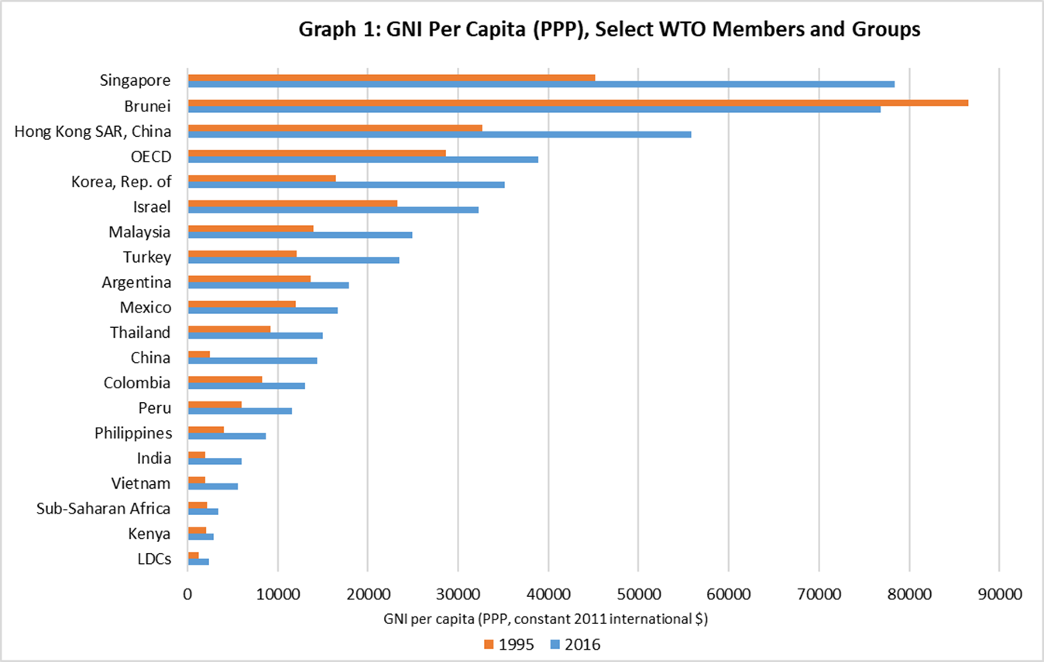
Hong Kong, China

Source: World Bank WDI, accessed on 7 January 2019.

Graph 2: GNI Per Capita, Select WTO Members, 1995-2017
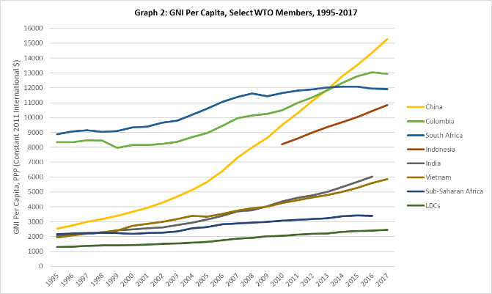
Source: World Bank WDI, accessed on 7 January 2019.

Graph 3: GNI Per Capita, Select WTO Members, 1995-2017
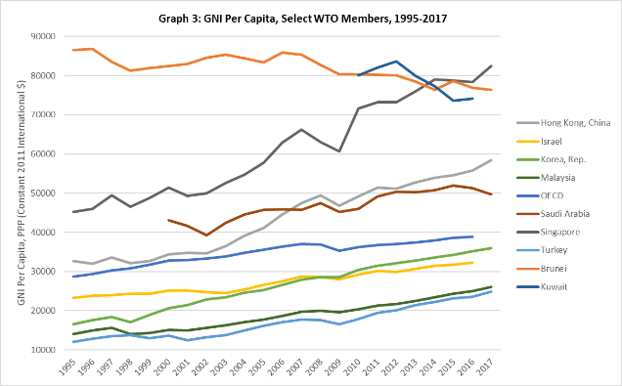
Source: World Bank WDI, accessed on 7 January 2019.

Graph 4: Employment in Agriculture, 1995-2017

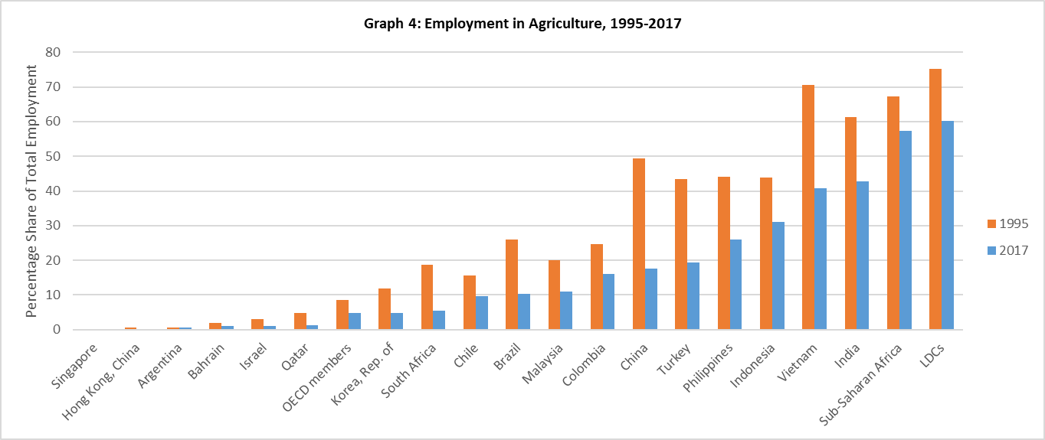
Source: World Bank WDI, accessed on 7 January 2019.

Graph 5: Shares of Global Agricultural Value Added, 1997-2016
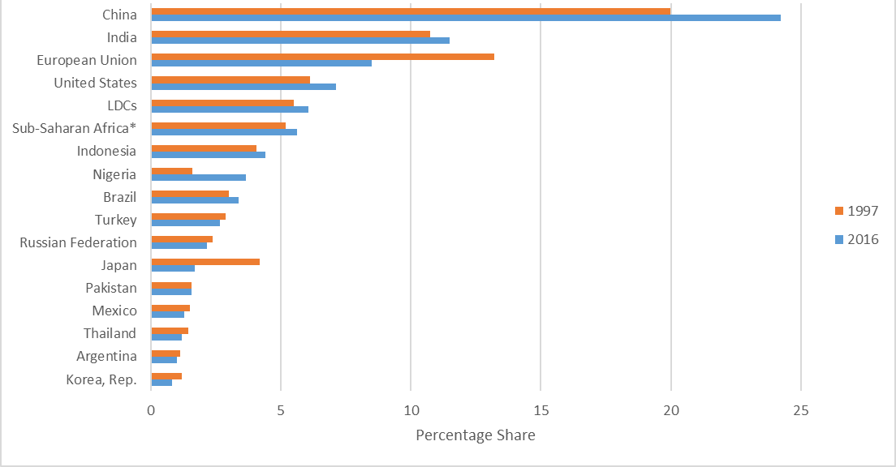
Note: Shares for Sub-Saharan Africa do not include shares for Nigeria, which are shown separately.
Source: World Bank WDI, accessed on 7 January 2019; data is modeled ILO estimate.

Graph 6: Urban Population as a Share of Total, 1995-2017
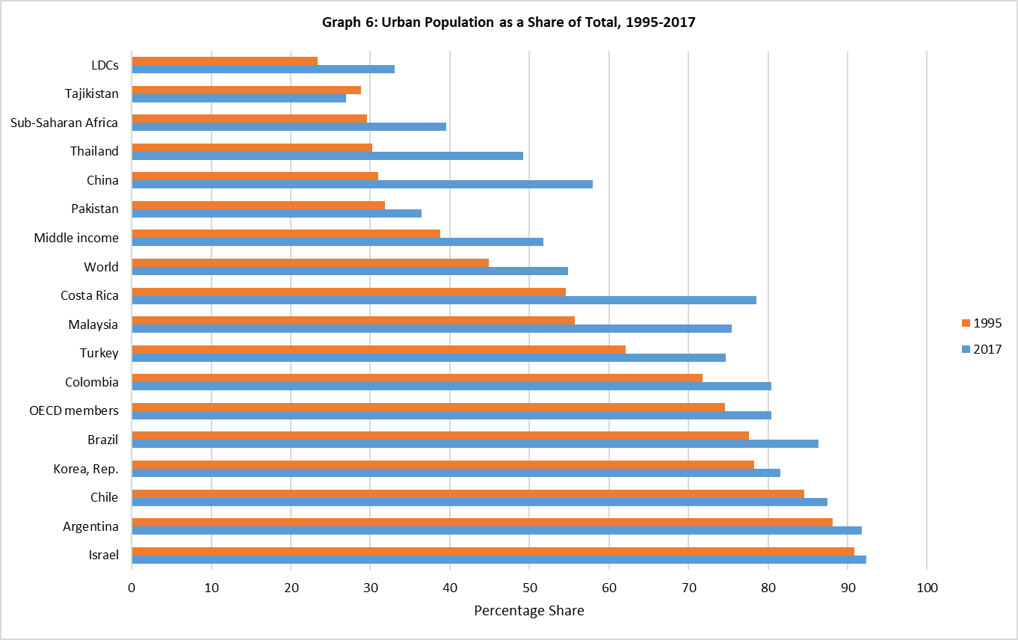
Source: World Bank WDI, accessed on 7 January 2019.

Graph 7: Share of Global Exports of Goods and Services, Select Members, 1995-2016
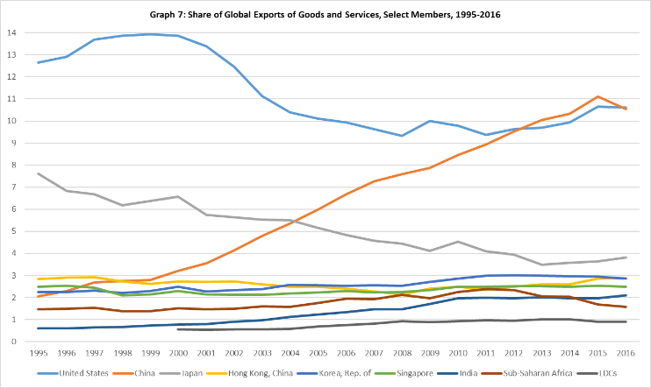
Notes: Calculations based on global exports in current USD. Data for LDCs are not available for 1995-1999.
Source: World Bank WDI, accessed on 9 January 2019.

Graph 8: Select WTO Members' Share of Global Exports of Goods, 1996-2017
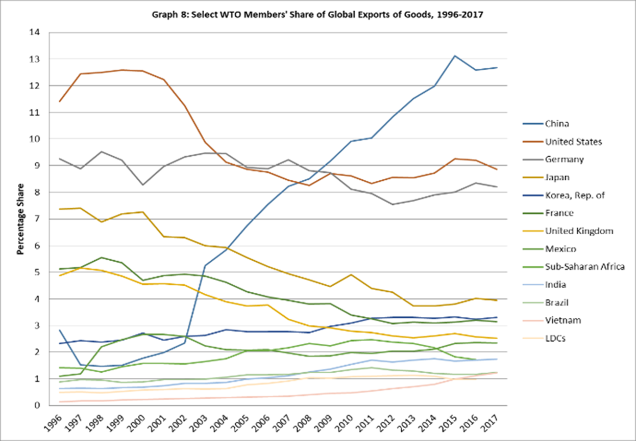
Note: 2017 figures are not available for LDCs, the Kingdom of Saudi Arabia, or Sub-Saharan Africa.
Source: World Bank WDI, accessed on 9 January 2019.
Graph 9: Shares of Global Exports of Goods, 1995 versus 2017
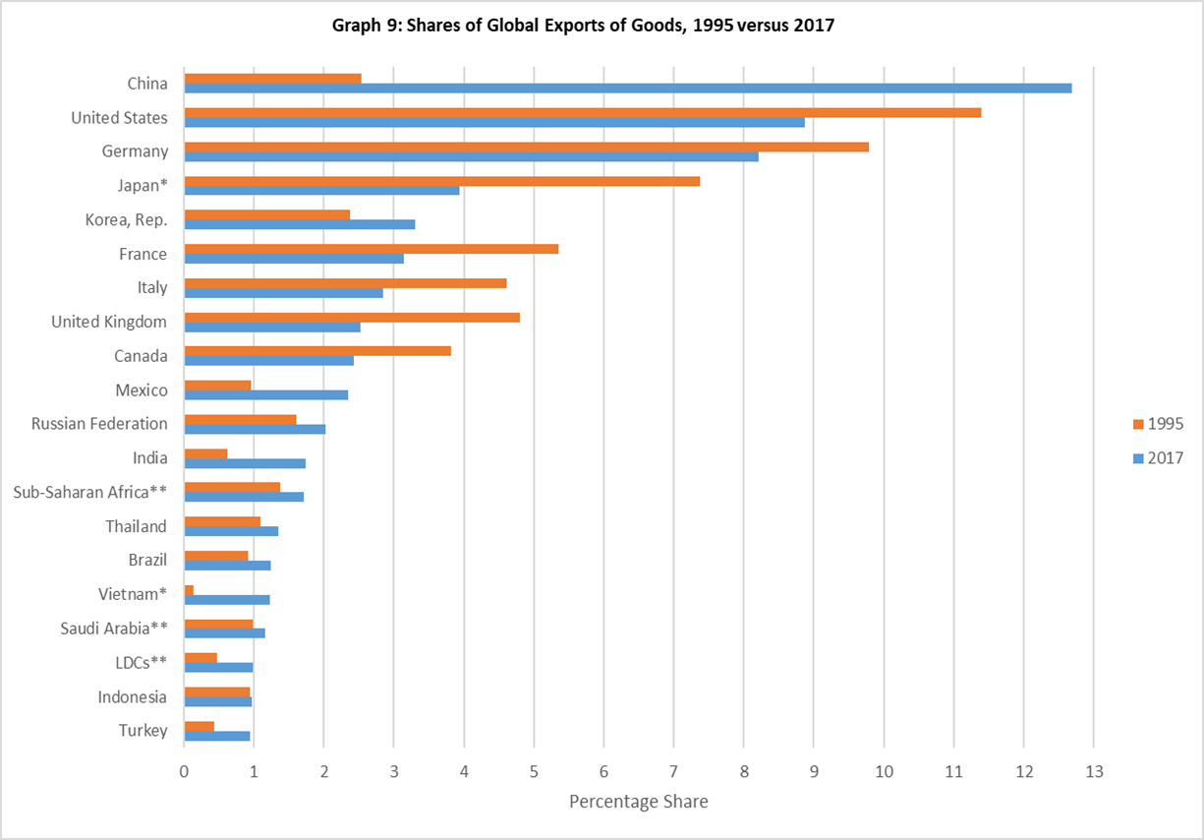
Notes:
* Shares of global exports of goods are calculated for 1996 and 2017
** Shares of global exports of goods are calculated for 1995 and 2016
Source: World Bank WDI, accessed on 9 January 2019.
Graph 10: Export Volume Index, 2000-2016 (Year 2000=100)
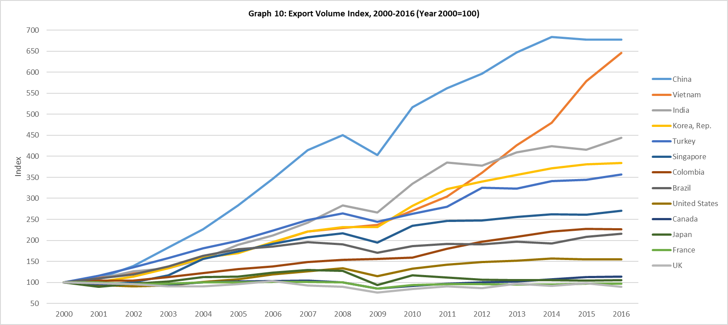
Source: World Bank WDI, accessed on 11 January 2019.

Graph 11: Export Value Index, 2000-2016 (Year 2000=100)
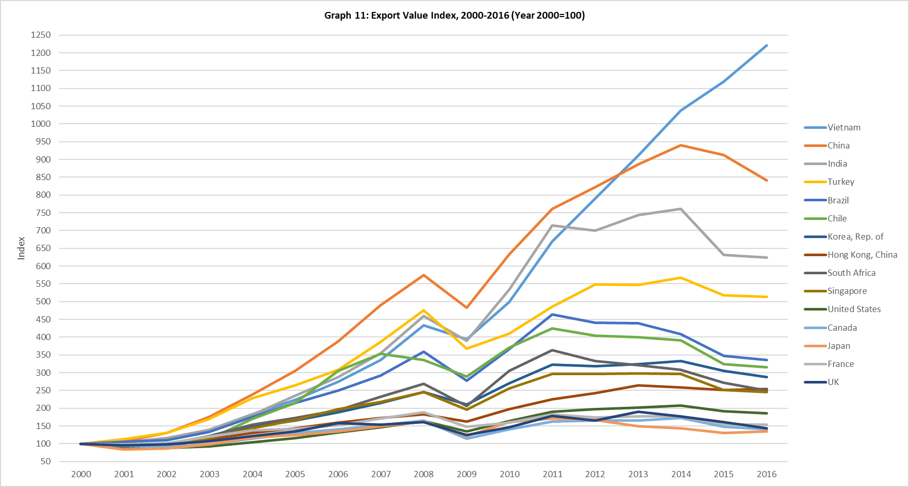
Source: World Bank WDI, accessed on 11 January 2019.

Graph 12: High Technology Exports, 1995 and 2016
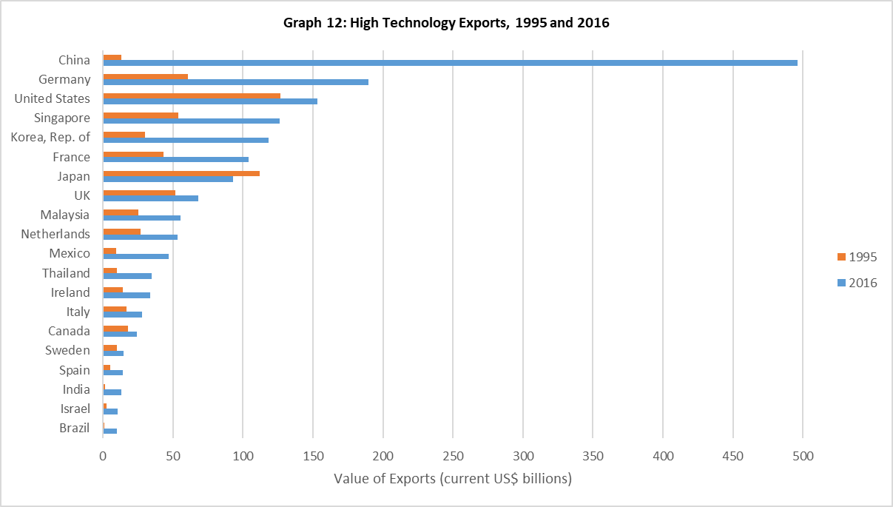
Note: The World Bank WDI defines high-technology exports as products with high R&D intensity, such as in aerospace, computers, pharmaceuticals, scientific instruments, and electrical machinery.
Source: World Bank WDI, accessed on 12 January 2019.

Graph 13: High Technology Exports as a Share of Manufacturing Exports, 1995 and 2016
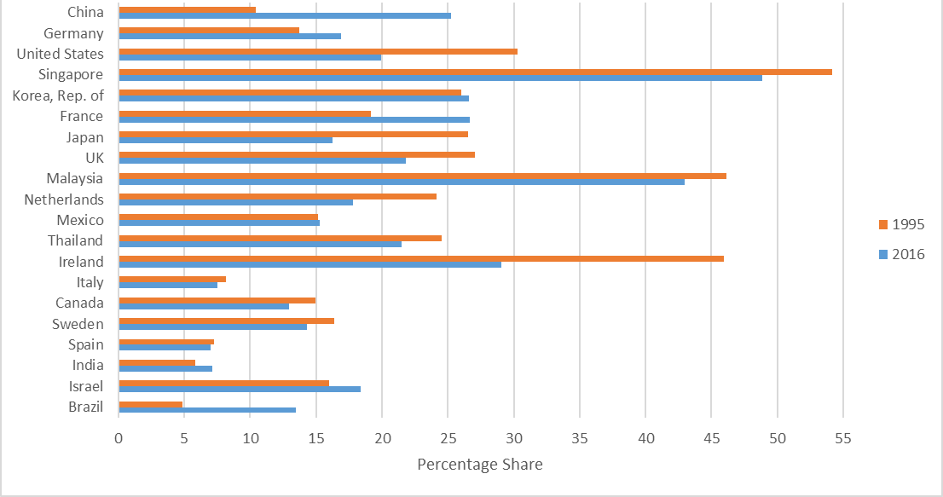
Note: The World Bank WDI defines high-technology exports as products with high R&D intensity, such as in aerospace, computers, pharmaceuticals, scientific instruments, and electrical machinery.
Source: World Bank WDI, accessed on 12 January 2019.

Graph 14: Medium- and High-Tech Exports as a Share of Manufacturing Exports, 1995 and 2015
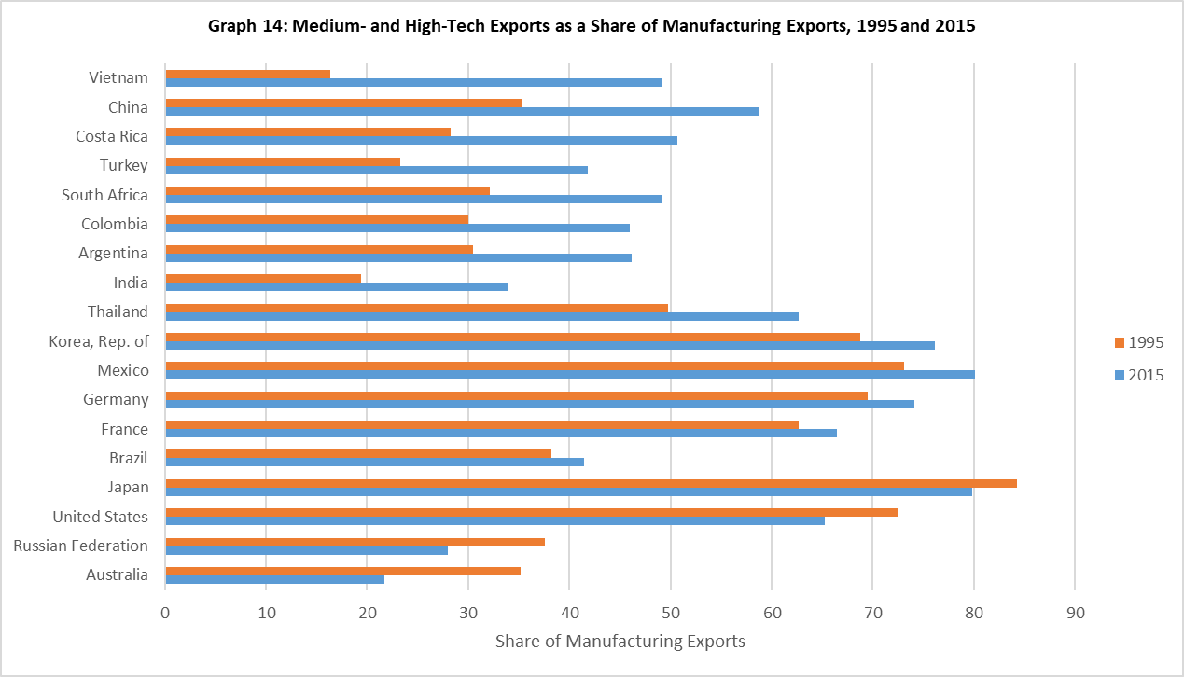
Source: World Bank WDI, accessed on 11 January 2019.

Graph 15: Exports of Advanced Technology Products (ATP), 1995 and 2016
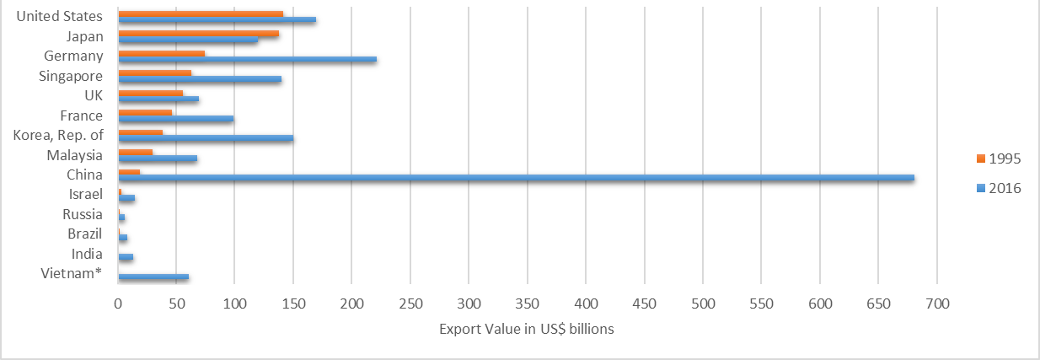
* Viet Nam figures in Graphs 15-15(j) are from 1997 and 2016.
Source: US Census Bureau data, July 2018.
Graph 15(a): ATP Exports – Computer Equipment, 1995 and 2016
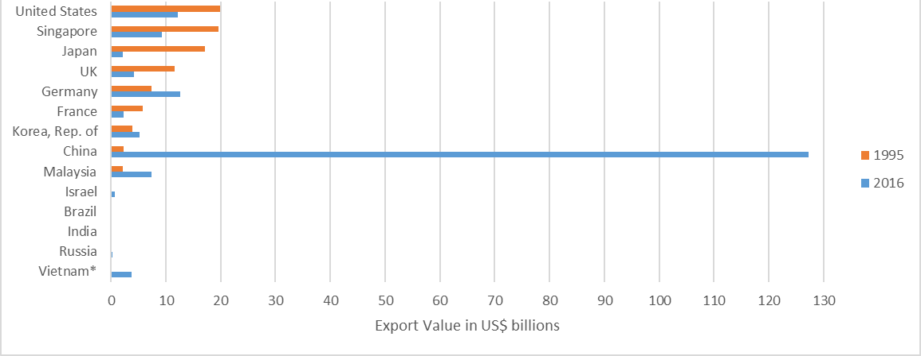

Graph 15(b): ATP Exports – Electrical Equipment, 1995 and 2016
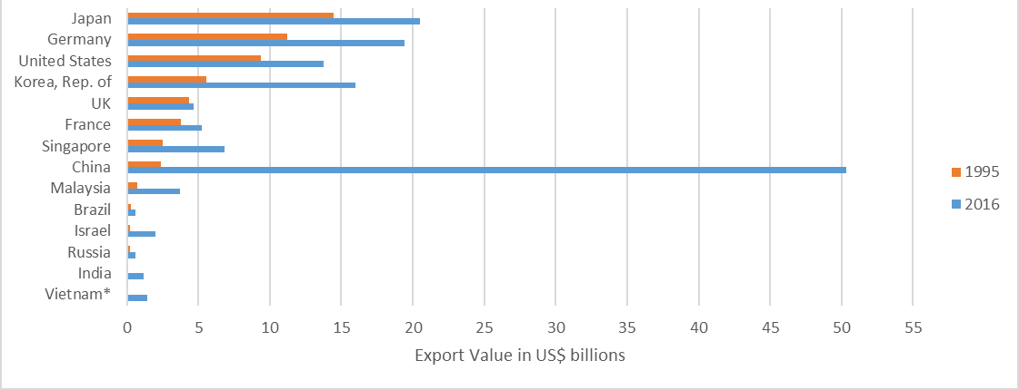

Graph 15(c): ATP Exports – Electrical Power Transmission Equipment, 1995 and 2016
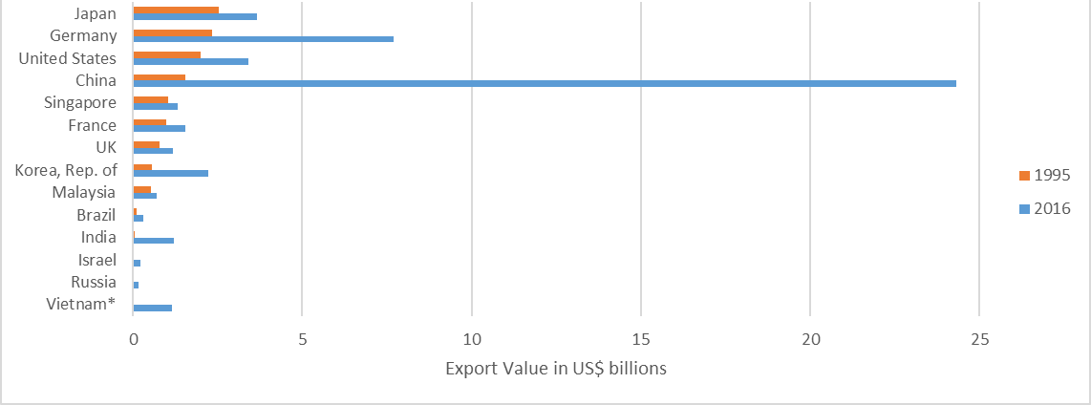

Graph 15(d): ATP Exports – Office Equipment, 1995 and 2016
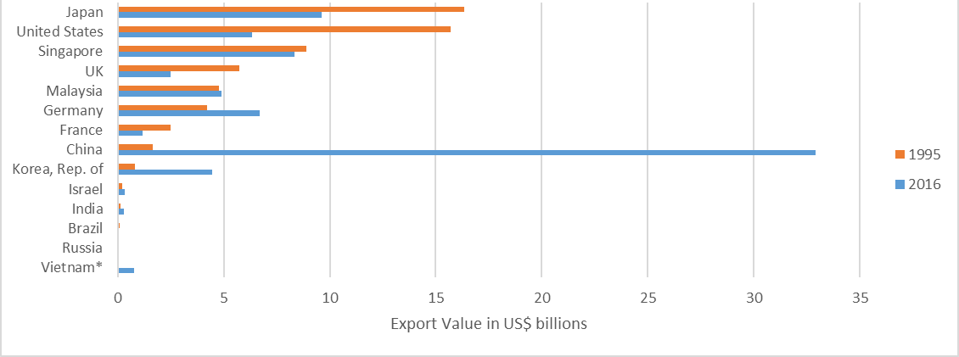

Graph 15(e): ATP Exports – Office Machines, 1995 and 2016
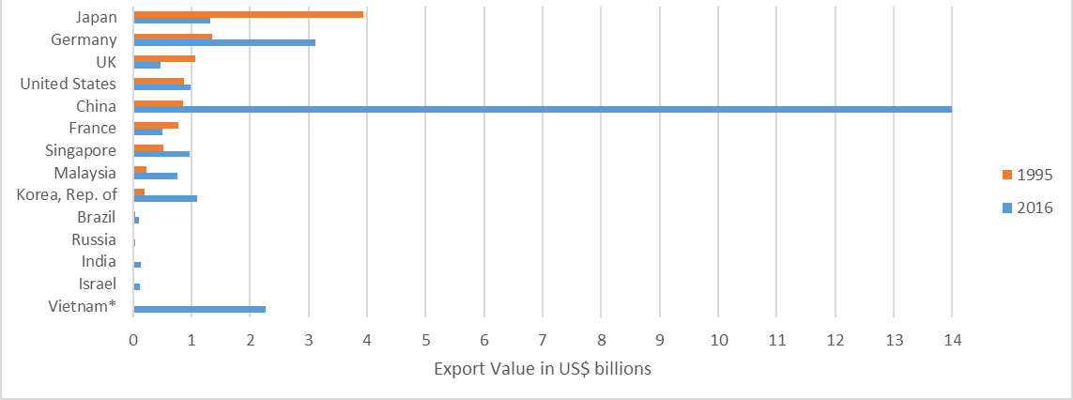

Graph 15(f): ATP Exports – Optical Instruments, 1995 and 2016
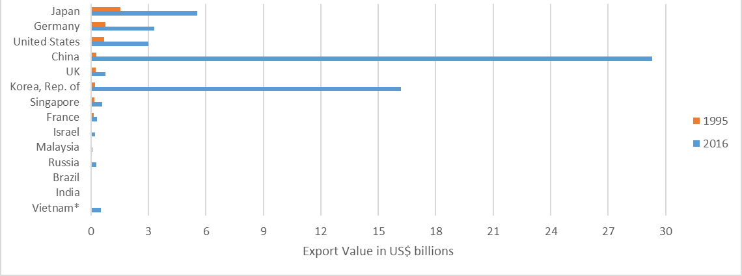

Graph 15(g): ATP Exports – Rotating Electric Plants, 1995 and 2016
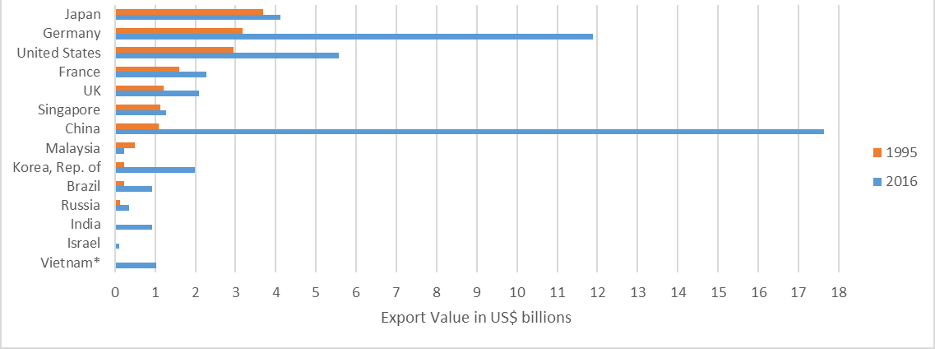

Graph 15(h): ATP Exports – Telecomm Equipment
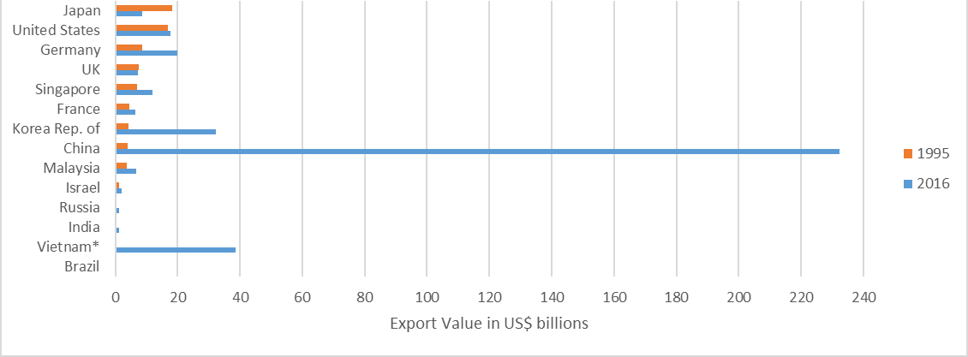

Graph 15(i): ATP Exports – Television Receivers, 1995 and 2016
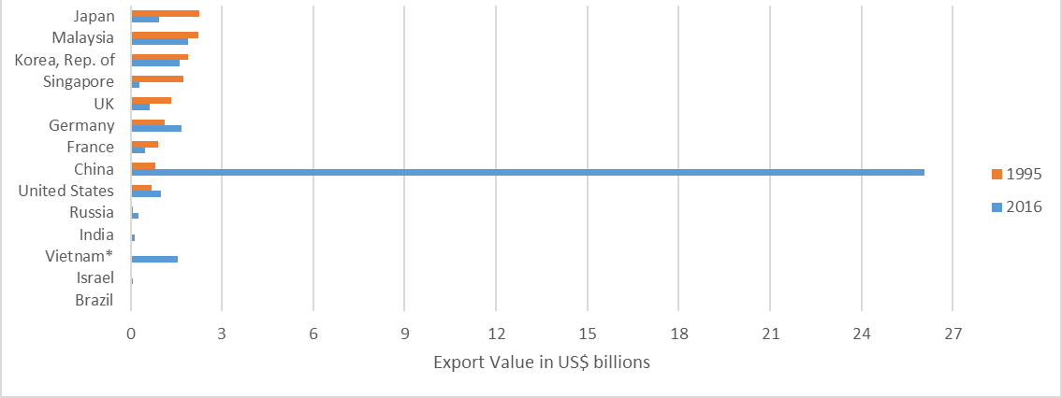

Graph 15(j): ATP Exports – Valves, Transistors, Etc, 1995 and 2016
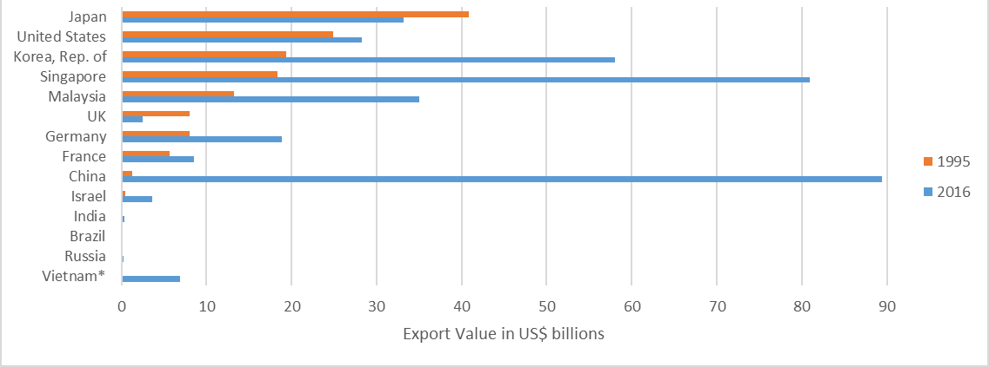

Graph 16: Receipts of Charges for Use of Intellectual Property, 1995-2017
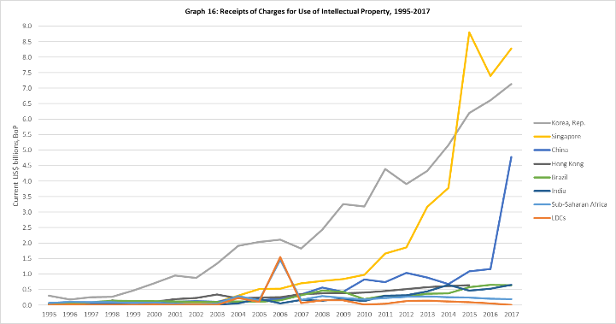
Notes: Data set does not contain data for China for 1995-96; for Hong Kong, China for 1995-97 and 2016-17; for Japan for 1995.
Source: World Bank WDI, accessed on 11 January 2019.

Graph 17: Outward Direct Investment Positions, Select WTO Members
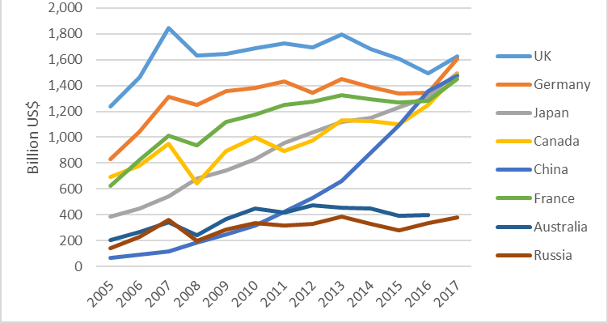
Source: https://stats.oecd.org, extracted on 8 January 2019.

Graph 18: Inward Foreign Direct Investment Positions, Select WTO Members
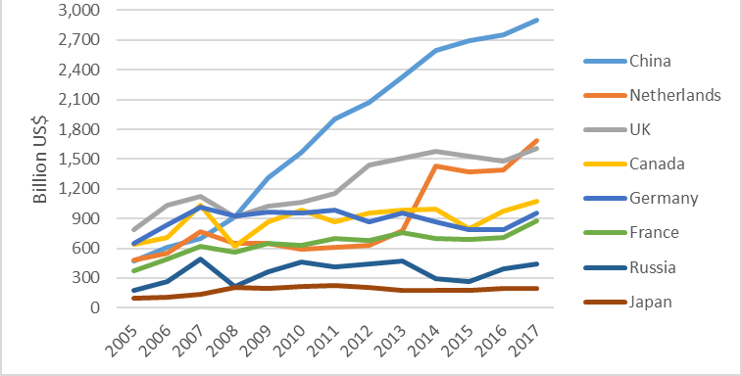
Source: https://stats.oecd.org, extracted on 8 January 2019.

Table 4: Fortune Global 500 Companies by Member
 | Number of Companies
 | 1995 | 2018
United States | 151 | 126
China | 2 | 111
Japan | 148 | 53
Germany | 44 | 32
France | 40 | 28
United Kingdom | 35 | 21
Korea, Republic of | 8 | 16
Netherlands | 12 | 15
Switzerland | 14 | 14
Canada | 5 | 12
Other | 41 | 72
Chinese Taipei | 2 | 9
Brazil | 2 | 7
India | 1 | 7
Singapore | 0 | 3
Mexico | 2 | 4
Notes:
- The Global 500 list for 1995, accessed on 11 January 2019 at http://fortune.com/global500/1995/, includes 483 companies. For purposes of Table 4, the missing 17 firms are included in the "Other" tally. A press article from 7 August 1995, accessed at https://money.cnn.com/magazines/fortune/fortune_archive/1995/08/07/205131/index.htm, stated that the United States had 151 companies in the Global 500, and Japan had 149. This would leave 16 unidentified companies in the "Other" tally.
- UK and Netherlands figures for 1995 include two companies whose headquarters are designated as UK/Netherlands.
- UK and Netherlands figures for 2018 include one company whose headquarters is designated as UK/Netherlands.
Source: Fortune Global 500, accessed on 13 January 2019 at: http://fortune.com/global500.

Table 5: Distribution of Supercomputers in the Top500 List of November 1994, by WTO Member
 | Top 10 | Top 100 | Top 500
United States | 5 | 59 | 257
Japan | 5 | 23 | 84
Germany |  | 3 | 48
UK |  | 5 | 23
France |  | 4 | 19
Netherlands |  |  | 8
Australia |  |  | 7
Switzerland |  | 3 | 7
Canada |  | 2 | 5
Sweden |  |  | 5
China |  |  | 0
Other |  |  | 37

Table 6: Distribution of Supercomputers in the Top500 List of November 2018, by WTO Member
 | Top 10 | Top 100 | Top 500
China | 2 | 10 | 227
United States | 5 | 35 | 109
Japan | 1 | 15 | 31
UK |  | 7 | 20
France |  | 7 | 18
Germany | 1 | 9 | 17
Ireland |  |  | 12
Canada |  | 1 | 9
Italy |  | 4 | 6
Korea, Republic of |  | 3 | 6
Netherlands |  |  | 6
Australia |  |  | 5
Other |  |  | 34
Source: The Top500, at: https://www.top500.org/lists/top500. Accessed on 8 January 2019.

Graph 19: Satellites in Space, as of 30 November 2018
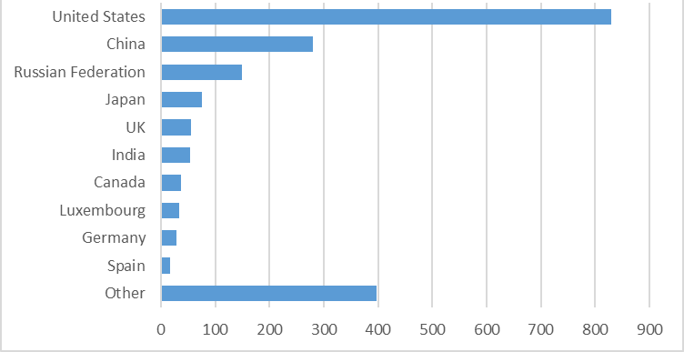
Note: Country is derived from "Country of Operator/Owner." "Other" category includes satellites for which more than one country of operator/owner is listed in the database.
Source: Union of Concerned Scientists' Satellite Database, accessed on 7 January 2019 at: https://www.ucsusa.org/nuclear-weapons/space-weapons/satellite-database.

Graph 20: Military Expenditure by Country, 1995-2017
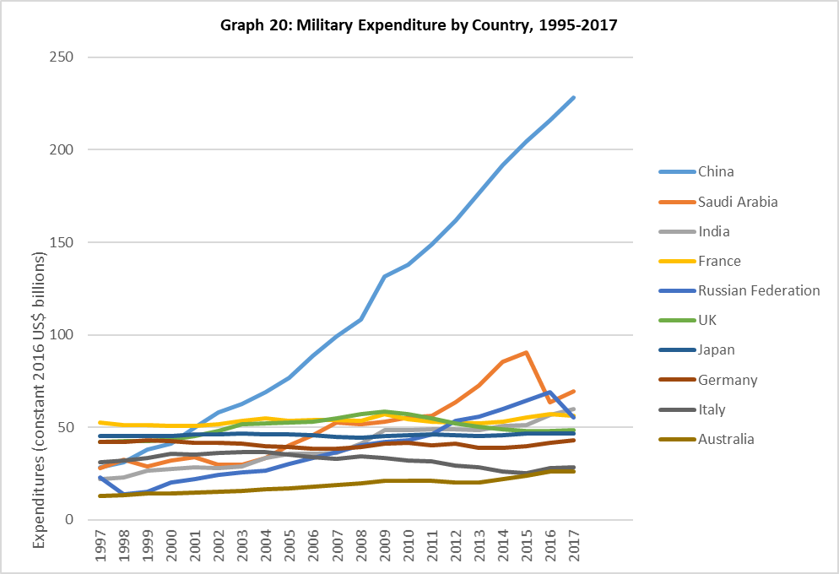
Note: Figures for China, Saudi Arabia, Russian Federation, Italy, and Australia contain estimates. Figures for Saudi Arabia are for the adopted budget, rather than actual expenditure. For more details, see: https://www.sipri.org/sites/default/files/5_Footnotes.pdf.
Source: Stockholm International Peace Research Institute (SIPRI) Military Expenditure Database, accessed on 11 January 2019 at: https://www.sipri.org/databases/milex.
Graph 21: Comparison of Chinese Naval Vessels Launched Since 2014 and the Total Size of Selected Navies
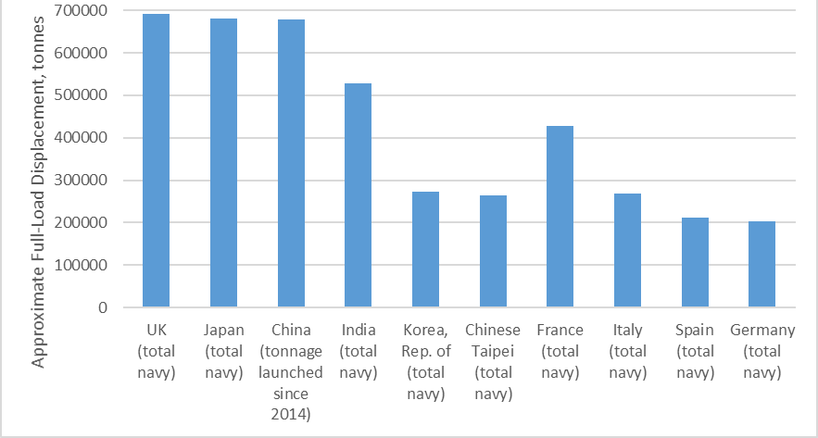
Note: China naval vessels include PLA Navy vessels only. Data as of April 2018.
Source: The International Institute for Strategic Studies Military Balance Blog, "China's naval shipbuilding, delivering on its ambition in a big way," 1 May 2018. See: https://www.iiss.org/blogs/military-balance/2018/05/china-naval-shipbuilding.
Table 7: OECD Membership, Applicants, and Key Partners
OECD Members, 1995
Australia | Finland | Ireland | Netherlands | Sweden
Austria | France | Italy | New Zealand | Switzerland
Belgium | Germany | Japan | Norway | Turkey
Canada | Greece | Luxembourg | Portugal | UK
Denmark | Iceland | Mexico | Spain | USA

OECD Members, 2019
Australia | Denmark | Hungary | Korea | New Zealand | Spain
Austria | Estonia | Iceland | Latvia | Norway | Sweden
Belgium | Finland | Ireland | Lithuania | Poland | Switzerland
Canada | France | Israel | Luxembourg | Portugal | Turkey
Chile | Germany | Italy | Mexico | Slovak Republic | UK
Czech Republic | Greece | Japan | Netherlands | Slovenia | USA
Notes: Countries shaded in orange became members after 1995. Countries highlighted in red have not self-declared as developed Members of the WTO.

OECD Applicants, 2019
Current: Costa Rica.
Prospective: Argentina; Brazil; Bulgaria; Croatia; Peru; Romania.

Note: The OECD approved Colombia's application for membership in 2018, and it is in the process of being finalized.

OECD "Key Partners"
Brazil; China; India; Indonesia; South Africa.

__________

World Bank, World Development Indicators (WDI), accessed on 7 January 2019. See: http://databank.worldbank.org/data/reports.aspx?source=world-development-indicators#.
UNDP Human Development Reports, Table 2: Human Development Index Trends, 1990-2017, accessed on 7 January 2019. See: http://hdr.undp.org/en/composite/trends.
The World Bank's preliminary forecast is that extreme poverty has declined to 8.6 percent in 2018. See: https://www.worldbank.org/en/news/press-release/2018/09/19/decline-of-global-extreme-poverty-continues-but-has-slowed-world-bank
World Bank, Poverty and Shared Prosperity 2018: Piecing Together the Poverty Puzzle, p. 1. See: https://openknowledge.worldbank.org/bitstream/handle/10986/30418/9781464813306.pdf.
A 2015 study by the World Bank and the WTO found a link between economic growth spurred by trade, and the reduction of poverty. See: The Role of Trade in Ending Poverty, p. 7, at: https://www.wto.org/english/res_e/booksp_e/worldbankandwto15_e.pdf.
World Bank, WDI, accessed on 7 January 2019. Data are in current US dollars.
World Bank, Poverty and Shared Prosperity 2018: Piecing Together the Poverty Puzzle, p. 8.
These trends also appear at income thresholds above the extreme poverty line of US$1.90 per day, including the $3.20 per day line and the US$5.50 per day line. See Table 1.
World Bank, Poverty and Shared Prosperity 2018: Piecing Together the Poverty Puzzle, p. 42.
Ibid, p. 42.
UNDP, Human Development Report 2016: Human Development for Everyone, p. 1-3. See: http://hdr.undp.org/sites/default/files/2016_human_development_report.pdf.
Average figures for OECD members can be a useful point of comparison given OECD members' relatively high income and human development scores. OECD members account for 63 percent of world GDP, three-quarters of world trade, 95 percent of world official development assistance, over half of the world's energy consumption, and 18 percent of the world's population. See: https://usoecd.usmission.gov/our-relationship/about-the-oecd/what-is-the-oecd/.
About 500 of some 22,000 commodity classification codes used in reporting US merchandise trade are identified as "advanced technology" codes and they meet the following criteria: the code contains products whose technology is from a recognized high technology field (e.g., biotechnology); these products represent leading edge technology in that field; and such products constitute a significant part of all items covered in the selected classification code.
See: https://data.oecd.org/fdi/fdi-stocks.htm.
See: http://fortune.com/global500/list/.
See: http://fortune.com/global500/1995/. The Global 500 list shows only 483 companies. It is therefore possible that the number of companies on the list in 1995 that were headquartered in the United States, Japan, or Europe was slightly higher than 473.
The rankings can be accessed at: https://www.top500.org/lists/top500.
On average, the systems in the United States are more powerful, resulting in an aggregate system performance of 38 percent, compared to 31 percent for China. See: https://www.top500.org/news/lists/2018/11/press-release.
Goldman, Emily O. and Blanken, Leo J. "The Economic Foundations of Military Power." University of California-Davis, 2006, p. 2-3. See: https://www.files.ethz.ch/isn/21806/GoldmanBlanken.pdf.
Stockholm International Peace Research Institute (SIPRI) Military Expenditure database, accessed on 11 January 2019. See: https://www.sipri.org/databases/milex.
The International Institute for Strategic Studies Military Balance Blog, "China's naval shipbuilding, delivering on its ambition in a big way," 1 May 2018, accessed on 11 January 2019. See: https://www.iiss.org/blogs/military-balance/2018/05/china-naval-shipbuilding.
Nielsen, Lynge. Classifications of Countries Based on Their Level of Development: How it is Done and How it Could be Done." IMF Working Paper WP/11/31, February 2011, p. 3.
Ibid, p. 4.
Ibid, p. 3.
Ibid, p. 4.
Convention on the Organisation for Economic Co-operation and Development. See: http://www.oecd.org/general/conventionontheorganisationforeconomicco-operationanddevelopment.htm.
Lynge, "Classifications of Countries Based on Their Level of Development: How it is Done and How it Could be Done," p. 15-16.
Ibid, p. 16. The quoted text is from Article V, Section 12 of the IMF's Articles of Agreement.
IMF Policy Paper, "Eligibility to Use the Fund's Facilities for Concessional Financing, 2017" May 2017, p. 5.
Ibid, p. 5.
IMF, "List of LIC DSAs for PRGT-Eligible Countries As of January 1, 2019." See: https://www.imf.org/external/Pubs/ft/dsa/DSAlist.pdf.
Lynge, "Classifications of Countries Based on Their Level of Development: How it is Done and How it Could be Done," p. 16-18.
World Economic Outlook, May 1997, p. 118.
Lynge, "Classifications of Countries Based on Their Level of Development: How it is Done and How it Could be Done," p. 17.
Ibid, p. 19.
Ibid, p. 19.
IMF Policy Paper, "Macroeconomic Developments and Prospects in Low-Income Developing Countries – 2018," March 2018, p. 62-67.
Ibid, p. 62-67.
Lynge, "Classifications of Countries Based on Their Level of Development: How it is Done and How it Could be Done," p. 8-9.
Ibid, p. 8-9.
Ibid, p. 8-9.
Fantom, Neil and Serajuddin, Umar. "The World Bank's Classification of Countries by Income," World Bank Group Policy Research Working Paper No. 7528, January 2016, p. 2-3.
Ibid, p. 2-3.
World Bank data, accessed on 11 October 2018 at https://datahelpdesk.worldbank.org/knowledgebase/articles/906519-world-bank-country-and-lending-groups.
Article XI:2 points to the UN's criteria for recognition in the Least Developed Countries group.
See WT/COMTD/W/219.
Chinese Taipei set an encouraging example for other Members at its Trade Policy Review meeting in September 2018, stating that it will not claim special and differential treatment afforded to developing country Members in future WTO negotiations. See WT/TPR/M/377.
China is by far the world's largest marine capture fisheries producer, with approximately 15 million tons of production. Indonesia is the second largest producer, with approximately 6.2 million tons. Peru, India, Viet Nam, and the Philippines are also among the world's top ten largest marine capture fisheries producers. See: Food and Agriculture Organization, The State of the World Fisheries and Aquaculture (2018), at Table 2.
Group of countries with less than 35% of non-agricultural products covered by legally bound tariff ceilings. They had agreed to increase their binding coverage substantially, but wanted to exempt some products. (In paragraph 6 of the first version of the NAMA text, later paragraph 8.) WTO Members: Cameroon; Congo; Côte d'Ivoire; Cuba; Ghana; Kenya; Macao, China; Mauritius; Nigeria; Sri Lanka; Suriname; Zimbabwe.
Coalition of developing countries seeking flexibilities to limit market opening in industrial goods trade. Despite its name, it only included 10 WTO Members: Argentina; Brazil; Egypt; India; Indonesia; Namibia; Philippines; South Africa; Tunisia; and Bolivarian Republic of Venezuela.
For a full list of NAMA country groupings, see: https://www.wto.org/english/tratop_e/markacc_e/nama_groups_e.htm.
WT/ACC/TPKM/18, paragraph 6.

