UNOFFICIAL ROOM DOCUMENT

Dialogue on Plastics Pollution and Environmentally Sustainable Plastics Trade
PRESENTATION BY THE WORLD BANK
Pre-Plenary Meeting – 16 February 2023

DOCUMENT DE SÉANCE NON OFFICIEL¹

Dialogue on Plastics Pollution and Environmentally Sustainable Plastics Trade
PRESENTATION BY THE WORLD BANK
Pre-Plenary Meeting – 16 February 2023

DOCUMENTO DE SALA NO OFICIAL¹

Dialogue on Plastics Pollution and Environmentally Sustainable Plastics Trade
PRESENTATION BY THE WORLD BANK
Pre-Plenary Meeting – 16 February 2023
_______________

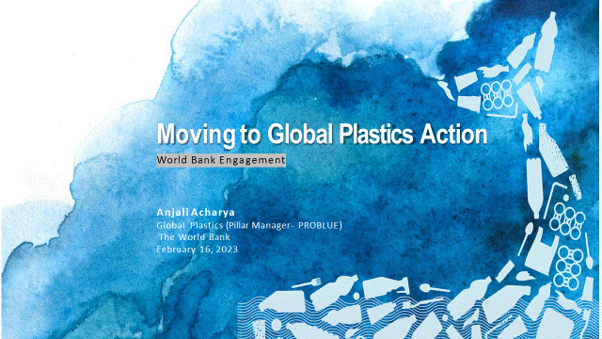

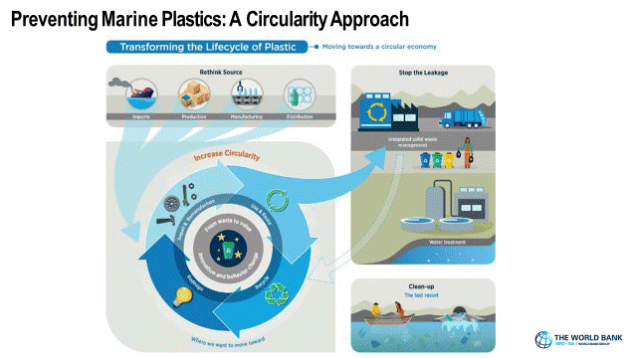

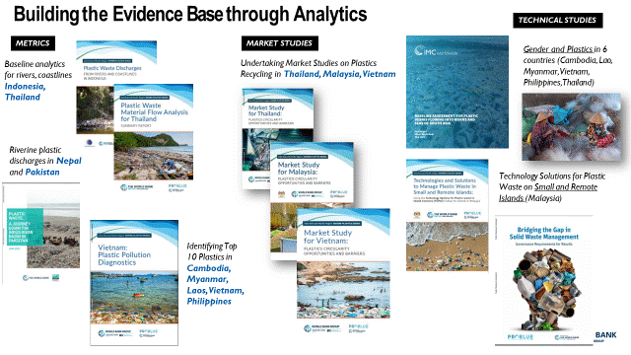

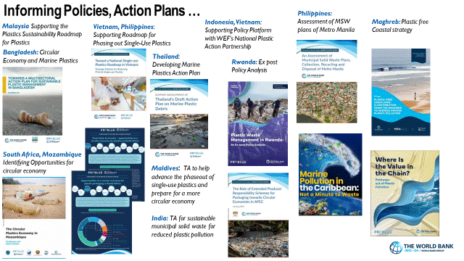

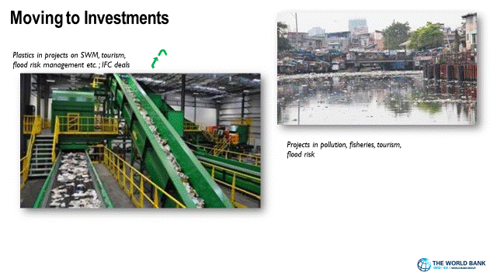

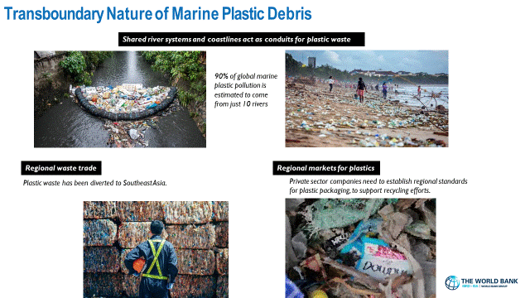

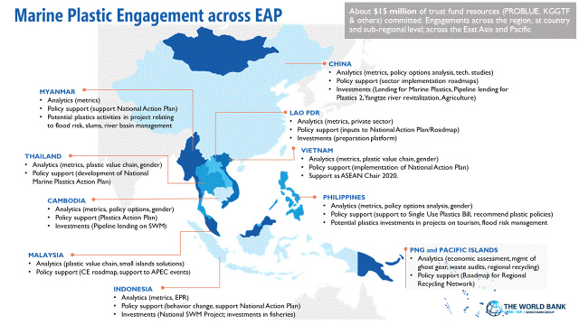

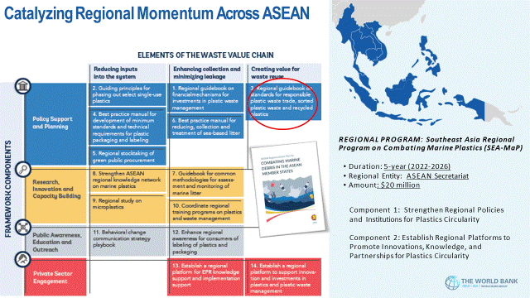

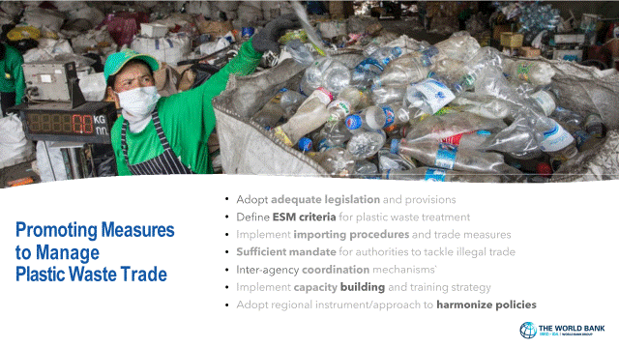

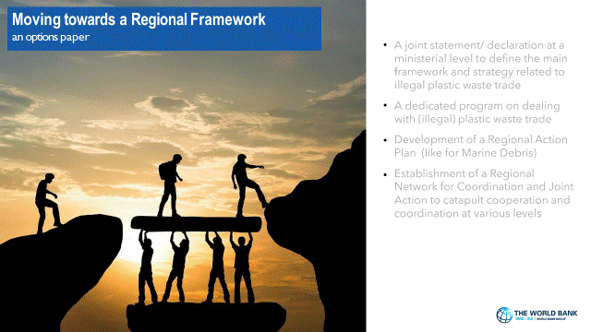

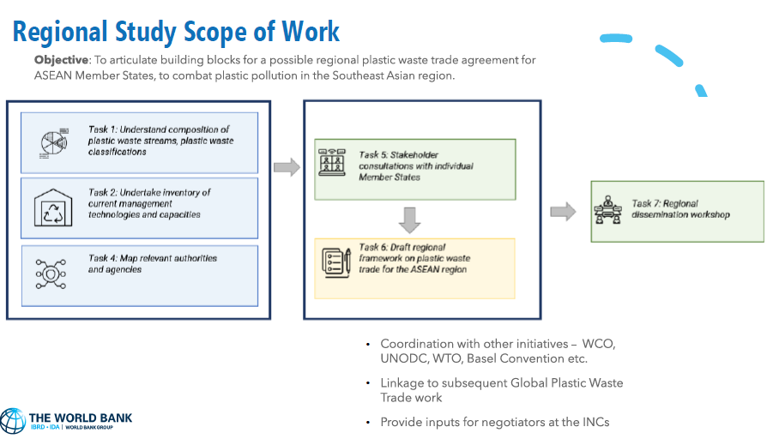

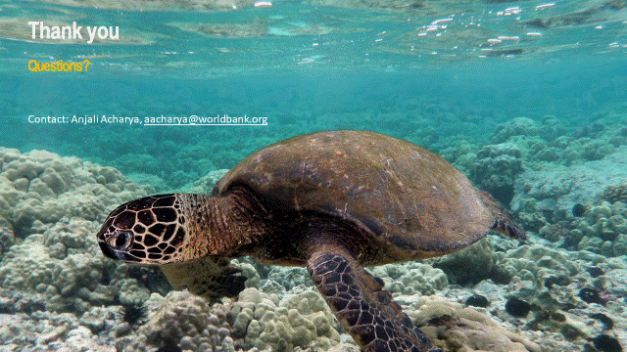

__________

* In Original language only/En langue originale seulement/En el idioma original solamente. Documents issued in the RD series are not official WTO documents. They usually appear in their language of submission and will not be translated systematically into the working languages of the WTO. They are intended for use in WTO meeting rooms and are attributed an unofficial symbol for archiving purposes only. Les documents de la série RD ne sont pas des documents officiels de l'OMC. Ils ne paraissent généralement que dans la langue dans laquelle ils ont été communiqués et ne seront pas systématiquement traduits dans les langues de travail de l'OMC. Ils sont destinés aux salles de réunion de l'OMC et une cote non officielle leur est attribuée à des fins d'archivage. Los documentos de la serie RD no son documentos oficiales de la OMC. Por lo general se distribuyen en el idioma en que han sido presentados y no se traducen sistemáticamente a los idiomas de trabajo de la Organización. Se distribuyen para su uso en las salas de reunión de la OMC y se les asigna una signatura no oficial a efectos de archivo únicamente.

