AnnuAl Report on notifications and other information flows
Note by the Secretariat
This document has been prepared under the Secretariat's own responsibility and is without prejudice to the positions of Members and to their rights and obligations under the WTO.

Contents
1 INTRODUCTION 2
2 e-TRIPS 3
3 TRANSPARENCY MECHANISMS 4
3.1 NOTIFICATIONS UNDER ARTICLE 63.2 4
3.1.1 Laws and regulations 4
3.1.2 Responses to the checklist on enforcement 11
3.2 NOTIFICATIONS OF CONTACT POINTS UNDER ARTICLE 69 12
3.3 AD HOC NOTIFICATIONS FROM MEMBERS AVAILING THEMSELVES OF CERTAIN
OPTIONS UNDER THE TRIPS AGREEMENT 13
3.3.1 Articles 1.3 and 3.1 13
3.3.2 Article 4(d) 13
3.3.3 Other notification requirements under the Berne Convention and the Rome Convention incorporated by reference into the TRIPS Agreement 14
3.4 NOTIFICATION REQUIREMENTS FOR MEMBERS MAKING USE OF THE ADDITIONAL FLEXIBILITIES RELATING TO TRIPS AND PUBLIC HEALTH 14
3.5 REPORTING REQUIREMENTS FOR DEVELOPED MEMBERS AGREED TO BY THE
TRIPS COUNCIL IN THE CONTEXT OF ARTICLES 66.2 AND 67 15
3.5.1 Reports under Article 66.2 15
3.5.2 Reports under Article 67 17
3.5.3 Contact points for technical cooperation under Article 67 19
3.6 CERTAIN OTHER INFORMATION FLOWS 20
3.6.1 Responses provided in the context of the review of the provisions of the Section on geographical indications under Article 24.2 20
3.6.2 Responses provided in the context of the review of the provisions of Article 27.3(b) 21
Annex 22
Table A.1: Notifications of laws and regulations pursuant to Article 63.2 by Member, identifying
the most recent (Latest) and total count (No.) of notifications received, 1995-2021 22
Table A.2: Responses to the checklist on enforcement under Article 63.2 27
Table A.3: Contact point submissions under Articles 69 and 67, 29
Table A.4: Notifications under Articles 1.3 and 3.1 32
Table A.5: Notifications under Article 4(d) 33
Table A.6: Other notifications made pursuant to requirements under the Berne Convention
and the Rome Convention incorporated by reference into the TRIPS Agreement 34
Table A.7: Notifications by Members making use of the additional flexibilities relating to
TRIPS and public health 35
Table A.8: Reports submitted by Members under Articles 66.2 and 67 36
Table A.9: Responses provided in the context of reviews under Articles 24.2 and 27.3(b) 37

INTRODUCTION
            - The TRIPS Agreement established a number of notification requirements to facilitate the TRIPS Council's efforts to monitor the operation of the Agreement and promote awareness of Members' policies on intellectual property (IP) protection. The Council subsequently established reporting requirements for developed country Members and invited Members to respond to checklists of questions in furtherance of the Council's mandated reviews of certain provisions in the Agreement. Together, these transparency mechanisms comprise the primary means by which Members keep the Council apprised of their TRIPS-related laws, regulations, programmes, practices, and contact points.
            - In 2009, the then-Chair of the General Council invited WTO Councils and Committees, including the TRIPS Council, to consult on ways to improve the timeliness and completeness of notifications and other information flows on trade measures falling within their respective areas of responsibility. At the Council's request, the Secretariat endeavoured to improve the visibility and user-friendliness of the TRIPS notification system, through an extended process of dialogue with Members and regular updates to the Council. This process culminated in the 2019 launch of the e-TRIPS information system (see section 2 ). With this new online tool, Members and the general public gained on-demand access to extensive data on Members' TRIPS-related notifications, reports, and information relating to reviews, dating back to 1995. It also streamlines and simplifies the means for Members to check on the status of their own notifications and reports, and to update and add to them as necessary.
            - As with the first note in this series, circulated in 2020, this second annual note capitalizes upon the information available through e-TRIPS to present and summarize submission rates and identify trends since 1995 for each of the primary TRIPS transparency mechanisms, with a particular focus on the prior year's submissions. It shows that Members exerted significant efforts to submit initial notifications of laws, regulations and contact points, as well as information regarding domestic practices relating to intellectual property enforcement and systems of protection for geographical indications (GIs), biotechnology inventions and plant varieties.
            - However, not all Members have kept up with their continuing notification obligations or maintained their contributions to the Council's monitoring function by providing updates to initial submissions. For example, despite evidence of substantial domestic legislative activity in the intellectual property arena over the past 15 years, 41% of developed and developing countries have not notified the Council of any new or amended laws or regulations since 2006. The majority of Members' contact point submissions are over ten years old, and over half of Members' submissions of information in relation to TRIPS-mandated reviews date back to the 1990s. The wealth of information that Members laboured to provide at the turn of the century now risks becoming outdated.
            - With respect to developed country Members' annual reporting obligations, the number of reports received in any given year under each mechanism has fluctuated, with few discernible trends. The number of annual reports on incentives to enterprises and institutions for the purpose of promoting and encouraging technology transfer to LDC Members appears to be somewhat stabler than the number of annual reports received on technical cooperation activities.
            - 2021 was atypical in certain respects with regard to the rate at which Members submitted TRIPS-related information. Notifications of laws and regulations reached an eight-year high, a product of the United Kingdom's continued effort, begun in 2020, to inform the Council of over 225 pieces of current and historical legislation. Fifteen other Members notified laws and regulations in 2021, fewer than in 2020, but within the typical range observed since 2005. The Central African Republic, an LDC Member, submitted its first notifications of laws and regulations in 2021. Three notifications under the special compulsory licensing system were also submitted in 2021, the first such notifications since 2007. Four Members submitted updated contact points, five fewer than in 2020. The Kingdom of Saudi Arabia submitted information regarding its domestic framework for protecting biotechnology inventions and new plant varieties, pursuant to the review of the provisions of Article 27.3(b). No other Members submitted new or updated information in relation to Council's ongoing reviews or their IP enforcement practices. The number of developed country Member reports received in 2021 varied only slightly from 2020 and was consistent with figures from previous years.

e-TRIPS
            - The e-TRIPS information system was developed to enhance the transparency of TRIPS-related information and simplify its submission to the Council. Composed of two linked platforms, the Submission System provides an online avenue for making submissions, while the Gateway aggregates and facilitates online access to, and analysis of, the documents and data underlying these submissions. Both platforms are available in English, French, and Spanish.
            - The e-TRIPS Submission System has become the primary means by which Members and observers submit notifications, responses to checklists of questions, and reports. Between the launch of the Submission System in March 2019 and the end of 2020, 63% of Members who submitted a notification, responses to a checklist, or report did so through the Submission System. In 2021, this figure rose to 74%. The number of submissions received through the Submission System has also continued to grow, from 79% between March 2019 and the end of 2020, to 88% in 2021. Notably, all reports submitted during the 2021 reporting cycle, except for those of two Members, were submitted through the Submission System.
            - The e-TRIPS Gateway, in turn, has become a frequently consulted publicly available resource for TRIPS-related information. The number of unique visitors to the site nearly doubled from 2020 to 2021, and it generates nearly 1,000 page views per day.
            - The Secretariat is available to answer questions and conduct in-person and virtual training sessions for Members and observers interested in learning more about e-TRIPS and the transparency requirements of the TRIPS Council.

TRANSPARENCY MECHANISMS

NOTIFICATIONS UNDER ARTICLE 63.2

Laws and regulations
            - Article 63.2 of the TRIPS Agreement, in conjunction with Article 63.1, requires Members to notify their domestic laws and regulations pertaining to the availability, scope, acquisition, enforcement and prevention of the abuse of intellectual property rights to the Council. Once a Member is obliged to apply a provision of the TRIPS Agreement, the corresponding laws and regulations must be notified without delay (normally within 30 days). Any subsequent amendments to notified laws and regulations or new laws and regulations must also be notified without delay after their entry into force.

A historical perspective: 1995 to 2021
            - From 1995 to 2021, Members made 5,634 notifications pertaining to 4,117 distinct laws or regulations (see Figure 1). The number of yearly notifications peaked in 1996 and 2000, corresponding with the end of transitional arrangements set forth in Article 65 of the TRIPS Agreement for developed country Members (1996), developing countries (2000), and Members transforming from a centrally-planned to a market economy (2000) (see Figure 2). Upon the conclusion of each transition period, Article 63.2 came into effect for a new group of Members, triggering waves of notifications of legislation. LDC Members availing themselves of the transition period under Article 66.1 are not yet obliged to notify their domestic laws and regulations under Article 63.2.
Figure 1: Notifications of laws and regulations pursuant to Article 63.2, 1995-2021
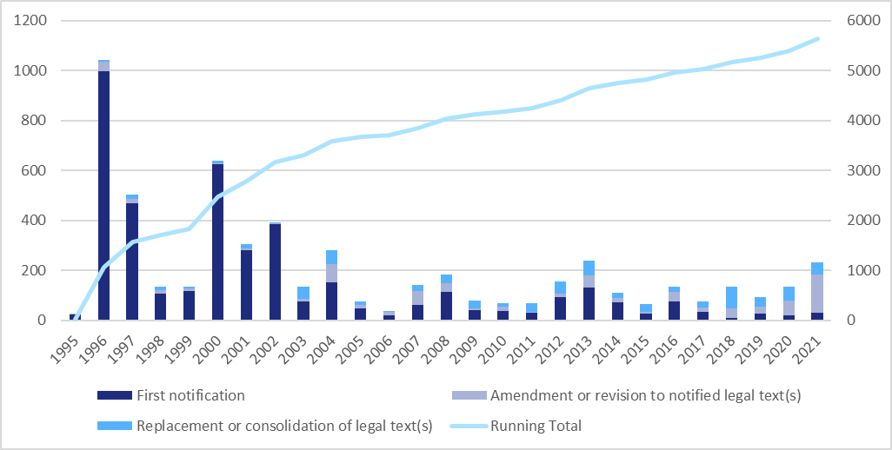

            - Since 2005, the yearly number of notifications has stabilized somewhat, ranging from a low of 39 in 2006 to a high of 238 in 2013 (nearly matched in 2021). Some of the yearly variations during this period have been influenced by bulk notifications made by (a) newly acceded WTO Members; and (b) Members catching up on past-due notifications that accumulated over a number of years.
            - As time has passed, the yearly composition of the notifications has predictably shifted from "first" (i.e. initial) notifications of a law or regulation to the WTO, to notifications of amendments or revisions, or replacements or consolidations, of previously notified laws or regulations. However, despite the ongoing nature of the obligation under Article 63.2 and Members' continuously evolving IP systems, notifications of subsequent legislative activity have been fewer than would be expected.
Figure 2: Notifications of laws and regulations pursuant to Article 63.2 by level of development, 1995-2021
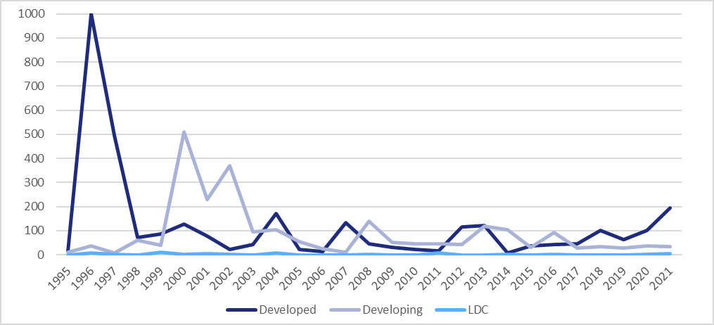

            - Figure 3 shows that, since 2005, the number of Members who have notified a law or regulation under Article 63.2 in any given year has also stabilized, ranging from a low of nine in 2007 to the recent high of 21 in 2020. Although the composition of the group of notifying Members shifts each year, there is a core group of eleven Members, led by Japan, as shown in Figure 4, who have consistently notified new or amended laws or regulations to the Council on a nearly annual or biennial basis.
Figure 3: Number of Members having notified a law or regulation pursuant to Article 63.2, 1995-2021

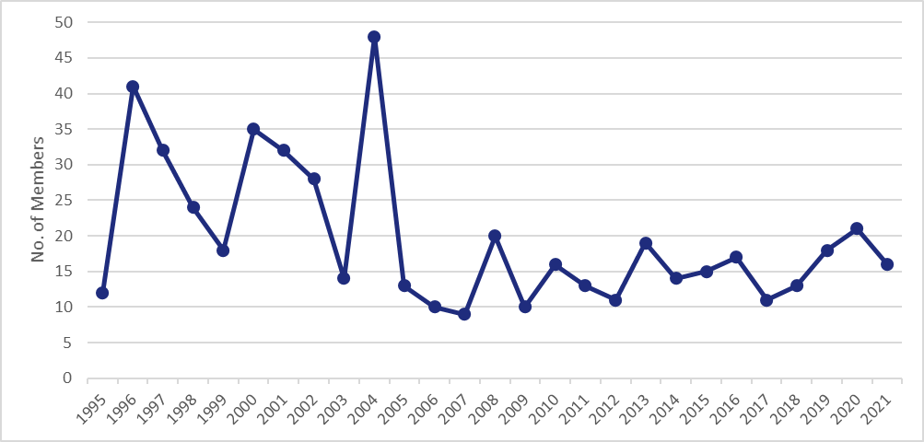

Figure 4: Members having made the most annual notifications of one or more laws or regulations pursuant to Article 63.2, 2005-2021 (number of years)
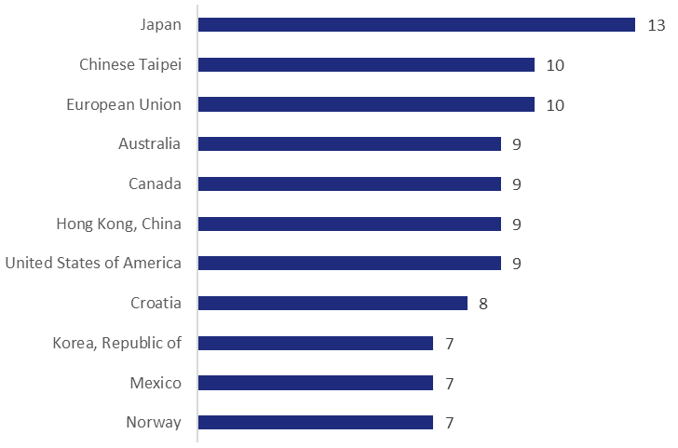

            - Figure 5 offers a snapshot of Members' notifications of laws and regulations over time, by development status. Despite the extended Article 66.1 LDC transition periods, 31% of LDC Members have notified a law or regulation since 1995. Unsurprisingly, 100% of developed country Members and nearly 100% of developing countries have notified a law or regulation since their transition periods ended in 1996 and 2000, respectively. Although WTO Trade Policy Reviews have shown that Members' IP systems have evolved considerably since then, far fewer Members have kept the Council apprised of changes to their laws and regulations. 44% of developed country Members and 40% of developing countries have not made a notification in the past 15 years.
Figure 5: Percentage of Members having submitted one or more notifications of a law or regulation pursuant to Article 63.2, and cumulative number of notifications, during specified periods, by development status
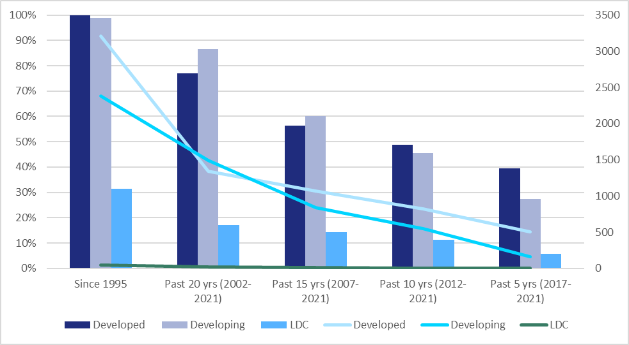

            - Since 2005, 85 Members (52%) have submitted a total of 2,038 notifications. It provides a rough snapshot of the rate at which Members have updated their initial pre-2005 notifications of laws and regulations. It does not, however, adjust for the following factors: (1) initial notifications made by developing countries who acceded since 2005, which have had a positive effect on engagement for the Commonwealth of Independent States, Oceania, Other Europe, and the Middle East during this period; (2) the number of Members subject to Article 63.2 in a region, which influences the absolute number of notifications made, and thus the size of a region's bubble; and (3) the proportion of LDC Members in a region, which has a downward effect on the percentage of Members having submitted a notification, particularly in Africa. The notifications of an individual Member can also heavily influence a region's total number of notifications and average number of notifications, and thus the size of a region's bubble and its position along the Y-axis. Precise information regarding individual Members' notifications of laws and regulations is available in Table A.1 of the Annex to this document.
            - Figure 6 graphically presents the number of submissions, Members' relative participation, and the average number of notifications per notifying Member, by region. It provides a rough snapshot of the rate at which Members have updated their initial pre-2005 notifications of laws and regulations. It does not, however, adjust for the following factors: (1) initial notifications made by developing countries who acceded since 2005, which have had a positive effect on engagement for the Commonwealth of Independent States, Oceania, Other Europe, and the Middle East during this period; (2) the number of Members subject to Article 63.2 in a region, which influences the absolute number of notifications made, and thus the size of a region's bubble; and (3) the proportion of LDC Members in a region, which has a downward effect on the percentage of Members having submitted a notification, particularly in Africa. The notifications of an individual Member can also heavily influence a region's total number of notifications and average number of notifications, and thus the size of a region's bubble and its position along the Y-axis. Precise information regarding individual Members' notifications of laws and regulations is available in Table A.1 of the Annex to this document.
Figure 6: Notifications of laws and regulations pursuant to Article 63.2 by region, 2005-2021
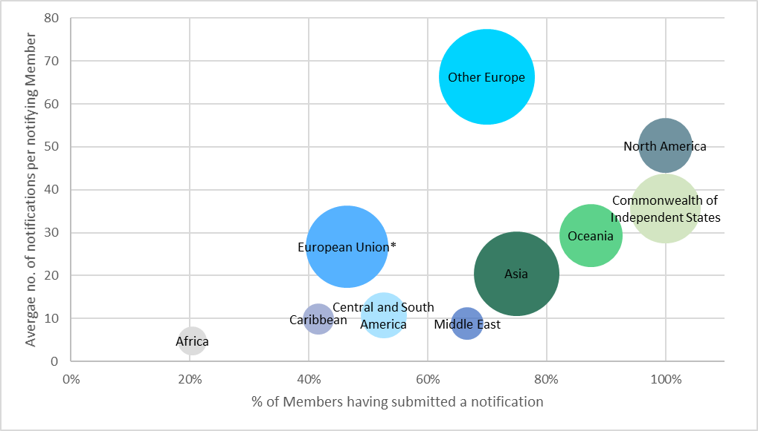

Note: The size of each bubble reflects the number of notifications received.
* Counting the European Union and each of its Member States individually, and attributing the notifications of each only to the submitter.

            - Certain trends nevertheless emerge from Figure 6. It is evident that the three-Member region of North America has significantly contributed to the notifications that have been submitted to the Council since 2005. All three Members have submitted an average of 50 notifications each since 2005. Members in the Caribbean and Central and South America, as well as most Member States of the European Union, have, conversely, been less active in updating their initial notifications. European Members outside of the European Union ("Other Europe") have submitted the most notifications overall and have the highest average number of notifications per Member – statistics that were heavily influenced by the 226 notifications submitted by the United Kingdom from 2020 to 2021. The relatively low level of notifications from Africa may be partly attributed to the greater number of LDCs in that region, which are not subject to notification obligations.
            - It is also possible to map notified laws and regulations by IP subject matter. Figure 7 shows the number of notifications falling into ten different IP subject areas. Some laws and regulations pertain to multiple subjects, and thus were counted more than once. Overall, 25% of notified laws and regulations relate to patents (including plant varieties), 23% to copyright and related rights, 16% to trademarks, 16% to enforcement, 12% to geographical indications, and 10% or fewer to each of the following: industrial designs, undisclosed information, industrial property (general), and layout-designs (topographies) of integrated circuits. 11% of notified laws and regulations relate to other subjects.
Figure 7: Notifications of laws and regulations pursuant to Article 63.2 by subject matter, 1995-2021

            - The annual rate at which notifications were made by subject matter generally track the rate at which notifications were made overall, although a few subject-specific trends are discernible in Figure 8. When developed country Members made their initial notifications of laws and regulations from 1995 to 1997, the greatest number of notified laws related to patents. In 2000, upon the expiration of the transition period for developing countries, more notified laws related to copyright than to patents. Developing countries also notified fewer laws pertaining to geographical indications than were notified by developed country Members from 1995 to 1997.
            - Since a more stable lower-level rate of notifications began in 2005, individual Members have generated visible peaks in certain subject area notifications. A spike in patent law notifications in 2008 is primarily attributable to the accession of Ukraine. A jump in notifications related to undisclosed information in 2018 reflects an initiative by the United States to notify State legislation on the topic. And an increase in industrial design and trademark notifications in 2020, and patent copyright, and enforcement notifications in 2021, resulted from the United Kingdom's efforts to bring their notifications up to date by notifying historical and current legislation on these matters.
Figure 8: Notifications of laws and regulations pursuant to Article 63.2 by subject matter and year, 1995-2021
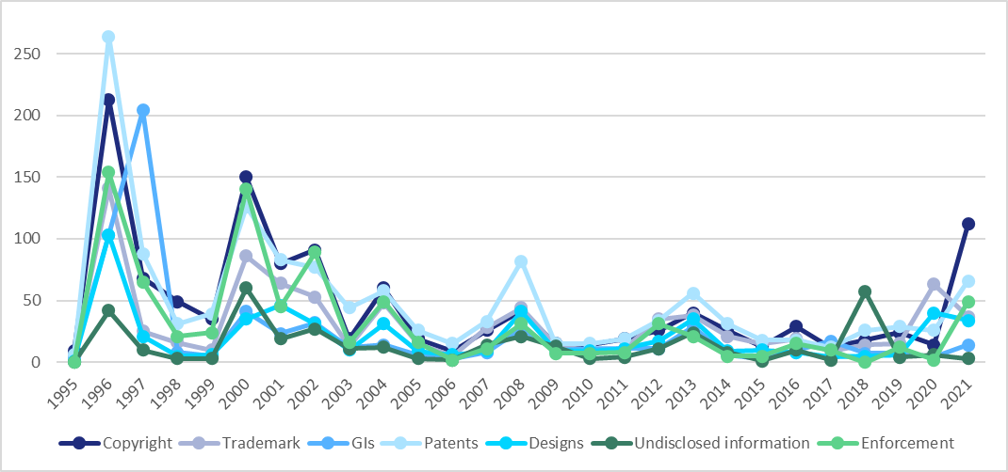

Year in review: 2021
            - In 2021, 16 Members (10%) notified 233 laws and regulations pursuant to Article 63.2. This is the second largest number of notifications of this type received in a single year since 2004, and only five fewer than were received in 2013 (see Figure 1). Compared to 2020, the number of notifications submitted in 2021 increased by over 70%, but were made by 24% fewer Members. The United Kingdom submitted 150 (64%) of 2021 notifications as part of its effort, begun in 2020, to update the Council on its current and historical legislation. Also among the notifications received in 2021 were the first three laws and regulations submitted by the Central African Republic, an LDC Member. Figure 9 plots each Member having notified in 2021 on a map, while Figure 10 groups notifying Members by region. Figure 11 shows the number of notifications made per 2021 notifying Member.
Figure 9: World map identifying Members having notified a law or regulation pursuant to Article 63.2 in 2021
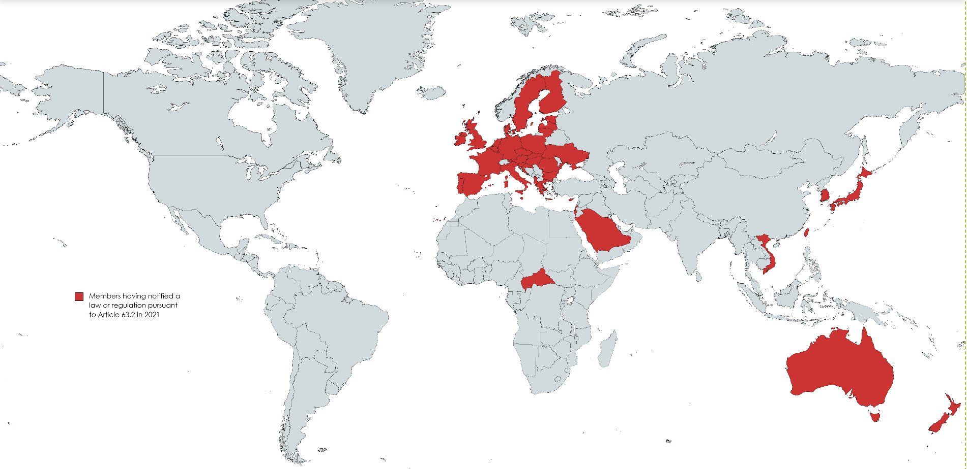
Note: Created using MapChart.net under Creative Commons Attribution-Share Alike 4.0 International licence.

Figure 10: Members having notified a law or regulation pursuant to Article 63.2 in 2021, by region
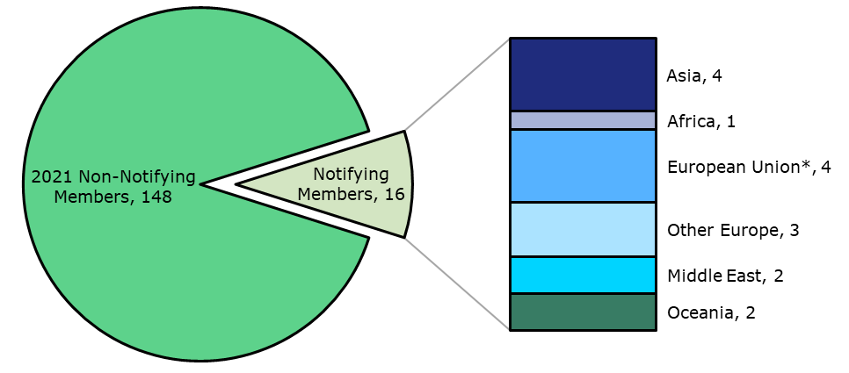
* Counting the European Union as one and each notifying Member State individually.

Figure 11: Notifications of laws and regulations pursuant to Article 63.2 in 2021, by Member
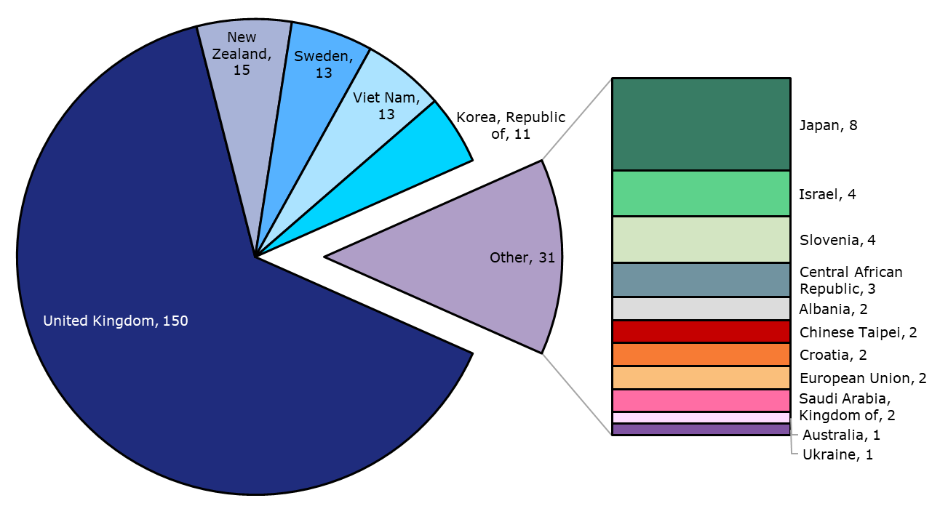
            - As shown in Figure 9 and Figure 10, most Members having notified a law or regulation in 2021 came from the European continent (7), followed by Asia (4). The United Kingdom alone submitted 64% of the notified laws and regulations, followed by New Zealand (6%), Sweden (6%), Viet Nam (6%), and the Republic of Korea (5%) (see Figure 11).
            - The most frequently notified subject areas in 2021 logically track those of the United Kingdom's notifications, which, in addition to current legislation, included historical legislation pertaining to copyright, patents, and IP enforcement (see Figure 12). Consequently 48% of the legislation notified in 2021 related to copyright, 28% to patents, and 21% to enforcement. 16% of the notified laws and regulations addressed trademarks, 15% industrial designs, and 6% geographical indications. 5% or fewer related to each of the following subject areas: industrial property (general), layout-designs (topographies) of integrated circuits, and undisclosed information.
Figure 12: Notifications of laws and regulations pursuant to Article 63.2 in 2021, by subject matter
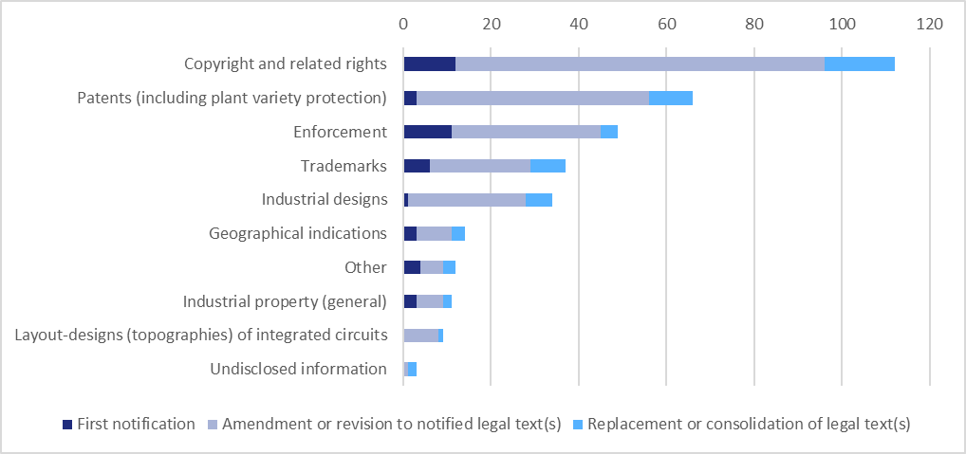

            - The allocation of notifications by subject area is more homogenous if the United Kingdom's notifications are temporarily excluded (see Table 1 below). Although the majority of the remaining 83 notifications also relate to copyright and patents, the proportion that pertain to trademarks, geographical indications, and industrial property (general) increases by about 10% each, while the proportion relating to copyright drops by 20% and enforcement by 8%.
Table 1: Notifications of laws and regulations pursuant to Article 63.2 in 2021, by subject matter
Subject matter | All notifications | All notifications (except UK)
Copyright and related rights | 48% | 28%
Patents (including plant variety protection) | 28% | 24%
Enforcement | 21% | 13%
Trademarks | 16% | 25%
Industrial designs | 15% | 18%
Geographical indications | 6% | 17%
Other | 5% | 4%
Industrial property (general) | 5% | 17%
Layout-designs (topographies) of integrated circuits | 4% | 6%
Undisclosed information | 1% | 4%

Responses to the checklist on enforcement
            - Members determined that notifying laws and regulations may not, alone, ensure full transparency as to how Members have given effect to the detailed enforcement provisions in Part III of the TRIPS Agreement. For example, Members with a common law tradition may not codify this area of law, but rely upon case law to guide their practices. Consequently, the Council adopted a "Checklist of Issues on Enforcement", which Members must respond to in addition to submitting texts of laws and regulations. Responses are to be submitted by each Member with their initial notifications of laws and regulations under Article 63.2, and should be subsequently updated or revised as needed. LDC Members availing themselves of the transition period under Article 66.1 are not yet obliged to respond to the checklist on enforcement.
Figure 13: Responses to the checklist on enforcement, 1996-2021
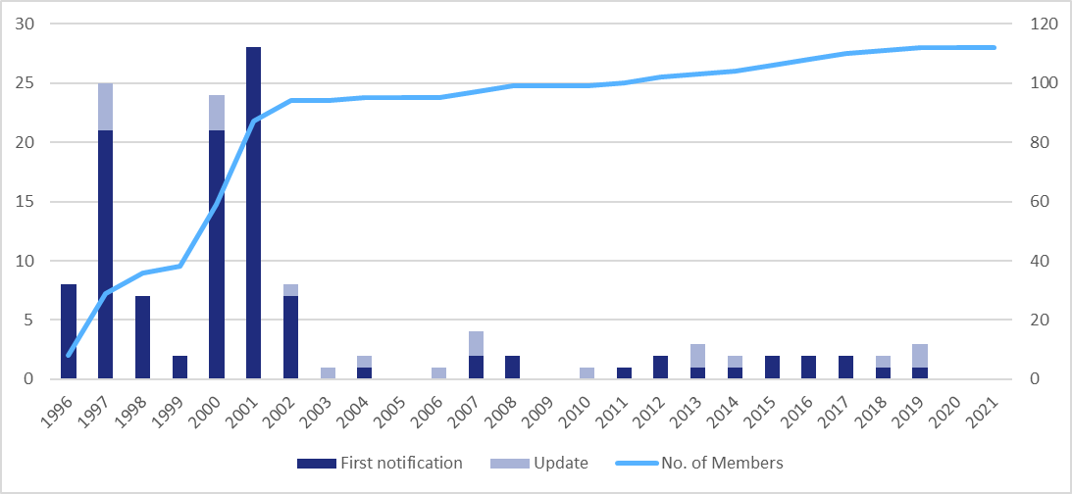

            - Figure 13 illustrates the pattern of responses to the checklist on enforcement. It shows an initial spike in first notifications by developed country Members from 1996 to 1997, and by developing countries from 2000 to 2002. Since then, some additional initial notifications have been received, mostly by acceding Members, and increasingly, by Members amending and updating earlier responses.
            - 112 Members, comprising 100% of developed country Members and 81% of developing countries, have submitted responses to the checklist on enforcement. Among them, 16 have updated their initial responses. 77% of Members who have submitted responses have not updated them since 2002. The most recent updates were received from the European Union and Kazakhstan in 2019. No new or updated responses were received in 2020 or 2021. An overview of responses by Member is available in Table A.2 of the Annex to this document.

NOTIFICATIONS OF CONTACT POINTS UNDER ARTICLE 69
            - Article 69 of the TRIPS Agreement provides that Members agree to cooperate with each other with a view to eliminating international trade in goods infringing IP rights and that, for this purpose, they shall establish and notify contact points in their administrations and be ready to exchange information on trade in infringing goods. The Council agreed in 1995 to invite each Member to notify information relating to their contact points, initially by 1 January 1996, with subsequent changes to the information to be notified promptly.
Figure 14: Percentage of Members having notified a contact point under Article 69, by development status
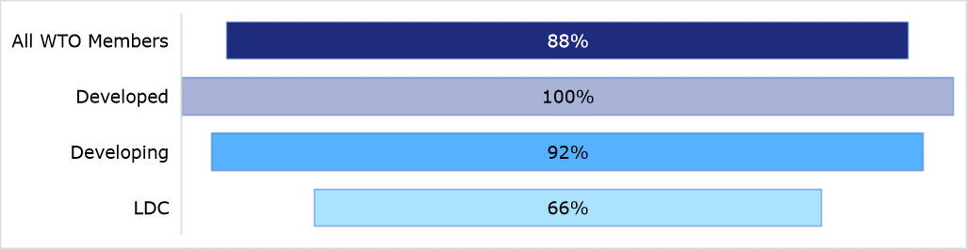

            - Since 1995, 145 (88%) of all WTO Members have notified a contact point under Article 69. An overview of notifications by Member is available in Table A.3 of the Annex to this document. Figure 14 identifies the percentage of Members having notified a contact point, by development status. Although LDC Members availing themselves of the Article 66.1 transition period are not yet obliged to notify an enforcement contact point, 66% have done so.
            - As shown in Figure 15, 58% of Members' enforcement contact points were notified over eleven years ago and have not been updated since. 31% of Members made their initial notification or updated a previous notification in the past eleven years.
Figure 15: Date of Members' most recent contact point notifications under Article 69
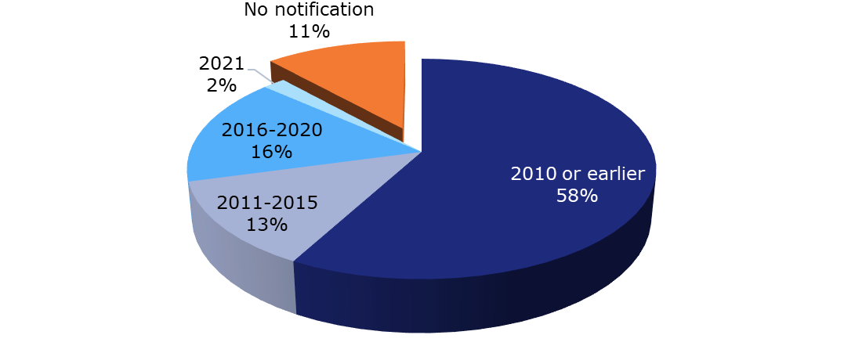
            - In 2021, three Members notified updated enforcement contact points under Article 69: Tonga, the United Kingdom, and Uruguay.

AD HOC NOTIFICATIONS FROM MEMBERS AVAILING THEMSELVES OF CERTAIN OPTIONS UNDER THE TRIPS AGREEMENT
            - Members wishing to avail themselves of certain possibilities in the Agreement that relate to substantive rights and obligations or contain various flexibilities must notify the Council. This section summarizes these possibilities and the related notifications received through 2021.

Articles 1.3 and 3.1
            - Article 1.3 of the TRIPS Agreement defines the persons that must be eligible for the protection to be made available by Members. It refers to the criteria for eligibility as laid down in the Paris Convention, the Berne Convention, the Rome Convention and the Washington Treaty for the relevant areas of IP. Certain exceptions to these criteria are allowed on the condition that they are notified to the TRIPS Council, regardless of whether they have been separately notified under the Berne Convention or the Rome Convention.
            - Article 3.1 of the Agreement requires national treatment to be given to persons eligible for protection under Article 1.3, subject to the exceptions allowed under the Conventions and Treaty mentioned above. Equally as under Article 1.3, certain exceptions under Article 3.1 are allowed on the condition that they are notified to the TRIPS Council.
            - Notification under Articles 1.3 and 3.1 is only required if a Member wishes to avail itself of one of the exceptions. Details regarding the 32 notifications received thus far under these provisions are available in Table A.4 of the Annex to this document. All of them pre-date 2004, with the exception of a notification from the Russian Federation, received in 2012, the year of its accession to the WTO.

Article 4(d)
            - Article 4 requires Members to provide most-favoured-nation treatment to foreign IP right holders eligible for protection under Article 1.3. Article 4(d) permits an exception where the advantage in question derives from an international agreement related to the protection of IP which entered into force prior to the entry into force of the WTO Agreement (1 January 1995). Members wishing to avail themselves of this exception must notify the agreement in question to the TRIPS Council. 33 Members have made notifications under this provision, all between 1996 and 1998. See Table A.5 in the Annex to this document for details.

Other notification requirements under the Berne Convention and the Rome Convention incorporated by reference into the TRIPS Agreement
            - A number of notification provisions of the Berne and the Rome Conventions are incorporated by reference into the TRIPS Agreement. They include:
- Berne Convention, Articles 14bis(2)(c) and 14bis(3): Members must notify the Council in certain circumstances where copyright-owning contributing authors and directors of films are not presumed under domestic law to have consented to particular exploitations of their work.
- Berne Convention, Article 15(4): Members must notify the Council if they have designated a competent authority to protect the interests of anonymous authors of unpublished works (i.e. folklore) presumed to have been created by a national of the notifying Member.
- Berne Convention, Appendix Articles I, II(3)(b), IV(2), IV(4)(c)(iv), and V: Developing countries availing themselves of the option to issue a compulsory licence for a copyrighted work in certain circumstances must notify the Council.
- Rome Convention, Article 17: Members wishing to avail themselves of this exception to protection for producers of phonograms must notify the Council.
- Rome Convention, Article 18: Members having notified certain exceptions under the Rome Convention must further notify the withdrawal or modification of such exceptions.
            - A notification under any of these provisions is only required if a Member chooses to avail itself of the option described in the indicated article. Through the end of 2021, five notifications from three Members have been received, all prior to 2000. See Table A.6 in the Annex to this document for details.

NOTIFICATION REQUIREMENTS FOR MEMBERS MAKING USE OF THE ADDITIONAL FLEXIBILITIES RELATING TO TRIPS AND PUBLIC HEALTH
            - Paragraph 6 of the 2001 Doha Declaration on the TRIPS Agreement and Public Health recognized that Members with insufficient or no manufacturing capacities in the pharmaceutical sector could face difficulties in making effective use of compulsory licensing. Article 31(f) requires production under a compulsory licence to be "predominantly for the supply of the domestic market", thus limiting the potential supply of patented medicines produced under a compulsory licence for export to importing countries in need.
            - In response, the 2003 General Council Decision on the Implementation of Paragraph 6 of the Doha Declaration on the TRIPS Agreement and Public Health (2003 Decision) waived under certain conditions (i) the obligation of exporting Members to ensure that compulsory licences are granted predominantly to supply the domestic market (Article 31(f)) and (ii) the obligation of importing Members to pay adequate remuneration to the right holder if a compulsory licence is granted (Article 31(h)). In 2017, the 2005 Protocol Amending the TRIPS Agreement (2005 Protocol) entered into force and permanently incorporated the mechanism established under the 2003 Decision into the TRIPS Agreement through a new Article 31bis and Annex to the Agreement. The amended Agreement applies to those Members who have accepted the 2005 Protocol and will apply to observer governments which accede to the WTO. Other Members may continue to rely upon the 2003 Decision.
            - This "special compulsory licensing system", established by the 2003 Decision and incorporated into the amended TRIPS Agreement, obliges Members wishing to avail themselves of the derogations to Articles 31(f) and 31(h) to notify the TRIPS Council as follows:
- An importing Member, unless it is an LDC, must notify its general intent to use the system. This notification need only be made once and can be made at any time, together with a first notification of specific needs (see bullet below).
- Each time an importing Member wishes to use the System, it must inform the Council of:
  - the names and expected quantities of the needed product(s);
  - its insufficient, or lack of, manufacturing capacity and how this has been established (unless the Member is an LDC);
  - the grant, or impending grant, of a compulsory licence (if the product is patented in its territory).
- An exporting Member responding to a specific importing notification must inform the Council of its grant of a compulsory licence, the details and conditions attached to it, and the address of a website where information regarding the quantities being shipped, their destination, and distinguishing features of the product will be posted prior to shipment.
            - These notifications are required for transparency purposes. Permission from the Council or any WTO body is not required to use the System. Additional information regarding these notifications, including model notifications, is available on the WTO website.
            - In 2021, three notifications were submitted under the special compulsory licensing system. The Plurinational State of Bolivia and Antigua and Barbuda separately notified their general intent to use the System as an importer. The Plurinational State of Bolivia subsequently notified its specific need to import 15 million doses of a COVID-19 vaccine. These notifications were the first of their kind made to the TRIPS Council since 2007, when Rwanda notified its specific need to import an HIV/AIDS drug and Canada submitted a related notification as an exporting Member. Details regarding these notifications received under the special compulsory licensing system through the end of 2021 are available in Table A.7 of the Annex to this document.

REPORTING REQUIREMENTS FOR DEVELOPED MEMBERS AGREED TO BY THE TRIPS COUNCIL IN THE CONTEXT OF ARTICLES 66.2 AND 67

Reports under Article 66.2
            - Article 66.2 of the TRIPS Agreement requires developed country Members to provide incentives to enterprises and institutions in their territories for the purpose of promoting and encouraging technology transfer to LDC Members in order to enable them to create a sound and viable technological base. Pursuant to a 2003 TRIPS Council decision giving effect to a direction by the Ministerial Conference, developed country Members are to submit annual reports on actions taken or planned in pursuance of their commitments under Article 66.2. Detailed reports are to be submitted every third year, and updates each intervening year.
            - Figure 16 identifies the annual number of Members having reported programmes under Article 66.2 since the Council's 2003 decision. Annual participation has fluctuated from 14 to 21, with an average of 17 Members reporting activities each year.
            - Figure 17 presents the number of annual reports submitted by each developed country Member from 2003 to 2021. Canada, the European Union, Japan, Norway, Switzerland and the United States have consistently submitted a report each year, and Finland, New Zealand and Sweden have reported activities in all but one year. Additional information regarding the reporting history of each developed country Member under Article 66.2 is available in Table A.8 of the Annex to this document.
Figure 16: Number of Members having reported on programmes under Article 66.2, 2003-2021,
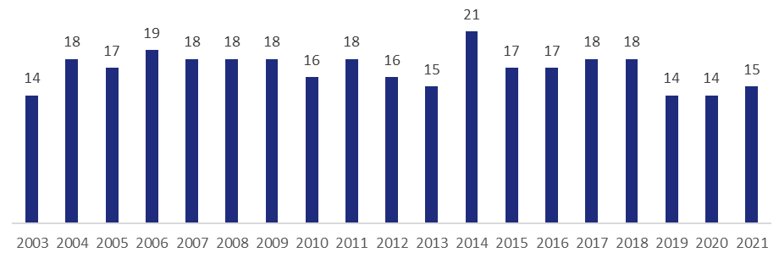
Figure 17: Reports under Article 66.2 submitted by developed country Members, 2003-2021
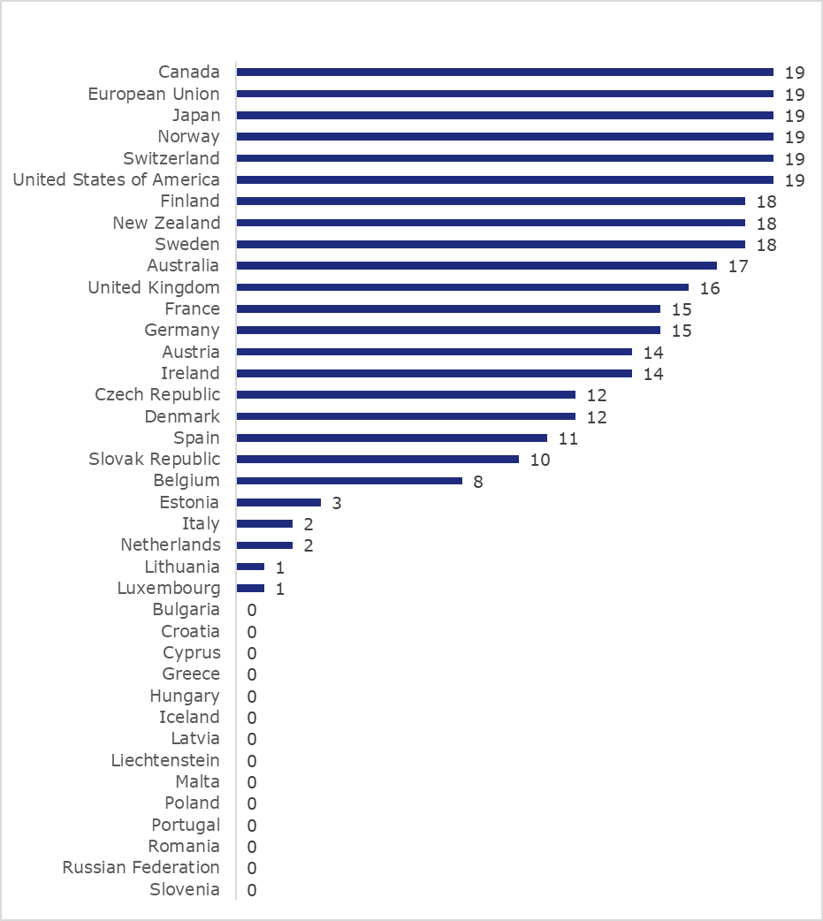
            - During the 2021 reporting cycle, 15 developed country Members reported programmes under Article 66.2, one more than the prior year (see Table 2).
Table 2: Members having reported on programmes under Article 66.2 during the 2021 reporting cycle
Australia | European Union | Japan | Switzerland
Austria* | Finland* | Norway | United Kingdom
Canada | Germany* | Spain* | United States
Czech Republic* | Ireland* | Sweden*
* Provided a distinct identifiable contribution to the report of the European Union.

Reports under Article 67
            - Article 67 of the TRIPS Agreement requires developed country Members to provide, on request and on mutually agreed terms and conditions, technical and financial cooperation in favour of developing and LDC Members. Developed country Members have agreed to present descriptions of their relevant programmes and to update them annually, in order to make the information accessible and facilitate compliance monitoring. Other Members engaging in relevant activities are also encouraged to report them to the Council. For the sake of transparency, a number of intergovernmental organizations (IGOs) have also presented, on the invitation of the Council, information on their activities.
            - Figure 18 identifies the annual rate at which Members and IGOs have submitted reports since 1995. Annual participation by Members has fluctuated from 13 to 28, with an average of 18.2 reports submitted per year. On two occasions, a developing Member has reported on its technical and financial cooperation activities (Morocco in 2001, Hong Kong, China in 2002, and Mexico in 2016).
Figure 18: Number of Members and IGOs having reported on activities under Article 67, 1995-2021,
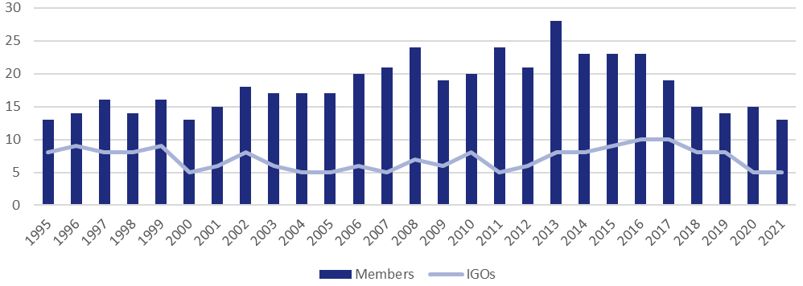
            - Figure 19 presents the number of annual reports submitted by each developed country Member from 1995 to 2021. The European Union, Germany, Japan and the United States have consistently submitted a report each year, and Spain, Switzerland and the United Kingdom submitted reports in all but one year. An overview of the reporting history under Article 67 of developed country Members is available in Table A.8 of the Annex to this document.
Figure 19: Reports under Article 67 submitted by developed country Members, 1995-2021
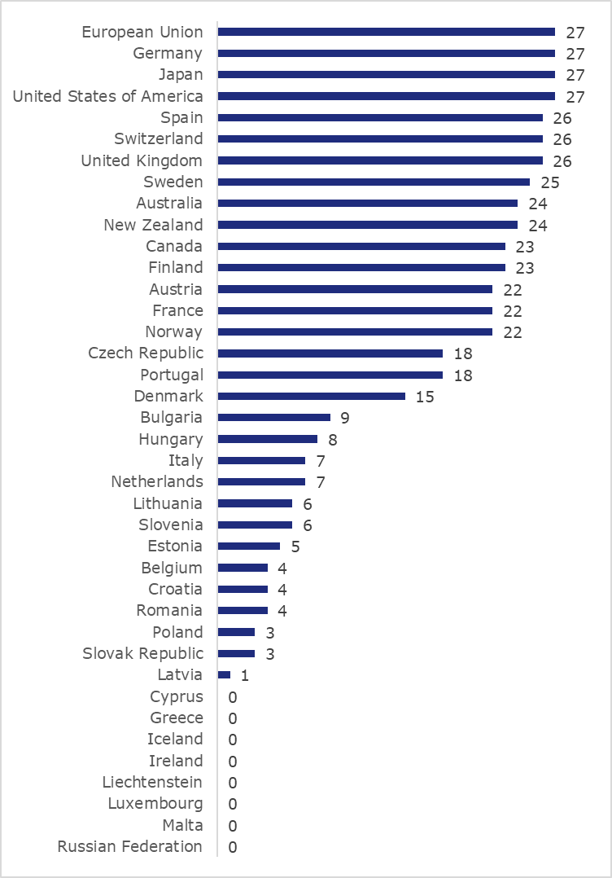

            - During the 2021 reporting cycle, 13 reports were submitted to the Council by developed country Members, two fewer than in 2020, and five by IGOs, the same number as in 2020 (see Table 3).
Table 3: Members and IGOs having reported on activities under Article 67 in 2021
Members | Intergovernmental Organizations
Australia | Cooperation Council for the Arab States of the Gulf
Canada | United Nations Conference on Trade and Development
European Union | World Health Organization
France* | World Intellectual Property Organization
Germany* | World Trade Organization
Japan
Lithuania*
Norway
Spain*
Sweden*
Switzerland
United Kingdom
United States
* Provided a distinct identifiable contribution to the report of the European Union.

Contact points for technical cooperation under Article 67
            - The TRIPS Council agreed in 1996 that each developed country Member should notify a contact point for technical cooperation on TRIPS, in particular to facilitate the exchange of information between donors and recipients of technical assistance. Developed country Members were invited to notify contact points at the same time that they update information on their technical cooperation activities.
            - 32 Members had notified contact points through the end of 2021, including 72% of developed country Members and four other Members (Chile; Hong Kong, China; the Republic of Korea; and Macao, China). An overview of contact points submitted by individual Members is available in Table A.3 of the Annex to this document.
            - As shown in Figure 20, 54% of the contact points for technical cooperation submitted by developed country Members predate 2010. Until 2021, when the United Kingdom updated its contact point, the most recent update by a developed country Member had been submitted in 2014 (by Japan). Macao, China also updated its contact point for technical cooperation in 2021.
Figure 20: Date of developed country Members' most recent submission of contact points for technical cooperation
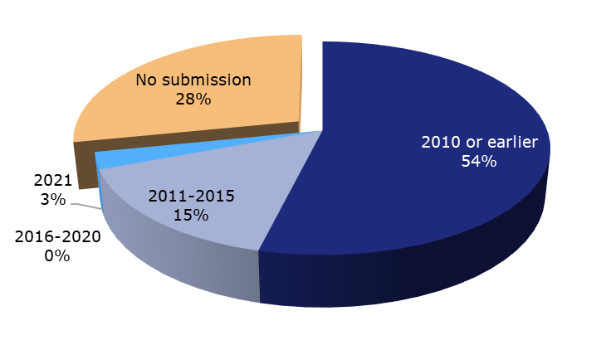

CERTAIN OTHER INFORMATION FLOWS

Responses provided in the context of the review of the provisions of the Section on geographical indications under Article 24.2
            - Article 24.2 of the Agreement requires the TRIPS Council to review the provisions on geographical indications (GIs) in Section 3, Part II of the Agreement. In the context of this review, the Council invited Members under an obligation to apply the provisions of that Section to provide information on their national systems on GI protection by responding to a checklist of questions. Council chairs have regularly invited Members to update responses where appropriate.
            - 52 Members, comprising 35 developed country Members and 18 developing countries, have submitted responses to the checklist. 26 of the responses date back to 2004 or earlier, despite indications from WTO Trade Policy Reviews and Members' notifications of laws and regulations under Article 63.2 that Members' systems of GI protection have evolved considerably in the past 15 years. Since 2016, six Members have submitted initial or updated responses to the checklist: El Salvador, Switzerland, Mexico, Ukraine, Montenegro, and Norway. No new or updated responses were submitted in 2020 or 2021.
            - Figure 21 presents the responses received through 2021. An overview of responses by Member is available in Table A.9 of the Annex to this document.
Figure 21: Responses provided in the context of the review of the provisions of the Section on geographical indications under Article 24.2, 1998-2021
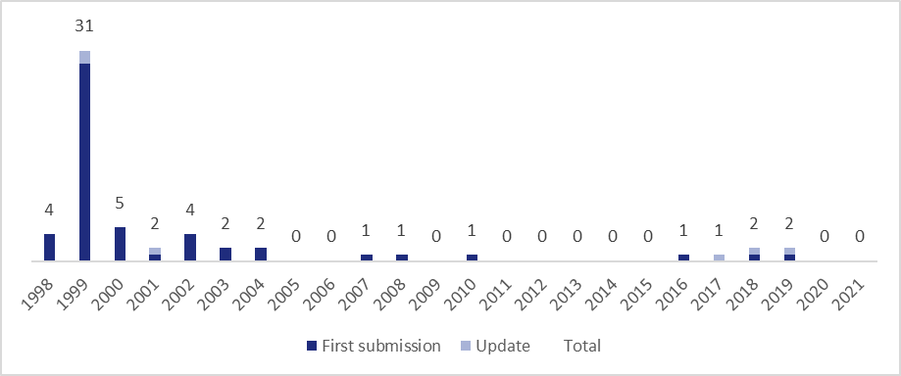

Responses provided in the context of the review of the provisions of Article 27.3(b)
            - The TRIPS Agreement requires Members to review Article 27.3(b), which relates to how Members protect biotechnology inventions and plant varieties. As part of this review, the TRIPS Council invited Members under an obligation to apply Article 27.3(b) to provide information on their domestic frameworks for protecting biotechnology inventions and new plant varieties. At the request of the Council, the Secretariat prepared an illustrative list of questions, and the delegations of Canada, the European Union, Japan and the United States also proposed a list of questions to assist Members in preparing their contributions.
            - Figure 22 presents the responses received through 2021. 28 Members, comprising 18 developed country Members, nine developing countries, and one LDC, have submitted responses to either or both of the lists of questions. Mexico and Ukraine submitted responses in 2019, breaking a 14-year drought during which no submissions were made. Saudi Arabia submitted its first responses in 2021. The remainder of Members' responses date to 2004 or earlier. An overview of responses by Member is available in Table A.9 of the Annex to this document.
Figure 22: Responses in the context of the review of the provisions of Article 27.3(b), 1999-2021
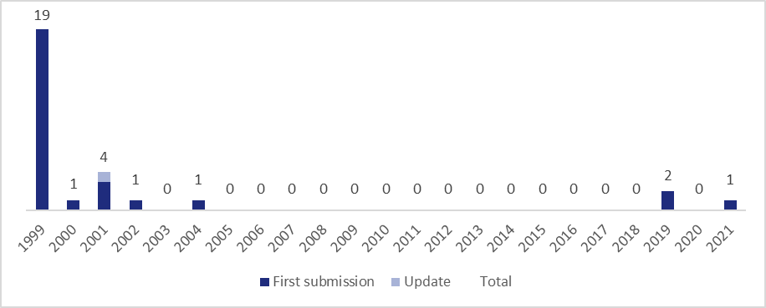

Annex
The tables below provide Member-specific information relating to each of the transparency mechanisms discussed in this report.

Table A.1: Notifications of laws and regulations pursuant to Article 63.2 by Member, identifying the most recent (Latest) and total count (No.) of notifications received, 1995-2021
Member | Copyright and related rights |  | Patents (including plant variety protection) |  | Industrial designs |  | Trademarks |  | Geographical indications |  | Enforcement |  | Industrial property (general) |  | Layout-designs (topographies) of integrated circuits |  | Undisclosed information |  | Other |  | Total
 | Latest | No. | Latest | No. | Latest | No. | Latest | No. | Latest | No. | Latest | No. | Latest | No. | Latest | No. | Latest | No. | Latest | No. | Latest | No.
Afghanistan |  | 0 |  | 0 |  | 0 |  | 0 |  | 0 |  | 0 |  | 0 |  | 0 |  | 0 |  | 0 |  | 0
Albania | 2021 | 13 | 2010 | 14 | 2010 | 7 | 2010 | 9 | 2010 | 5 | 2002 | 8 | 2002 | 1 | 2002 | 2 | 2002 | 7 | 2005 | 1 | 2021 | 52
Angola |  | 0 |  | 0 |  | 0 |  | 0 |  | 0 |  | 0 |  | 0 |  | 0 |  | 0 |  | 0 |  | 0
Antigua and Barbuda | 2002 | 2 | 2002 | 1 | 2002 | 1 | 2002 | 1 | 2002 | 1 |  | 0 | 2002 | 2 | 2002 | 1 |  | 0 |  | 0 | 2002 | 8
Argentina | 2007 | 18 | 2002 | 23 | 2002 | 10 | 2002 | 23 | 2002 | 13 | 2002 | 6 |  | 0 | 2002 | 4 | 2002 | 11 | 2002 | 3 | 2007 | 79
Armenia | 2008 | 2 | 2008 | 3 |  | 0 | 2008 | 3 | 2008 | 2 |  | 0 |  | 0 | 2003 | 1 | 2003 | 1 | 2003 | 1 | 2008 | 10
Australia | 2019 | 58 | 2020 | 67 | 2021 | 32 | 2020 | 55 | 2019 | 17 | 2019 | 8 | 2018 | 30 | 2007 | 6 | 2007 | 19 | 2018 | 24 | 2021 | 228
Austria | 1996 | 4 | 1999 | 14 | 1996 | 3 | 1996 | 4 |  | 0 | 1997 | 6 |  | 0 | 1996 | 4 | 1997 | 2 | 1996 | 6 | 1999 | 39
Bahrain, Kingdom of | 2014 | 5 | 2014 | 13 | 2014 | 9 | 2014 | 14 | 2014 | 6 | 2004 | 8 |  | 0 | 2014 | 3 | 2014 | 8 | 2014 | 10 | 2014 | 54
Bangladesh | 2008 | 3 |  | 0 |  | 0 |  | 0 |  | 0 |  | 0 |  | 0 |  | 0 |  | 0 |  | 0 | 2008 | 3
Barbados | 2011 | 10 | 2011 | 10 | 2011 | 5 | 2011 | 7 | 2002 | 2 | 2002 | 11 | 2001 | 1 | 2002 | 3 |  | 0 | 2002 | 13 | 2011 | 49
Belgium | 1997 | 8 | 1997 | 13 | 1996 | 11 | 1996 | 9 | 1997 | 11 | 1997 | 11 |  | 0 | 1996 | 1 |  | 0 | 1996 | 1 | 1997 | 60
Belize | 2005 | 3 | 2005 | 8 | 2005 | 4 | 2005 | 5 |  | 0 |  | 0 |  | 0 | 2003 | 3 |  | 0 | 2005 | 2 | 2005 | 23
Benin |  | 0 |  | 0 |  | 0 |  | 0 |  | 0 |  | 0 |  | 0 |  | 0 |  | 0 |  | 0 |  | 0
Bolivia, Plurinational State of | 2001 | 11 | 2001 | 9 | 2001 | 1 | 2001 | 2 | 2001 | 2 |  | 0 | 2001 | 1 |  | 0 |  | 0 | 2001 | 1 | 2001 | 20
Botswana | 2013 | 3 | 2013 | 5 | 2013 | 5 | 2013 | 5 | 2013 | 5 |  | 0 |  | 0 |  | 0 | 2013 | 1 | 2013 | 2 | 2013 | 8
Brazil | 2000 | 4 | 2019 | 14 | 2000 | 2 | 2000 | 2 | 2000 | 2 | 2000 | 18 | 2001 | 1 |  | 0 | 2000 | 1 |  | 0 | 2019 | 40
Brunei Darussalam | 2004 | 2 | 2016 | 5 | 2016 | 5 | 2004 | 3 |  | 0 | 2004 | 1 |  | 0 | 2004 | 1 |  | 0 | 2016 | 1 | 2016 | 17
Bulgaria | 2010 | 11 | 2010 | 8 | 2010 | 3 | 2010 | 5 | 2010 | 3 | 2010 | 8 |  | 0 | 2000 | 1 | 1998 | 1 |  | 0 | 2010 | 34
Burkina Faso | 2004 | 7 |  | 0 |  | 0 |  | 0 |  | 0 |  | 0 |  | 0 |  | 0 |  | 0 |  | 0 | 2004 | 7
Burundi |  | 0 | 2001 | 2 |  | 0 |  | 0 |  | 0 |  | 0 |  | 0 |  | 0 |  | 0 | 2001 | 1 | 2001 | 3
Cabo Verde | 2013 | 2 |  | 0 |  | 0 |  | 0 |  | 0 |  | 0 | 2010 | 1 |  | 0 |  | 0 |  | 0 | 2013 | 2
Cambodia |  | 0 |  | 0 |  | 0 |  | 0 |  | 0 |  | 0 |  | 0 |  | 0 |  | 0 |  | 0 |  | 0
Cameroon |  | 0 |  | 0 |  | 0 |  | 0 |  | 0 |  | 0 |  | 0 |  | 0 |  | 0 |  | 0 |  | 0
Canada | 2019 | 18 | 2020 | 27 | 2019 | 6 | 2019 | 12 | 2018 | 5 | 2008 | 3 |  | 0 | 1997 | 2 | 2008 | 10 | 2017 | 6 | 2020 | 74
Central African Republic |  | 0 |  | 0 |  | 0 | 2021 | 1 | 2021 | 1 |  | 0 | 2021 | 1 |  | 0 |  | 0 |  | 0 | 2021 | 3
Chad |  | 0 |  | 0 |  | 0 |  | 0 |  | 0 |  | 0 |  | 0 |  | 0 |  | 0 | 2000 | 1 | 2000 | 1
Chile | 2009 | 17 | 2009 | 5 |  | 0 | 2009 | 1 | 2009 | 4 | 2009 | 8 | 2009 | 10 | 2009 | 1 | 2009 | 18 | 2009 | 4 | 2009 | 59
China | 2017 | 8 | 2017 | 6 | 2002 | 1 | 2020 | 7 | 2002 | 1 | 2004 | 4 |  | 0 | 2003 | 3 | 2020 | 2 | 2002 | 1 | 2020 | 32
Colombia | 2018 | 12 | 2014 | 10 |  | 0 | 2015 | 4 | 2012 | 1 | 2014 | 4 | 2018 | 6 |  | 0 | 2012 | 2 | 2018 | 1 | 2018 | 34
Congo | 2002 | 2 |  | 0 |  | 0 |  | 0 |  | 0 |  | 0 | 2002 | 2 |  | 0 |  | 0 |  | 0 | 2002 | 3
Costa Rica | 2002 | 5 | 2001 | 1 | 2001 | 1 |  | 0 | 2002 | 1 | 2002 | 5 | 2002 | 5 | 2001 | 1 | 2001 | 1 | 2001 | 2 | 2002 | 19
Côte d'Ivoire | 2001 | 1 |  | 0 |  | 0 |  | 0 |  | 0 |  | 0 |  | 0 |  | 0 |  | 0 |  | 0 | 2001 | 1
Croatia | 2018 | 16 | 2021 | 18 | 2018 | 10 | 2021 | 10 | 2018 | 11 | 2016 | 21 | 2016 | 4 | 2018 | 8 | 2018 | 13 | 2016 | 50 | 2021 | 125
Cuba |  | 0 | 2019 | 9 | 2019 | 2 | 2001 | 2 | 2004 | 2 | 2004 | 5 | 2019 | 4 | 2019 | 2 | 2019 | 1 | 2012 | 1 | 2019 | 26
Cyprus | 2000 | 8 | 2000 | 10 | 2000 | 3 | 2000 | 9 | 2000 | 6 | 2000 | 13 |  | 0 | 2000 | 2 | 2000 | 3 | 2000 | 8 | 2000 | 49
Czech Republic | 2008 | 10 | 2011 | 9 | 2005 | 4 | 2020 | 7 | 2004 | 4 | 2011 | 13 | 2011 | 3 | 2001 | 2 | 2020 | 1 | 1996 | 2 | 2020 | 47
Democratic Republic of the Congo |  | 0 |  | 0 |  | 0 |  | 0 |  | 0 |  | 0 |  | 0 |  | 0 |  | 0 |  | 0 |  | 0
Denmark | 2015 | 7 | 2001 | 44 | 2001 | 5 | 2001 | 12 |  | 0 | 2015 | 10 | 1999 | 2 | 2001 | 5 | 1996 | 2 | 2001 | 13 | 2015 | 82
Djibouti |  | 0 |  | 0 |  | 0 |  | 0 |  | 0 |  | 0 |  | 0 |  | 0 |  | 0 |  | 0 |  | 0
Dominica | 2001 | 1 | 2001 | 2 | 2001 | 1 | 2001 | 1 | 2001 | 1 |  | 0 |  | 0 | 2001 | 1 |  | 0 |  | 0 | 2001 | 7
Dominican Republic | 2002 | 2 |  | 0 |  | 0 |  | 0 |  | 0 |  | 0 | 2002 | 2 |  | 0 |  | 0 | 1996 | 1 | 2002 | 5
Ecuador | 2017 | 16 | 2017 | 10 |  | 0 | 1998 | 2 |  | 0 | 1998 | 3 | 2017 | 7 |  | 0 |  | 0 | 2017 | 11 | 2017 | 43
Egypt |  | 0 |  | 0 |  | 0 |  | 0 |  | 0 |  | 0 | 2004 | 1 |  | 0 |  | 0 | 2000 | 3 | 2004 | 4
El Salvador | 2000 | 8 | 2000 | 1 |  | 0 | 2000 | 2 | 2000 | 1 | 2000 | 5 | 2004 | 11 |  | 0 | 2000 | 1 |  | 0 | 2004 | 20
Estonia | 2004 | 9 | 2004 | 26 | 2000 | 7 | 2004 | 12 | 2004 | 3 | 2004 | 16 | 2000 | 1 | 2000 | 3 | 2000 | 10 | 2004 | 8 | 2004 | 81
Eswatini | 2004 | 3 | 2004 | 2 | 2004 | 1 | 2004 | 1 |  | 0 | 2004 | 1 |  | 0 |  | 0 |  | 0 |  | 0 | 2004 | 7
European Union | 2019 | 20 | 2019 | 17 | 2013 | 5 | 2020 | 25 | 2021 | 29 | 2017 | 9 |  | 0 | 1996 | 8 | 2017 | 7 | 1996 | 4 | 2021 | 114
Fiji | 2016 | 4 | 2016 | 3 |  | 0 | 2016 | 3 |  | 0 |  | 0 |  | 0 |  | 0 |  | 0 |  | 0 | 2016 | 10
Finland | 2019 | 16 | 2019 | 35 | 2018 | 8 | 2019 | 15 | 2018 | 3 | 2019 | 25 | 2019 | 4 | 2018 | 7 | 2019 | 10 | 2019 | 23 | 2019 | 138
France | 1998 | 6 | 1996 | 8 |  | 0 | 1996 | 1 | 1996 | 19 |  | 0 | 1997 | 2 | 1996 | 1 |  | 0 | 1996 | 3 | 1998 | 40
Gabon | 2002 | 1 |  | 0 |  | 0 |  | 0 |  | 0 |  | 0 | 2002 | 1 |  | 0 |  | 0 |  | 0 | 2002 | 1
The Gambia | 2014 | 1 |  | 0 |  | 0 |  | 0 |  | 0 |  | 0 |  | 0 |  | 0 |  | 0 |  | 0 | 2014 | 1
Georgia | 2011 | 10 | 2011 | 12 | 2011 | 7 | 2011 | 8 | 2013 | 7 | 2011 | 8 | 2011 | 1 | 2011 | 4 | 2011 | 4 | 2011 | 4 | 2013 | 42
Germany | 2004 | 14 | 2009 | 25 | 2009 | 10 | 2009 | 15 | 2004 | 1 | 1996 | 12 | 2004 | 8 | 2004 | 11 | 2004 | 6 | 2004 | 8 | 2009 | 87
Ghana | 2002 | 1 | 2002 | 1 | 2002 | 2 | 2002 | 1 |  | 0 | 2002 | 5 |  | 0 |  | 0 | 2002 | 1 |  | 0 | 2002 | 11
Greece | 2017 | 15 | 2017 | 33 | 2017 | 4 | 1996 | 2 | 1997 | 182 | 2017 | 4 |  | 0 | 1996 | 2 |  | 0 | 2017 | 3 | 2017 | 242
Grenada | 2002 | 2 | 2002 | 2 | 2002 | 1 |  | 0 |  | 0 |  | 0 | 2002 | 3 |  | 0 |  | 0 |  | 0 | 2002 | 8
Guatemala | 2004 | 12 | 2000 | 1 |  | 0 | 2000 | 2 |  | 0 | 2000 | 9 | 2004 | 6 |  | 0 | 2000 | 1 | 2004 | 6 | 2004 | 32
Guinea |  | 0 |  | 0 |  | 0 |  | 0 |  | 0 |  | 0 |  | 0 |  | 0 |  | 0 |  | 0 |  | 0
Guinea-Bissau |  | 0 |  | 0 |  | 0 |  | 0 |  | 0 |  | 0 |  | 0 |  | 0 |  | 0 |  | 0 |  | 0
Guyana | 2002 | 2 | 2002 | 1 | 2002 | 1 | 2002 | 1 |  | 0 |  | 0 |  | 0 |  | 0 |  | 0 |  | 0 | 2002 | 4
Haiti | 1999 | 3 | 1999 | 2 | 1999 | 2 | 1999 | 3 | 1999 | 1 |  | 0 | 1999 | 2 |  | 0 |  | 0 |  | 0 | 1999 | 10
Honduras | 2002 | 2 | 2002 | 2 |  | 0 | 2002 | 1 |  | 0 | 2002 | 9 | 2002 | 2 |  | 0 |  | 0 |  | 0 | 2002 | 13
Hong Kong, China | 2020 | 24 | 2020 | 24 | 2017 | 14 | 2020 | 25 | 2004 | 4 | 2000 | 30 | 2020 | 1 | 2017 | 9 | 2000 | 3 | 2000 | 3 | 2020 | 126
Hungary | 2004 | 5 | 2020 | 5 | 1997 | 3 | 2019 | 5 | 2004 | 2 | 1998 | 9 | 1998 | 2 | 1996 | 1 |  | 0 |  | 0 | 2020 | 29
Iceland | 1997 | 22 | 1997 | 12 | 1996 | 5 | 1998 | 11 |  | 0 | 1996 | 7 |  | 0 | 1997 | 2 |  | 0 | 1996 | 11 | 1998 | 65
India | 2001 | 2 | 2005 | 7 | 2001 | 1 | 2003 | 2 | 2003 | 2 |  | 0 |  | 0 | 2003 | 2 |  | 0 |  | 0 | 2005 | 16
Indonesia | 2000 | 20 | 2000 | 15 |  | 0 | 2000 | 6 | 2000 | 1 | 2000 | 7 | 2000 | 1 |  | 0 | 2000 | 1 | 1996 | 1 | 2000 | 50
Ireland | 1999 | 26 | 1999 | 32 | 1996 | 14 | 1996 | 12 | 1996 | 1 | 1996 | 14 |  | 0 | 1996 | 3 | 1996 | 1 |  | 0 | 1999 | 88
Israel | 2013 | 11 | 2021 | 6 | 2021 | 3 | 2021 | 6 | 2000 | 3 |  | 0 | 2000 | 2 | 2000 | 2 |  | 0 |  | 0 | 2021 | 30
Italy | 1997 | 30 | 1997 | 13 | 1997 | 8 | 2020 | 11 | 1997 | 11 | 1997 | 11 | 1997 | 5 | 1996 | 2 | 2020 | 1 | 1997 | 15 | 2020 | 96
Jamaica | 2002 | 2 |  | 0 |  | 0 | 2002 | 1 | 2005 | 2 |  | 0 | 2002 | 1 | 2002 | 1 |  | 0 | 2007 | 3 | 2007 | 10
Japan | 2021 | 10 | 2021 | 35 | 2021 | 22 | 2021 | 23 | 2019 | 7 | 2015 | 52 | 2004 | 4 | 1996 | 2 | 2021 | 14 | 2016 | 80 | 2021 | 171
Jordan | 2004 | 4 | 2013 | 3 | 2000 | 1 | 2001 | 3 | 2000 | 1 | 2004 | 9 |  | 0 | 2000 | 1 | 2000 | 1 | 2001 | 1 | 2013 | 23
Kazakhstan | 2016 | 14 | 2016 | 2 |  | 0 | 2016 | 4 | 2016 | 3 |  | 0 | 2016 | 12 | 2016 | 1 | 2016 | 1 | 2016 | 31 | 2016 | 34
Kenya | 2002 | 2 | 2002 | 4 | 2002 | 2 | 2001 | 1 | 2002 | 1 |  | 0 |  | 0 | 2002 | 1 |  | 0 |  | 0 | 2002 | 9
Korea, Republic of | 2021 | 10 | 2021 | 14 | 2021 | 7 | 2021 | 9 | 2021 | 11 | 2021 | 19 |  | 0 | 2011 | 4 | 2021 | 11 | 2021 | 8 | 2021 | 90
Kuwait, the State of | 2004 | 3 |  | 0 |  | 0 |  | 0 |  | 0 |  | 0 |  | 0 |  | 0 |  | 0 | 1997 | 2 | 2004 | 5
Kyrgyz Republic | 2020 | 31 | 2020 | 34 | 2008 | 7 | 2018 | 19 | 2008 | 9 | 2006 | 12 | 2019 | 6 | 2018 | 10 | 1999 | 1 | 2020 | 12 | 2020 | 106
Lao People's Democratic Republic |  | 0 |  | 0 |  | 0 |  | 0 |  | 0 |  | 0 |  | 0 |  | 0 |  | 0 |  | 0 |  | 0
Latvia | 1999 | 2 | 1999 | 1 | 1999 | 1 | 1999 | 1 |  | 0 | 1999 | 7 | 2004 | 2 | 1999 | 1 |  | 0 | 1999 | 1 | 2004 | 16
Lesotho |  | 0 |  | 0 |  | 0 |  | 0 |  | 0 |  | 0 |  | 0 |  | 0 |  | 0 |  | 0 |  | 0
Liberia |  | 0 |  | 0 |  | 0 |  | 0 |  | 0 |  | 0 |  | 0 |  | 0 |  | 0 |  | 0 |  | 0
Liechtenstein | 2004 | 6 | 1996 | 9 | 1996 | 4 | 1996 | 8 | 1999 | 12 | 1999 | 16 | 1999 | 1 | 1996 | 4 | 1996 | 5 | 1996 | 1 | 2004 | 36
Lithuania | 2001 | 5 | 2003 | 10 | 2001 | 4 | 2001 | 11 | 2001 | 2 | 2001 | 11 | 2001 | 1 | 2001 | 3 |  | 0 |  | 0 | 2003 | 39
Luxembourg | 2004 | 9 | 1998 | 25 | 1997 | 5 | 1997 | 4 |  | 0 |  | 0 |  | 0 | 1997 | 1 |  | 0 | 1997 | 1 | 2004 | 44
Macao, China | 2014 | 7 |  | 0 |  | 0 | 1998 | 3 | 2000 | 2 | 2004 | 11 |  | 0 |  | 0 | 2000 | 2 |  | 0 | 2014 | 19
Madagascar | 2016 | 5 |  | 0 |  | 0 |  | 0 |  | 0 | 2011 | 4 | 2016 | 3 |  | 0 |  | 0 | 2016 | 1 | 2016 | 8
Malawi |  | 0 |  | 0 |  | 0 |  | 0 |  | 0 |  | 0 |  | 0 |  | 0 |  | 0 |  | 0 |  | 0
Malaysia | 2001 | 3 | 2006 | 4 | 2013 | 4 | 2001 | 7 | 2013 | 3 |  | 0 |  | 0 | 2001 | 1 |  | 0 | 2001 | 1 | 2013 | 23
Maldives | 2011 | 1 |  | 0 |  | 0 |  | 0 |  | 0 |  | 0 |  | 0 |  | 0 |  | 0 |  | 0 | 2011 | 1
Mali |  | 0 |  | 0 |  | 0 |  | 0 |  | 0 |  | 0 |  | 0 |  | 0 |  | 0 |  | 0 |  | 0
Malta | 2000 | 1 | 2000 | 3 | 2000 | 1 | 2000 | 3 |  | 0 | 2000 | 1 |  | 0 |  | 0 |  | 0 |  | 0 | 2000 | 7
Mauritania |  | 0 |  | 0 |  | 0 |  | 0 |  | 0 |  | 0 |  | 0 |  | 0 |  | 0 |  | 0 |  | 0
Mauritius | 2019 | 3 | 2008 | 4 | 2008 | 4 | 2008 | 4 | 2003 | 2 | 2008 | 2 | 2003 | 2 | 2003 | 2 |  | 0 |  | 0 | 2019 | 15
Mexico | 2020 | 14 | 2000 | 2 |  | 0 | 2013 | 1 | 2020 | 10 | 2020 | 7 | 2020 | 21 |  | 0 |  | 0 | 2016 | 3 | 2020 | 53
Moldova, Republic of | 2018 | 12 | 2016 | 18 | 2016 | 8 | 2016 | 12 | 2013 | 4 | 2013 | 12 | 2018 | 7 | 2013 | 5 | 2013 | 3 | 2018 | 27 | 2018 | 97
Mongolia | 1998 | 9 | 1998 | 4 |  | 0 | 1998 | 3 |  | 0 | 1998 | 1 | 1998 | 3 |  | 0 | 1998 | 1 | 1998 | 4 | 1998 | 16
Montenegro | 2016 | 2 | 2013 | 2 | 2016 | 3 | 2016 | 4 | 2013 | 3 | 2013 | 1 |  | 0 | 2016 | 2 | 2013 | 1 | 2013 | 10 | 2016 | 28
Morocco | 2008 | 5 | 2003 | 20 | 2008 | 4 | 2008 | 5 | 2008 | 9 | 2008 | 10 | 2008 | 4 | 2008 | 4 | 2008 | 7 | 2008 | 7 | 2008 | 53
Mozambique |  | 0 |  | 0 |  | 0 |  | 0 |  | 0 |  | 0 |  | 0 |  | 0 |  | 0 |  | 0 |  | 0
Myanmar |  | 0 | 2020 | 1 |  | 0 |  | 0 |  | 0 |  | 0 |  | 0 |  | 0 |  | 0 |  | 0 | 2020 | 1
Namibia |  | 0 |  | 0 |  | 0 |  | 0 |  | 0 |  | 0 | 2001 | 1 |  | 0 |  | 0 |  | 0 | 2001 | 1
Nepal |  | 0 |  | 0 |  | 0 |  | 0 |  | 0 |  | 0 |  | 0 |  | 0 |  | 0 |  | 0 |  | 0
Netherlands | 1996 | 19 | 2004 | 6 | 1997 | 5 | 1997 | 6 |  | 0 | 1997 | 8 |  | 0 | 1997 | 2 |  | 0 |  | 0 | 2004 | 46
New Zealand | 2021 | 25 | 2021 | 39 | 2021 | 9 | 2021 | 23 | 2021 | 7 |  | 0 | 2004 | 6 | 2004 | 3 | 1996 | 3 | 2021 | 3 | 2021 | 104
Nicaragua | 2013 | 16 | 2013 | 9 | 2008 | 4 | 2013 | 4 |  | 0 |  | 0 | 2013 | 7 | 2008 | 2 |  | 0 |  | 0 | 2013 | 34
Niger |  | 0 |  | 0 |  | 0 |  | 0 |  | 0 |  | 0 |  | 0 |  | 0 |  | 0 |  | 0 |  | 0
Nigeria | 2001 | 5 | 2001 | 4 | 2001 | 4 | 2001 | 2 |  | 0 |  | 0 |  | 0 |  | 0 |  | 0 | 1996 | 1 | 2001 | 13
North Macedonia | 2016 | 2 |  | 0 |  | 0 |  | 0 |  | 0 | 2016 | 2 | 2016 | 4 | 2003 | 1 |  | 0 |  | 0 | 2016 | 9
Norway | 2004 | 3 | 2019 | 17 | 2019 | 9 | 2019 | 11 | 2015 | 2 | 2015 | 2 | 2019 | 4 | 1996 | 2 |  | 0 | 2015 | 2 | 2019 | 50
Oman | 2011 | 2 | 2011 | 3 | 2001 | 1 | 2011 | 2 | 2011 | 3 |  | 0 |  | 0 | 2001 | 1 | 2011 | 2 |  | 0 | 2011 | 9
Pakistan | 2002 | 2 | 2002 | 2 | 2002 | 2 | 2004 | 2 | 2020 | 1 | 2002 | 5 |  | 0 | 2002 | 1 |  | 0 | 2002 | 1 | 2020 | 15
Panama | 2004 | 4 | 2014 | 4 |  | 0 | 2014 | 1 |  | 0 | 2004 | 5 | 2014 | 6 |  | 0 |  | 0 | 2004 | 4 | 2014 | 23
Papua New Guinea | 2005 | 1 | 2005 | 2 | 2005 | 2 | 2005 | 2 |  | 0 |  | 0 |  | 0 |  | 0 |  | 0 | 1998 | 1 | 2005 | 6
Paraguay | 2000 | 2 | 2000 | 4 |  | 0 | 2000 | 2 |  | 0 |  | 0 |  | 0 |  | 0 |  | 0 | 1995 | 1 | 2000 | 9
Peru | 2015 | 7 | 2010 | 5 |  | 0 |  | 0 |  | 0 | 2010 | 3 | 2010 | 6 |  | 0 | 2010 | 3 | 2010 | 5 | 2015 | 29
Philippines | 2003 | 19 | 2003 | 19 | 2003 | 18 | 2003 | 18 | 2001 | 8 | 2003 | 19 | 2009 | 3 | 2003 | 16 | 2003 | 15 | 2001 | 2 | 2009 | 48
Poland | 1998 | 5 | 1996 | 6 | 1996 | 1 | 1996 | 1 | 1996 | 1 | 2000 | 4 | 2001 | 2 | 1996 | 3 | 2000 | 1 | 2000 | 3 | 2001 | 21
Portugal | 1999 | 20 | 1999 | 8 | 1998 | 2 | 1998 | 2 | 1998 | 2 | 1999 | 9 |  | 0 | 1997 | 1 |  | 0 |  | 0 | 1999 | 38
Qatar | 2002 | 1 | 2002 | 1 | 2002 | 1 | 2002 | 1 | 2002 | 1 |  | 0 |  | 0 | 2006 | 1 | 2006 | 1 | 1999 | 1 | 2006 | 6
Romania | 1998 | 1 | 1999 | 7 | 1999 | 2 | 1999 | 5 | 1998 | 2 | 2004 | 15 |  | 0 | 1999 | 3 |  | 0 | 1998 | 1 | 2004 | 31
Russian Federation | 2015 | 15 | 2012 | 13 | 2012 | 7 | 2012 | 12 | 2019 | 6 | 2015 | 13 |  | 0 | 2012 | 4 | 2012 | 3 | 2015 | 10 | 2019 | 55
Rwanda |  | 0 |  | 0 |  | 0 |  | 0 |  | 0 |  | 0 |  | 0 |  | 0 |  | 0 |  | 0 |  | 0
Saint Kitts and Nevis | 2016 | 1 | 2016 | 1 |  | 0 | 2016 | 1 |  | 0 |  | 0 |  | 0 | 2016 | 1 |  | 0 |  | 0 | 2016 | 4
Saint Lucia | 2001 | 4 | 2004 | 1 | 2004 | 2 | 2004 | 2 | 2004 | 2 | 2004 | 5 |  | 0 | 2004 | 2 | 2001 | 1 |  | 0 | 2004 | 19
Saint Vincent and the Grenadines | 2015 | 3 | 2015 | 2 | 2015 | 3 | 2015 | 5 | 2015 | 2 | 2015 | 3 |  | 0 | 2015 | 2 |  | 0 | 2015 | 2 | 2015 | 21
Samoa |  | 0 |  | 0 |  | 0 |  | 0 |  | 0 |  | 0 | 2019 | 3 |  | 0 |  | 0 |  | 0 | 2019 | 3
Saudi Arabia, Kingdom of | 2021 | 6 | 2006 | 2 | 2006 | 2 | 2006 | 2 | 2006 | 1 | 2021 | 1 |  | 0 | 2006 | 1 | 2006 | 1 | 2021 | 5 | 2021 | 16
Senegal | 1997 | 1 |  | 0 |  | 0 |  | 0 |  | 0 |  | 0 | 1997 | 1 |  | 0 |  | 0 |  | 0 | 1997 | 1
Seychelles | 2016 | 1 | 2016 | 1 | 2016 | 1 | 2016 | 1 | 2016 | 1 | 2016 | 5 |  | 0 | 2016 | 1 | 2016 | 1 | 2016 | 3 | 2016 | 10
Sierra Leone |  | 0 |  | 0 |  | 0 |  | 0 |  | 0 |  | 0 |  | 0 |  | 0 |  | 0 |  | 0 |  | 0
Singapore | 2010 | 18 | 2009 | 9 | 2009 | 3 | 2009 | 9 | 2000 | 1 |  | 0 | 2009 | 2 | 2000 | 1 | 2009 | 3 |  | 0 | 2010 | 45
Slovak Republic | 2011 | 3 | 2011 | 9 | 2011 | 3 | 2011 | 7 | 2011 | 5 | 2011 | 7 | 2011 | 6 | 2011 | 3 |  | 0 | 1996 | 6 | 2011 | 41
Slovenia | 2021 | 7 | 2008 | 7 | 2021 | 8 | 2021 | 7 | 2021 | 3 | 2021 | 12 |  | 0 | 2008 | 4 | 2021 | 4 | 2021 | 1 | 2021 | 35
Solomon Islands |  | 0 |  | 0 |  | 0 |  | 0 |  | 0 |  | 0 |  | 0 |  | 0 |  | 0 |  | 0 |  | 0
South Africa | 2004 | 6 | 2004 | 6 | 2004 | 3 | 2004 | 5 | 2004 | 7 |  | 0 |  | 0 | 1996 | 1 |  | 0 | 1996 | 1 | 2004 | 22
Spain | 2004 | 21 | 2004 | 16 | 2004 | 1 | 2004 | 5 | 1996 | 20 | 2004 | 7 | 2004 | 15 | 1996 | 2 |  | 0 | 2004 | 6 | 2004 | 92
Sri Lanka | 2010 | 3 |  | 0 | 2001 | 1 | 2001 | 1 |  | 0 |  | 0 | 2010 | 2 | 2001 | 1 |  | 0 |  | 0 | 2010 | 4
Suriname |  | 0 | 2001 | 1 | 2001 | 1 | 2001 | 1 |  | 0 |  | 0 |  | 0 |  | 0 |  | 0 |  | 0 | 2001 | 1
Sweden | 2021 | 22 | 2021 | 19 | 2021 | 7 | 2021 | 12 | 1997 | 1 | 1996 | 1 |  | 0 | 2021 | 5 | 1996 | 1 | 2004 | 5 | 2021 | 71
Switzerland | 2017 | 11 | 2017 | 24 | 2017 | 11 | 2017 | 16 | 2017 | 39 | 2017 | 35 | 2003 | 1 | 2017 | 6 | 2013 | 28 | 2017 | 34 | 2017 | 162
Chinese Taipei | 2021 | 33 | 2020 | 31 | 2020 | 2 | 2020 | 17 | 2002 | 4 | 2014 | 14 | 2002 | 1 | 2014 | 5 | 2020 | 3 | 2018 | 5 | 2021 | 108
Tajikistan | 2015 | 1 | 2014 | 1 | 2014 | 1 | 2014 | 1 | 2014 | 1 |  | 0 |  | 0 | 2014 | 1 | 2015 | 1 | 2015 | 2 | 2015 | 9
Tanzania |  | 0 |  | 0 |  | 0 |  | 0 |  | 0 |  | 0 |  | 0 |  | 0 |  | 0 |  | 0 |  | 0
Thailand | 2020 | 4 | 2010 | 12 |  | 0 | 2020 | 3 |  | 0 |  | 0 | 2003 | 1 | 2003 | 1 | 2020 | 3 |  | 0 | 2020 | 24
Togo |  | 0 |  | 0 |  | 0 |  | 0 |  | 0 |  | 0 |  | 0 |  | 0 |  | 0 |  | 0 |  | 0
Tonga | 2009 | 1 | 2009 | 3 | 2009 | 3 | 2009 | 3 | 2009 | 1 | 2009 | 1 |  | 0 | 2009 | 1 | 2009 | 3 | 2009 | 2 | 2009 | 8
Trinidad and Tobago | 2000 | 2 | 2000 | 3 | 2000 | 2 | 2000 | 7 | 2000 | 3 | 2000 | 8 |  | 0 | 2000 | 2 | 2000 | 1 |  | 0 | 2000 | 27
Tunisia | 2010 | 1 | 2004 | 9 | 2003 | 3 | 2008 | 4 | 2008 | 2 | 2003 | 3 |  | 0 | 2003 | 3 |  | 0 |  | 0 | 2010 | 25
Turkey | 2004 | 10 | 2000 | 8 | 2000 | 3 | 2000 | 3 | 2000 | 2 | 2000 | 10 | 2000 | 1 | 2000 | 1 | 2000 | 4 | 2000 | 6 | 2004 | 43
Uganda | 2000 | 2 | 2000 | 4 | 2000 | 2 | 2000 | 2 |  | 0 |  | 0 |  | 0 |  | 0 |  | 0 |  | 0 | 2000 | 7
Ukraine | 2021 | 17 | 2021 | 51 | 2021 | 21 | 2021 | 24 | 2021 | 17 | 2008 | 10 |  | 0 | 2021 | 16 | 2008 | 7 | 2008 | 4 | 2021 | 85
United Arab Emirates | 2004 | 1 | 1997 | 1 |  | 0 |  | 0 |  | 0 |  | 0 |  | 0 |  | 0 |  | 0 |  | 0 | 2004 | 2
United Kingdom | 2021 | 126 | 2021 | 81 | 2021 | 69 | 2021 | 73 | 1996 | 8 | 2021 | 62 |  | 0 | 2021 | 14 | 2004 | 14 |  | 0 | 2021 | 327
United States of America | 2019 | 8 | 2020 | 17 | 2013 | 10 | 2013 | 7 | 2012 | 3 | 2012 | 9 | 2004 | 3 | 1997 | 2 | 2018 | 56 | 1997 | 1 | 2020 | 105
Uruguay | 2004 | 17 | 2012 | 5 |  | 0 | 2012 | 4 |  | 0 | 2012 | 7 | 2015 | 9 |  | 0 | 2002 | 1 | 2012 | 7 | 2015 | 45
Vanuatu | 2014 | 2 | 2014 | 3 | 2014 | 2 | 2014 | 5 | 2014 | 1 |  | 0 |  | 0 | 2014 | 1 | 2014 | 1 | 2014 | 1 | 2014 | 16
Venezuela, Bolivarian Republic of | 2001 | 12 | 2001 | 7 | 2001 | 4 | 2001 | 6 | 2001 | 4 |  | 0 | 2001 | 6 | 2001 | 4 | 2001 | 4 | 2001 | 14 | 2001 | 37
Viet Nam | 2021 | 18 | 2021 | 12 | 2021 | 11 | 2021 | 13 | 2021 | 13 | 2021 | 21 | 2021 | 14 | 2013 | 9 | 2013 | 12 | 2021 | 22 | 2021 | 49
Yemen |  | 0 |  | 0 |  | 0 |  | 0 |  | 0 |  | 0 |  | 0 |  | 0 |  | 0 |  | 0 |  | 0
Zambia |  | 0 |  | 0 |  | 0 |  | 0 |  | 0 |  | 0 |  | 0 |  | 0 |  | 0 |  | 0 |  | 0
Zimbabwe | 2002 | 3 | 2002 | 3 | 2002 | 2 | 2002 | 2 | 2002 | 1 | 2002 | 1 | 2002 | 1 | 2002 | 1 |  | 0 |  | 0 | 2002 | 13

Table A.2: Responses to the checklist on enforcement under Article 63.22
Member | Most recent | Document Symbol
Afghanistan
Albania | 18/04/2001 | IP/N/6/ALB/1
Angola
Antigua and Barbuda | 28/11/2001 | IP/N/6/ATG/1
Argentina | 04/12/2002 | IP/N/6/ARG/1
Armenia | 04/06/2004 | IP/N/6/ARM/1
Australia | 16/09/1997 | IP/N/6/AUS/1
Austria | 13/09/1996 | IP/N/6/AUT/1
Bahrain, Kingdom of | 21/06/2001 | IP/N/6/BHR/1
Bangladesh
Barbados | 06/07/2001 | IP/N/6/BRB/1
Belgium | 30/04/1997 | IP/N/6/BEL/1/Rev.1
Belize | 06/06/2000 | IP/N/6/BLZ/1
Benin
Bolivia, Plurinational State of | 11/04/2001 | IP/N/6/BOL/1
Botswana
Brazil | 24/03/2000 | IP/N/6/BRA/1
Brunei Darussalam | 27/11/2001 | IP/N/6/BRN/1
Bulgaria | 31/03/2004 | IP/N/6/BGR/1/Add.1
Burkina Faso
Burundi
Cabo Verde
Cambodia
Cameroon
Canada | 18/02/1997 | IP/N/6/CAN/1
Central African Republic
Chad
Chile | 03/05/2000 | IP/N/6/CHL/1
China | 19/07/2002 | IP/N/6/CHN/1
Colombia | 24/11/2000 | IP/N/6/COL/1/Add.1
Congo
Costa Rica | 20/03/2001 | IP/N/6/CRI/1
Côte d'Ivoire | 18/07/2001 | IP/N/6/CIV/1
Croatia | 29/10/2002 | IP/N/6/HRV/1/Rev.1
Cuba | 20/11/2001 | IP/N/6/CUB/1
Cyprus | 03/05/2000 | IP/N/6/CYP/1
Czech Republic | 16/09/1997 | IP/N/6/CZE/1
Democratic Republic of the Congo
Denmark | 07/03/1997 | IP/N/6/DNK/1
Djibouti
Dominica | 30/05/2001 | IP/N/6/DMA/1
Dominican Republic | 21/06/2001 | IP/N/6/DOM/1
Ecuador | 27/11/1998 | IP/N/6/ECU/1
Egypt
El Salvador | 24/11/2000 | IP/N/6/SLV/1
Estonia | 21/03/2000 | IP/N/6/EST/1
Eswatini | 20/07/2007 | IP/N/6/SWZ/1
European Union | 10/07/2019 | IP/N/6/EU/1
Fiji | 05/10/2001 | IP/N/6/FJI/1
Finland | 24/01/2018 | IP/N/6/FIN/2
France | 15/10/1997 | IP/N/6/FRA/1
Gabon | 03/10/2017 | IP/N/6/GAB/1
The Gambia
Georgia | 15/03/2002 | IP/N/6/GEO/1
Germany | 07/05/1997 | IP/N/6/DEU/1
Ghana | 04/12/2001 | IP/N/6/GHA/1
Greece | 12/11/1997 | IP/N/6/GRC/1/Add.2
Grenada
Guatemala | 10/11/2000 | IP/N/6/GTM/1
Guinea
Guinea-Bissau
Guyana
Haiti
Honduras | 03/05/2001 | IP/N/6/HND/1
Hong Kong, China | 10/02/2000 | IP/N/6/HKG/1
Hungary | 16/09/1997 | IP/N/6/HUN/1
Iceland | 04/12/1997 | IP/N/6/ISL/1/Corr.1
India | 29/11/2001 | IP/N/6/IND/1
Indonesia | 25/04/2000 | IP/N/6/IDN/1/Rev.1
Ireland | 30/04/1997 | IP/N/6/IRL/1/Add.1
Israel | 20/04/2000 | IP/N/6/ISR/1
Italy | 03/09/1996 | IP/N/6/ITA/1
Jamaica | 08/10/2001 | IP/N/6/JAM/1
Japan | 18/02/1997 | IP/N/6/JPN/1
Jordan | 18/10/2000 | IP/N/6/JOR/1
Kazakhstan | 05/07/2019 | IP/N/6/KAZ/2
Kenya
Korea, Republic of | 26/06/2000 | IP/N/6/KOR/1/Corr.1
Kuwait, the State of
Kyrgyz Republic | 05/07/1999 | IP/N/6/KGZ/1
Lao People's Democratic Republic
Latvia | 11/06/1999 | IP/N/6/LVA/1
Lesotho
Liberia
Liechtenstein | 18/02/1997 | IP/N/6/LIE/1
Lithuania | 28/10/2001 | IP/N/6/LTU/1
Luxembourg | 03/10/1997 | IP/N/6/LUX/1
Macao, China | 01/05/2000 | IP/N/6/MAC/1
Madagascar
Malawi
Malaysia | 03/12/2001 | IP/N/6/MYS/1
Maldives
Mali
Malta | 11/05/2000 | IP/N/6/MLT/1
Mauritania
Mauritius | 15/01/2018 | IP/N/6/MUS/1
Mexico | 30/03/2000 | IP/N/6/MEX/1
Moldova, Republic of | 04/12/2013 | IP/N/6/MDA/2
Mongolia | 09/11/1998 | IP/N/6/MNG/1
Montenegro | 11/03/2013 | IP/N/6/MNE/1
Morocco | 18/04/2001 | IP/N/6/MAR/1
Mozambique
Myanmar
Namibia | 30/03/2001 | IP/N/6/NAM/1
Nepal
Netherlands | 31/01/1997 | IP/N/6/NLD/1
New Zealand | 24/02/1997 | IP/N/6/NZL/1
Nicaragua | 17/01/2013 | IP/N/6/NIC/1/Rev.1
Niger
Nigeria | 28/11/2001 | IP/N/6/NGA/1
North Macedonia
Norway | 02/09/1996 | IP/N/6/NOR/1
Oman
Pakistan | 20/11/2001 | IP/N/6/PAK/1
Panama | 21/07/1998 | IP/N/6/PAN/1/Corr.1
Papua New Guinea
Paraguay | 29/09/2000 | IP/N/6/PRY/1
Peru | 16/08/2000 | IP/N/6/PER/1
Philippines | 23/04/2001 | IP/N/6/PHL/1
Poland | 29/06/2000 | IP/N/6/POL/1/Add.1
Portugal | 09/11/1998 | IP/N/6/PRT/1
Qatar | 24/06/2002 | IP/N/6/QAT/1
Romania | 15/10/1997 | IP/N/6/ROM/1
Russian Federation | 16/11/2012 | IP/N/6/RUS/1
Rwanda
Saint Kitts and Nevis | 21/12/2016 | IP/N/6/KNA/1
Saint Lucia | 20/03/2001 | IP/N/6/LCA/1
Saint Vincent and the Grenadines | 06/06/2011 | IP/N/6/VCT/1
Samoa | 01/02/2019 | IP/N/6/WSM/1
Saudi Arabia, Kingdom of | 12/02/2007 | IP/N/6/SAU/1
Senegal
Seychelles | 07/04/2016 | IP/N/6/SYC/1
Sierra Leone
Singapore | 03/03/2000 | IP/N/6/SGP/1
Slovak Republic | 17/09/1997 | IP/N/6/SVK/1
Slovenia | 27/07/2007 | IP/N/6/SVN/1/Rev.1
Solomon Islands
South Africa | 23/02/1998 | IP/N/6/ZAF/1
Spain | 07/05/1997 | IP/N/6/ESP/1
Sri Lanka | 15/01/2015 | IP/N/6/LKA/1
Suriname | 15/03/2002 | IP/N/6/SUR/1
Sweden | 13/09/1996 | IP/N/6/SWE/1
Switzerland | 12/02/2014 | IP/N/6/CHE/2
Chinese Taipei | 18/06/2002 | IP/N/6/TPKM/1
Tajikistan | 27/10/2014 | IP/N/6/TJK/1
Tanzania
Thailand | 14/01/2015 | IP/N/6/THA/1
Togo
Tonga
Trinidad and Tobago | 01/05/2000 | IP/N/6/TTO/1
Tunisia | 03/03/2010 | IP/N/6/TUN/1/Rev.1
Turkey | 17/05/2000 | IP/N/6/TUR/1
Uganda
Ukraine | 11/08/2008 | IP/N/6/UKR/1
United Arab Emirates
United Kingdom | 13/09/1996 | IP/N/6/GBR/1
United States of America | 19/06/1997 | IP/N/6/USA/1
Uruguay | 03/09/2012 | IP/N/6/URY/1
Vanuatu
Venezuela, Bolivarian Republic of | 09/04/2001 | IP/N/6/VEN/1
Viet Nam | 01/02/2008 | IP/N/6/VNM/1
Yemen
Zambia
Zimbabwe

Table A.3: Contact point submissions under Articles 69 and 673,4
Member | Article 69 |  | Article 67
 | Most recent | Document symbol | Most recent | Document symbol
Afghanistan | 19/09/2019 | IP/N/3/AFG/1
Albania | 18/09/2020 | IP/N/3/ALB/1
Angola | 01/05/2019 | IP/N/3/AGO/1
Antigua and Barbuda
Argentina | pre-2010 | IP/N/3/Rev.11
Armenia | pre-2010 | IP/N/3/Rev.11
Australia | 11/06/2013 | IP/N/3/AUS/2 | 07/06/2013 | IP/N/7/AUS/1
Austria | pre-2010 | IP/N/3/Rev.11 | pre-2010 | IP/N/7/Rev.3
Bahrain, Kingdom of | pre-2010 | IP/N/3/Rev.11
Bangladesh | pre-2010 | IP/N/3/Rev.11
Barbados | pre-2010 | IP/N/3/Rev.11
Belgium | pre-2010 | IP/N/3/Rev.11 | pre-2010 | IP/N/7/Rev.3
Belize | 02/04/2020 | IP/N/3/BLZ/1
Benin | 30/11/2016 | IP/N/3/BEN/1
Bolivia, Plurinational State of | pre-2010 | IP/N/3/Rev.11
Botswana | 09/06/2017 | IP/N/3/BWA/3
Brazil | pre-2010 | IP/N/3/Rev.11
Brunei Darussalam | pre-2010 | IP/N/3/Rev.11
Bulgaria | pre-2010 | IP/N/3/Rev.11
Burkina Faso | pre-2010 | IP/N/3/Rev.11
Burundi | pre-2010 | IP/N/3/Rev.11
Cabo Verde | 17/04/2013 | IP/N/3/CPV/1
Cambodia | 24/05/2018 | IP/N/3/KHM/1
Cameroon
Canada | 07/11/2012 | IP/N/3/CAN/1 | 07/11/2012 | IP/N/7/CAN/1
Central African Republic
Chad | pre-2010 | IP/N/3/Rev.11
Chile | pre-2010 | IP/N/3/Rev.11 | 02/04/2020 | IP/N/7/CHL/2
China | pre-2010 | IP/N/3/Rev.11 |  | 2001
Colombia | pre-2010 | IP/N/3/Rev.11
Congo | 26/05/2014 | IP/N/3/COG/1
Costa Rica | pre-2010 | IP/N/3/Rev.11
Côte d'Ivoire
Croatia | 03/05/2013 | IP/N/3/HRV/1/Rev.1
Cuba | pre-2010 | IP/N/3/Rev.11
Cyprus | pre-2010 | IP/N/3/Rev.11
Czech Republic | 22/04/2010 | IP/N/3/Rev.11/Add.1 | 17/02/2010 | IP/N/7/Rev.3/Add.1
Democratic Republic of the Congo | 26/05/2014 | IP/N/3/COG/1
Denmark | pre-2010 | IP/N/3/Rev.11 | pre-2010 | IP/N/7/Rev.3
Djibouti
Dominica | pre-2010 | IP/N/3/Rev.11
Dominican Republic | pre-2010 | IP/N/3/Rev.11
Ecuador | 22/04/2010 | IP/N/3/Rev.11/Add.1
Egypt | pre-2010 | IP/N/3/Rev.11
El Salvador | 18/08/2010 | IP/N/3/Rev.11/Add.4
Estonia | pre-2010 | IP/N/3/Rev.11
Eswatini | pre-2010 | IP/N/3/Rev.11
European Union | 26/01/2011 | IP/N/3/Rev.11/Add.6 | 26/01/2011 | IP/N/7/Rev.3/Add.2
Fiji | pre-2010 | IP/N/3/Rev.11
Finland | 18/01/2018 | IP/N/3/FIN/1 | pre-2010 | IP/N/7/Rev.3
France | pre-2010 | IP/N/3/Rev.11 | pre-2010 | IP/N/7/Rev.3
Gabon | 18/08/2010 | IP/N/3/Rev.11/Add.4
Georgia | 07/11/2012 | IP/N/3/GEO/1
Germany | 22/04/2010 | IP/N/3/Rev.11/Add.1 | pre-2010 | IP/N/7/Rev.3
Ghana | pre-2010 | IP/N/3/Rev.11
Greece | pre-2010 | IP/N/3/Rev.11 | pre-2010 | IP/N/7/Rev.3
Grenada | pre-2010 | IP/N/3/Rev.11
Guatemala | pre-2010 | IP/N/3/Rev.11
Guinea | pre-2010 | IP/N/3/Rev.11
Guinea-Bissau
Guyana | 06/09/2016 | IP/N/3/GUY/1
Haiti | pre-2010 | IP/N/3/Rev.11
Honduras | pre-2010 | IP/N/3/Rev.11
Hong Kong, China | 20/12/2012 | IP/N/3/HKG/1 | pre-2010 | IP/N/7/Rev.3
Hungary | pre-2010 | IP/N/3/Rev.11
Iceland | pre-2010 | IP/N/3/Rev.11 | pre-2010 | IP/N/7/Rev.3
India | 17/01/2020 | IP/N/3/IND/1
Indonesia | 08/08/2019 | IP/N/3/IDN/3
Ireland | pre-2010 | IP/N/3/Rev.11 | pre-2010 | IP/N/7/Rev.3
Israel | pre-2010 | IP/N/3/Rev.11
Italy | pre-2010 | IP/N/3/Rev.11 | pre-2010 | IP/N/7/Rev.3
Jamaica | pre-2010 | IP/N/3/Rev.11
Japan | pre-2010 | IP/N/3/Rev.11 | 14/10/2014 | IP/N/7/JPN/1
Jordan | pre-2010 | IP/N/3/Rev.11
Kazakhstan | 03/09/2019 | IP/N/3/KAZ/2
Kenya | pre-2010 | IP/N/3/Rev.11
Korea, Republic of | 29/11/2019 | IP/N/3/KOR/2 | 26/01/2011 | IP/N/7/Rev.3/Add.2
Kuwait, the State of | 13/10/2010 | IP/N/3/Rev.11/Add.5
Kyrgyz Republic | 29/10/2019 | IP/N/3/KGZ/3
Lao People's Democratic Republic
Latvia | 26/01/2011 | IP/N/3/Rev.11/Add.6
Lesotho | 26/06/2013 | IP/N/3/LSO/2
Liberia | 14/09/2017 | IP/N/3/LBR/1
Liechtenstein | pre-2010 | IP/N/3/Rev.11 | pre-2010 | IP/N/7/Rev.3
Lithuania | pre-2010 | IP/N/3/Rev.11
Luxembourg | pre-2010 | IP/N/3/Rev.11 | pre-2010 | IP/N/7/Rev.3
Macao, China | 14/01/2013 | IP/N/3/MAC/1 | 12/03/2021 | IP/N/7/MAC/3
Madagascar | pre-2010 | IP/N/3/Rev.11
Malawi | pre-2010 | IP/N/3/Rev.11
Malaysia | 01/08/2013 | IP/N/3/MYS/1
Maldives | 22/07/2019 | IP/N/3/MDV/1
Mali | pre-2010 | IP/N/3/Rev.11
Malta | 19/08/2014 | IP/N/3/MLT/1
Mauritania
Mauritius | pre-2010 | IP/N/3/Rev.11
Mexico | pre-2010 | IP/N/3/Rev.11
Moldova, Republic of | pre-2010 | IP/N/3/Rev.11
Mongolia | pre-2010 | IP/N/3/Rev.11
Montenegro | 15/02/2013 | IP/N/3/MNE/1
Morocco | pre-2010 | IP/N/3/Rev.11
Mozambique | pre-2010 | IP/N/3/Rev.11
Myanmar | 21/03/2019 | IP/N/3/MMR/2/Rev.1
Namibia | pre-2010 | IP/N/3/Rev.11
Nepal | 22/01/2015 | IP/N/3/NPL/1
Netherlands | pre-2010 | IP/N/3/Rev.11 | pre-2010 | IP/N/7/Rev.3
New Zealand | pre-2010 | IP/N/3/Rev.11 | pre-2010 | IP/N/7/Rev.3
Nicaragua | 07/11/2012 | IP/N/3/NIC/1
Niger
Nigeria | pre-2010 | IP/N/3/Rev.11
North Macedonia | pre-2010 | IP/N/3/Rev.11
Norway | 07/11/2012 | IP/N/3/NOR/2 | 07/11/2012 | IP/N/7/NOR/1
Oman | 18/08/2010 | IP/N/3/Rev.11/Add.4
Pakistan | pre-2010 | IP/N/3/Rev.11
Panama | pre-2010 | IP/N/3/Rev.11
Papua New Guinea
Paraguay | pre-2010 | IP/N/3/Rev.11
Peru | pre-2010 | IP/N/3/Rev.11
Philippines | pre-2010 | IP/N/3/Rev.11
Poland | pre-2010 | IP/N/3/Rev.11
Portugal | pre-2010 | IP/N/3/Rev.11 | pre-2010 | IP/N/7/Rev.3
Qatar | 20/03/2020 | IP/N/3/QAT/1
Romania | pre-2010 | IP/N/3/Rev.11
Russian Federation | 23/10/2012 | IP/N/3/RUS/1 | 23/10/2012 | IP/N/7/RUS/1
Rwanda
Saint Kitts and Nevis | 07/11/2016 | IP/N/3/KNA/1
Saint Lucia | pre-2010 | IP/N/3/Rev.11
Saint Vincent and the Grenadines | pre-2010 | IP/N/3/Rev.11
Samoa | 14/01/2019 | IP/N/3/WSM/1
Saudi Arabia, Kingdom of | 30/04/2020 | IP/N/3/SAU/1
Senegal | pre-2010 | IP/N/3/Rev.11
Seychelles | 04/04/2016 | IP/N/3/SYC/1
Sierra Leone
Singapore | pre-2010 | IP/N/3/Rev.11
Slovak Republic | pre-2010 | IP/N/3/Rev.11
Slovenia | 02/10/2020 | IP/N/3/SVN/1 | pre-2010 | IP/N/7/Rev.3
Solomon Islands
South Africa | pre-2010 | IP/N/3/Rev.2/Add.2
Spain | pre-2010 | IP/N/3/Rev.11 | pre-2010 | IP/N/7/Rev.3
Sri Lanka | 15/01/2015 | IP/N/3/LKA/1
Suriname | pre-2010 | IP/N/3/Rev.11
Sweden | pre-2010 | IP/N/3/Rev.11 | pre-2010 | IP/N/7/Rev.3
Switzerland | 04/02/2010 | IP/N/3/Rev.11 | 17/02/2010 | IP/N/7/Rev.3
Chinese Taipei | pre-2010 | IP/N/3/Rev.11 |  | 2002
Tajikistan
Tanzania
Thailand | 18/02/2014 | IP/N/3/THA/1
The Gambia
Togo | 07/11/2012 | IP/N/3/TGO/1
Tonga | 20/05/2021 | IP/N/3/TON/4
Trinidad and Tobago | pre-2010 | IP/N/3/Rev.11
Tunisia | pre-2010 | IP/N/3/Rev.11
Turkey | pre-2010 | IP/N/3/Rev.11
Uganda | pre-2010 | IP/N/3/Rev.11
Ukraine | 22/06/2018 | IP/N/3/UKR/3
United Arab Emirates | pre-2010 | IP/N/3/Rev.11
United Kingdom | 22/01/2021 | IP/N/3/GBR/1 | 22/01/2021 | IP/N/7/GBR/1
United States of America | pre-2010 | IP/N/3/Rev.11 | 07/11/2012 | IP/N/7/USA/1
Uruguay | 16/09/2021 | IP/N/3/URY/1
Vanuatu | 09/12/2019 | IP/N/3/VUT/1
Venezuela, Bolivarian Republic of | pre-2010 | IP/N/3/Rev.11
Viet Nam | 15/10/2020 | IP/N/3/VNM/1
Yemen
Zambia | pre-2010 | IP/N/3/Rev.11
Zimbabwe | pre-2010 | IP/N/3/Rev.11

Table A.4: Notifications under Articles 1.3 and 3.1
Member | Most recent | Document Symbol
Australia | 12/07/1995 | IP/N/2/AUS/1
Austria | 10/07/1995 | IP/N/2/AUT/1
Belgium | 21/09/1995 | IP/N/2/BEL/1
Denmark | 22/01/2003 | IP/N/2/DNK/2
Estonia | 14/03/2000 | IP/N/2/EST/1
Finland | 12/07/1995 | IP/N/2/FIN/1
France | 19/07/1995 | IP/N/2/FRA/1
Germany | 05/07/1995 | IP/N/2/DEU/1
Hong Kong, China | 19/07/1995 | IP/N/2/HKG/1
Ireland | 30/11/1995 | IP/N/2/IRL/1
Israel | 22/03/2000 | IP/N/2/ISR/1
Italy | 12/07/1995 | IP/N/2/ITA/2
Jamaica | 29/07/1999 | IP/N/2/JAM/1
Japan | 10/07/1995 | IP/N/2/JPN/1
Jordan | 27/11/2000 | IP/N/2/JOR/1
Korea, Republic of | 03/10/1995 | IP/N/2/KOR/1
New Zealand | 14/09/1995 | IP/N/2/NZL/1
North Macedonia | 11/12/2003 | IP/N/2/MKD/1
Norway | 13/09/1995 | IP/N/2/NOR/1
Philippines | 18/07/1995 | IP/N/2/PHL/1
Poland | 31/01/1996 | IP/N/2/POL/1
Portugal | 27/10/1995 | IP/N/2/PRT/1/Corr.1
Russian Federation | 15/10/2012 | IP/N/2/RUS/1
Singapore | 02/03/1998 | IP/N/2/SGP/1
Slovenia | 13/09/1995 | IP/N/2/SVN/1
Spain | 29/06/1995 | IP/N/2/ESP/1
Switzerland | 29/06/1995 | IP/N/2/CHE/1
Chinese Taipei | 05/07/2002 | IP/N/2/TPKM/1
Tunisia | 14/07/1995 | IP/N/2/TUN/1
United Kingdom | 29/06/1995 | IP/N/2/GBR/1
Zambia | 23/06/2000 | IP/N/2/ZMB/1
Zimbabwe | 20/02/1996 | IP/N/2/ZWE/1

Table A.5: Notifications under Article 4(d)
Member | Most recent | Document Symbol
Argentina | 14/07/1998 | IP/N/4/ARG/1
Austria | 29/01/1996 | IP/N/4/AUT/1
Belgium | 19/02/1996 | IP/N/4/BEL/1
Bolivia, Plurinational State of | 19/08/1997 | IP/N/4/BOL/1
Brazil | 14/07/1998 | IP/N/4/BRA/1
Colombia | 19/08/1997 | IP/N/4/COL/1
Cyprus | 12/09/1996 | IP/N/4/CYP/1
Czech Republic | 29/02/1996 | IP/N/4/CZE/1
Denmark | 07/11/1997 | IP/N/4/DNK/1/Rev.3
Ecuador | 19/08/1997 | IP/N/4/ECU/1
European Union | 29/01/1996 | IP/N/4/EEC/1
France | 17/11/1997 | IP/N/4/FRA/1/Corr.1
Germany | 17/11/1997 | IP/N/4/DEU/3
Hungary | 13/09/1996 | IP/N/4/HUN/1
Iceland | 29/01/1996 | IP/N/4/ISL/1
Indonesia | 28/03/1996 | IP/N/4/IDN/1
Italy | 21/02/1996 | IP/N/4/ITA/1
Japan | 29/02/1996 | IP/N/4/JPN/1
Liechtenstein | 06/03/1996 | IP/N/4/LIE/2
Mexico | 12/02/1996 | IP/N/4/MEX/1
Norway | 29/01/1996 | IP/N/4/NOR/1
Paraguay | 14/07/1998 | IP/N/4/PRY/1
Peru | 19/08/1997 | IP/N/4/PER/1
Portugal | 19/02/1996 | IP/N/4/PRT/1
Romania | 18/09/1996 | IP/N/4/ROM/1
Slovak Republic | 19/02/1997 | IP/N/4/SVK/2/Corr.1
Spain | 06/05/1998 | IP/N/4/ESP/1/Rev.1
Sweden | 05/02/1996 | IP/N/4/SWE/1
Switzerland | 07/02/1996 | IP/N/4/CHE/1
United States of America | 29/02/1996 | IP/N/4/USA/1
Uruguay | 14/07/1998 | IP/N/4/URY/1
Venezuela, Bolivarian Republic of | 19/08/1997 | IP/N/4/VEN/2
Zambia | 07/11/1996 | IP/N/4/ZMB/1

Table A.6: Other notifications made pursuant to requirements under the Berne Convention and the Rome Convention incorporated by reference into the TRIPS Agreement
Member | Date | Document Symbol | Subject
Panama | 29/04/1998 | IP/N/5/PAN/1 | Article 14bis(2)(c) of the Berne Convention
Panama | 29/04/1998 | IP/N/5/PAN/2 | Articles II, III and IV(2) of the Appendix to the Berne Convention
Portugal | 26/03/1996 | IP/N/5/PRT/1 | Article 14bis(2)(c) of the Berne Convention
Zambia | 12/02/1999 | IP/N/5/ZMB/1 | Article 14bis(2)(c) of the Berne Convention
Zambia | 12/02/1999 | IP/N/5/ZMB/2 | Articles II and III of the Appendix to the Berne Convention

Table A.7: Notifications by Members making use of the additional flexibilities relating to TRIPS and public health
Member | Date | Document Symbol | Notification type
Antigua and Barbuda | 17/05/2021 | IP/N/8/ATG/1 | General notification of intent to use the System as an importer
Bolivia, Plurinational State of | 19/02/2021 | IP/N/8/BOL/1 | General notification of intent to use the System as an importer
Bolivia, Plurinational State of | 11/05/2021 | IP/N/9/BOL/1 | Specific notification - importing Member
Rwanda | 19/07/2007 | IP/N/9/RWA/1 | Specific notification - importing Member
Canada | 08/10/2007 | IP/N/10/CAN/1 | Specific notification - exporting Member

Table A.8: Reports submitted by Members under Articles 66.2 and 676
 | Article 66.2 |  | Article 67
Member | Most recent | Count7 | Most recent | Count8
Australia | 2021 | 17 | 2021 | 24
Austria | 2021 | 14 | 2018 | 22
Belgium | 2014 | 8 | 2013 | 4
Bulgaria |  | 0 | 2018 | 9
Canada | 2021 | 19 | 2021 | 23
Croatia |  | 0 | 2017 | 4
Cyprus |  | 0 |  | 0
Czech Republic | 2021 | 12 | 2020 | 18
Denmark | 2018 | 12 | 2017 | 15
Estonia | 2017 | 3 | 2017 | 5
European Union | 2021 | 19 | 2021 | 27
Finland | 2021 | 18 | 2020 | 23
France | 2018 | 15 | 2021 | 22
Germany | 2021 | 15 | 2021 | 27
Greece |  | 0 |  | 0
Hong Kong, China |  | 0 | 2002 | 1
Hungary |  | 0 | 2015 | 8
Iceland |  | 0 |  | 0
Ireland | 2021 | 14 |  | 0
Italy | 2018 | 2 | 2013 | 7
Japan | 2021 | 19 | 2021 | 27
Latvia |  | 0 | 2016 | 1
Liechtenstein |  | 0 |  | 0
Lithuania | 2011 | 1 | 2021 | 6
Luxembourg | 2014 | 1 |  | 0
Malta |  | 0 |  | 0
Mexico |  |  | 2016 | 1
Morocco |  | 0 | 2001 | 1
Netherlands | 2014 | 2 | 2018 | 7
New Zealand | 2020 | 18 | 2018 | 24
Norway | 2021 | 19 | 2021 | 22
Poland |  | 0 | 2013 | 3
Portugal |  | 0 | 2020 | 18
Romania |  | 0 | 2016 | 4
Russian Federation |  | 0 |  | 0
Slovak Republic | 2017 | 10 | 2017 | 3
Slovenia |  | 0 | 2014 | 6
Spain | 2021 | 11 | 2021 | 26
Sweden | 2021 | 18 | 2021 | 25
Switzerland | 2021 | 19 | 2021 | 26
United Kingdom | 2021 | 16 | 2021 | 26
United States of America | 2021 | 19 | 2021 | 27

Table A.9: Responses provided in the context of reviews under Articles 24.2 and 27.3(b)9,10
Member | Art. 24.2 (GIs) |  | Art. 27.3(b) (Biotech)
 | Most recent | Document symbol | Most recent | Document symbol
Afghanistan
Albania
Angola
Antigua and Barbuda
Argentina
Armenia
Australia | 09/07/1999 | IP/C/W/117/Add.19 | 16/03/1999 | IP/C/W/125/Add.13
Austria* | 26/03/1999 | IP/C/W/117/Add.10
Bahrain, Kingdom of
Bangladesh
Barbados
Belgium* | 26/03/1999 | IP/C/W/117/Add.10
Belize
Benin
Bolivia, Plurinational State of
Botswana
Brazil
Brunei Darussalam
Bulgaria | 01/12/1998 | IP/C/W/117/Add.2 | 03/02/1999 | IP/C/W/125
Burkina Faso
Burundi
Cabo Verde
Cambodia
Cameroon
Canada | 14/01/1999 | IP/C/W/117/Add.5 | 12/03/1999 | IP/C/W/125/Add.12
Central African Republic
Chad
Chile
China
Colombia | 29/05/2009 | IP/C/W/117/Add.32/Corr.2
Congo
Costa Rica
Côte d'Ivoire
Croatia | 07/09/2010 | IP/C/W/117/Add.33
Cuba | 15/11/2002 | IP/C/W/117/Add.26
Cyprus
Czech Republic | 12/11/1998 | IP/C/W/117 | 18/09/2001 | IP/C/W/125/Add.8/Suppl.1
Democratic Republic of the Congo
Denmark* | 26/03/1999 | IP/C/W/117/Add.10
Djibouti
Dominica
Dominican Republic
Ecuador | 16/02/1999 | IP/C/W/117/Add.9
Egypt
El Salvador | 09/12/2016 | IP/C/W/117/Add.34
Estonia | 10/07/2001 | IP/C/W/117/Add.22 | 02/07/2001 | IP/C/W/125/Add.20
Eswatini
European Union | 26/03/1999 | IP/C/W/117/Add.10 | 10/02/1999 | IP/C/W/125/Add.4
Fiji
Finland* | 26/03/1999 | IP/C/W/117/Add.10
France* | 26/03/1999 | IP/C/W/117/Add.10
Gabon
The Gambia
Georgia
Germany* | 26/03/1999 | IP/C/W/117/Add.10
Ghana
Greece* | 24/07/2000 | IP/C/W/117/Add.10/Suppl.2
Grenada
Guatemala
Guinea
Guinea-Bissau
Guyana
Haiti
Honduras | 18/05/2007 | IP/C/W/117/Add.31
Hong Kong, China | 15/12/2000 | IP/C/W/117/Add.21 | 10/07/2001 | IP/C/W/125/Add.21
Hungary | 05/02/1999 | IP/C/W/117/Add.8 | 16/02/1999 | IP/C/W/125/Add.1
Iceland | 15/03/1999 | IP/C/W/117/Add.15/Suppl.1 | 17/07/2000 | IP/C/W/125/Add.19
India
Indonesia
Ireland* | 24/07/2000 | IP/C/W/117/Add.10/Suppl.2
Israel
Italy* | 26/03/1999 | IP/C/W/117/Add.10
Jamaica
Japan | 01/12/1998 | IP/C/W/117/Add.1 | 12/03/1999 | IP/C/W/125/Add.7
Jordan
Kazakhstan
Kenya
Korea, Republic of | 16/10/2000 | IP/C/W/117/Add.20 | 16/02/1999 | IP/C/W/125/Add.9
Kuwait, the State of
Kyrgyz Republic
Lao People's Democratic Republic
Latvia
Lesotho
Liberia
Liechtenstein | 15/04/1999 | IP/C/W/117/Add.11/Rev.1
Lithuania | 10/09/2002 | IP/C/W/117/Add.24 | 22/07/2002 | IP/C/W/125/Add.23
Luxembourg* | 24/07/2000 | IP/C/W/117/Add.10/Suppl.2
Macao, China
Madagascar
Malawi
Malaysia
Maldives
Mali
Malta
Mauritania
Mauritius
Mexico | 01/06/2018 | IP/C/W/117/Add.14/Rev.1 | 21/05/2019 | IP/C/W/125/Add.25
Moldova, Republic of | 23/01/2004 | IP/C/W/117/Add.29 | 26/01/2004 | IP/C/W/125/Add.24
Mongolia
Montenegro | 08/02/2019 | IP/C/W/117/Add.36
Morocco | 16/09/2002 | IP/C/W/117/Add.25 | 20/04/1999 | IP/C/W/125/Add.14
Mozambique
Myanmar
Namibia
Nepal
Netherlands* | 26/03/1999 | IP/C/W/117/Add.10
New Zealand | 10/02/1999 | IP/C/W/117/Add.12 | 12/02/1999 | IP/C/W/125/Add.2
Nicaragua
Niger
Nigeria
North Macedonia
Norway | 07/02/2019 | IP/C/W/117/Add.7/Rev.1 | 19/05/1999 | IP/C/W/125/Add.17
Oman
Pakistan
Panama
Papua New Guinea
Paraguay
Peru | 14/02/2001 | IP/C/W/117/Add.16/Rev.1
Philippines
Poland | 05/06/2002 | IP/C/W/117/Add.23 | 12/03/1999 | IP/C/W/125/Add.11
Portugal* | 28/06/1999 | IP/C/W/117/Add.10/Suppl.1
Qatar
Romania | 09/03/1999 | IP/C/W/117/Add.17 | 16/02/1999 | IP/C/W/125/Add.6
Russian Federation
Rwanda
Saint Kitts and Nevis
Saint Lucia
Saint Vincent and the Grenadines
Samoa
Saudi Arabia, Kingdom of |  |  | 21/01/2021 | IP/C/R/BT/SAU/1
Senegal
Seychelles
Sierra Leone
Singapore
Slovak Republic | 28/01/1999 | IP/C/W/117/Add.6 | 27/07/1999 | IP/C/W/125/Add.18
Slovenia | 05/02/2003 | IP/C/W/117/Add.27 | 16/02/1999 | IP/C/W/125/Add.10
Solomon Islands
South Africa |  |  | 25/05/1999 | IP/C/W/125/Add.16/Corr.1
Spain* | 26/03/1999 | IP/C/W/117/Add.10
Sri Lanka
Suriname
Sweden* | 26/03/1999 | IP/C/W/117/Add.10
Switzerland | 11/02/2019 | IP/C/W/117/Add.13/Rev.1 | 13/04/1999 | IP/C/W/125/Add.15
Chinese Taipei | 26/07/2004 | IP/C/W/117/Add.30/Corr.1
Tajikistan
Tanzania
Thailand |  |  | 10/08/2001 | IP/C/W/125/Add.22
Togo
Tonga
Trinidad and Tobago
Tunisia
Turkey | 05/02/1999 | IP/C/W/117/Add.4
Uganda
Ukraine | 10/10/2018 | IP/C/W/117/Add.35 | 15/07/2019 | IP/C/W/125/Add.26
United Arab Emirates
United Kingdom* | 26/03/1999 | IP/C/W/117/Add.10
United States of America | 01/12/1998 | IP/C/W/117/Add.3 | 20/04/1999 | IP/C/W/125/Add.5
Uruguay | 16/09/2003 | IP/C/W/117/Add.28
Vanuatu
Venezuela, Bolivarian Republic of | 15/04/1999 | IP/C/W/117/Add.18
Viet Nam
Yemen
Zambia |  |  | 10/02/1999 | IP/C/W/125/Add.3
Zimbabwe

__________

Additional information regarding TRIPS transparency mechanisms is available on the WTO website. Guide to the TRIPS Agreement, Appendix 1: Guide to Transparency Under TRIPS, available at: https://www.wto.org/english/tratop_e/trips_e/ta_modules_e.htm. Technical Cooperation Handbook on Notification Requirements, Agreement on Trade-Related Aspects of Intellectual Property Rights, available at: https://www.wto.org/english/tratop_e/trips_e/ip_handbook_on_notifications_e.pdf.
Resources permitting, this note will be updated annually.
e-TRIPS Submission System: https://nss.wto.org/tripsmembers (restricted access). TRIPS Council delegates may request access credentials at e-trips@wto.org.
e-TRIPS Gateway: https://e-trips.wto.org.
The WTO cooperates with the World Intellectual Property Organization (WIPO) to support Members' efforts to satisfy overlapping notification obligations. To that end, notifications of laws and regulations pursuant to Article 63.2 of the TRIPS Agreement submitted to the WTO through the e-TRIPS Submission System are automatically also transmitted to WIPO. Members may also use the WIPO-WTO Common Portal to make a single submission to both organizations.
The LDC transition period under Article 66.1 has been extended by the TRIPS Council three times, following successive requests by LDC Members. See documents IP/C/40, IP/C/64, and IP/C/88. The current transition period is set to expire on 1 July 2034.
Counting the European Union and each of its Member States individually, and attributing the notifications of each only to the submitter.
The European Union itself has endeavoured to keep the Council up-to-date on its legislative measures pertaining to the TRIPS Agreement.
Document IP/C/5.
Counting the European Union as one Member and each EU member State individually.
More information on these notification provisions can be found in the Guide to Transparency Under TRIPS referenced in fn 1 above.
Document WT/MIN(01)/DEC/2.
Document WT/L/540 and WT/L/540/Corr.1.
Document WT/L/641.
https://www.wto.org/medicinesnotifications.
Document IP/C/28.
Associating each report with the year of the invitation made by the TRIPS Council to which it responds.
Counting reports of the European Union individually, and each distinct identifiable contribution by an EU member State to an EU report individually; technical or financial contributions by individual EU Member States to EU-wide programmes are not separately identified.
Counting separately each distinct identifiable contribution of an EU Member State to a report of the European Union and attributing it to the EU member State; technical or financial contributions by individual EU Member States to EU-wide programmes are not separately identified.
Associating each report with the year of the invitation made by the TRIPS Council to which it responds.
Counting reports of the European Union individually, and each distinct identifiable contribution by an EU member State to an EU report individually; technical or financial contributions by individual EU Member States to EU-wide programmes are not separately identified.
Counting separately each distinct identifiable contribution of an EU Member State to a report of the European Union and attributing it to the EU Member State; technical or financial contributions by individual EU Member States to EU-wide programmes are not separately identified.
Counting the European Union as one Member and each EU member State individually.
Documents IP/C/13 and IP/C/13/Add.1.
Document IP/C/W/122.
Document IP/C/W/126.
The names of LDC Members appear in italics.
2 The names of LDC Members appear in italics.
3 The names of LDC Members appear in italics.
4 If a notification was received between 1995 and 2009, "pre-2010" has been provided in lieu of an exact submission date in the "Most recent" columns.
6 Counting separately each distinct identifiable contribution of an EU member State to a report of the European Union and attributing it to the EU member State; technical or financial contributions by individual EU Member States to EU-wide programmes are not separately identified. EU Member States whose separately identifiable contributions were incorporated into the report of the European Union appear in italics. Activities of the United Kingdom were reported by the European Union through the 2019 reporting cycle.
7 From 2003 to 2020.
8 From 1995 to 2020.
9 The names of LDC Members appear in italics.
10 Responses submitted by the European Community are indicated with an asterisk (*). On 1 December 2009, the European Union succeeded the European Community (WT/Let/679).

